Practice: Volume of a Cone

For all questions, round your answer to the nearest tenth of a unit when necessary.

1. Find the height of each cone.
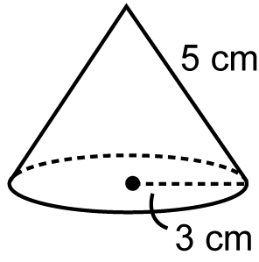
a)

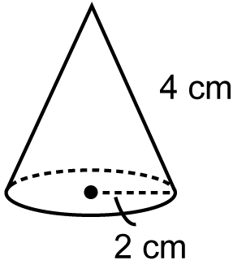
b)

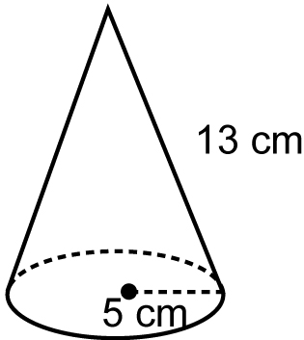
c)

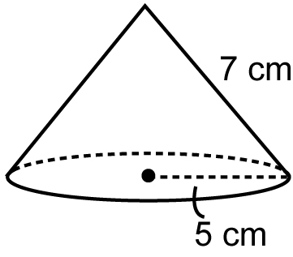
d)

2. Find the volume of each cone in question 1.

3. Find the volume of each cone.
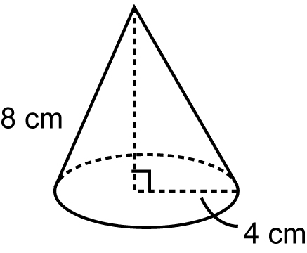
a)

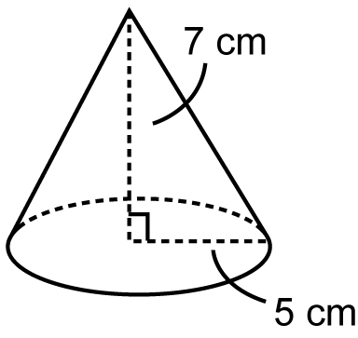
b)

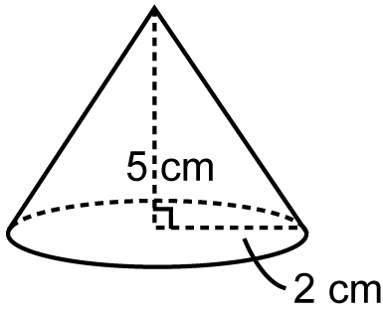
c)

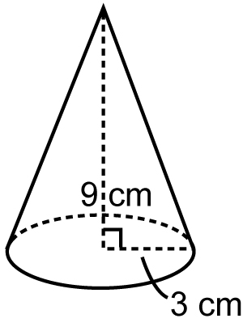
d)

4. Find the volume of each cone.
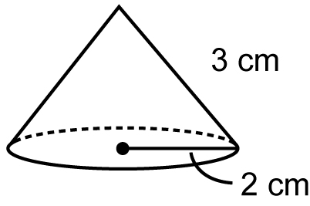
a)

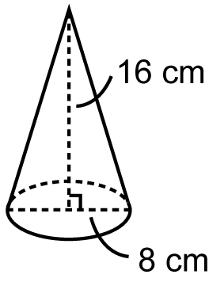
b)

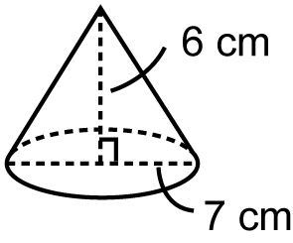
c)

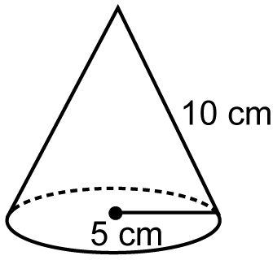
d)

5. A cone has volume 263.9 cm³ and base radius 6 cm. What is the height of
the cone?

6. A cone has volume 424.1 cm³ and height
5 cm. What is the base radius of the cone?

