Practice: Surface Area of a Sphere

For all questions, round your answer to the nearest tenth of a unit when necessary.

1. Find the surface area of each sphere
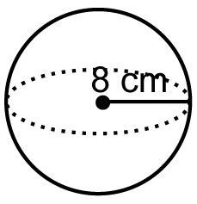
a)

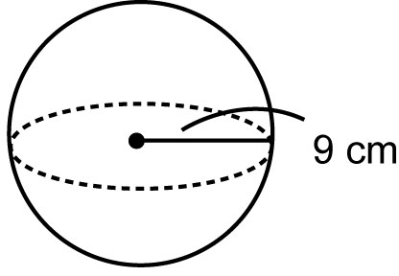
b)

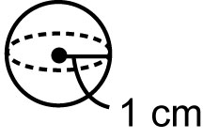
c)

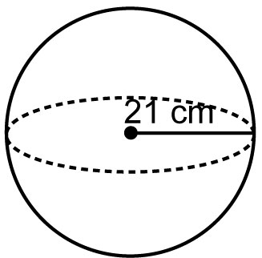
d)

2. Find the surface area of each sphere
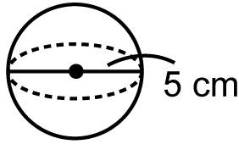
a)

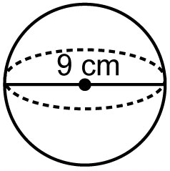
b)

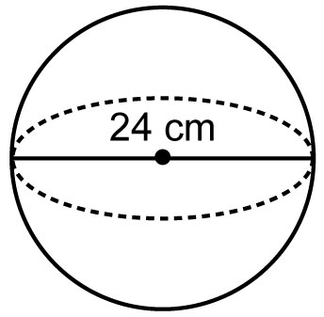
c)

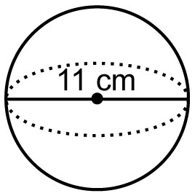
d)

3. Find the radius of each sphere
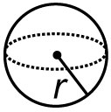
a)

Surface Area = 50.3 cm²

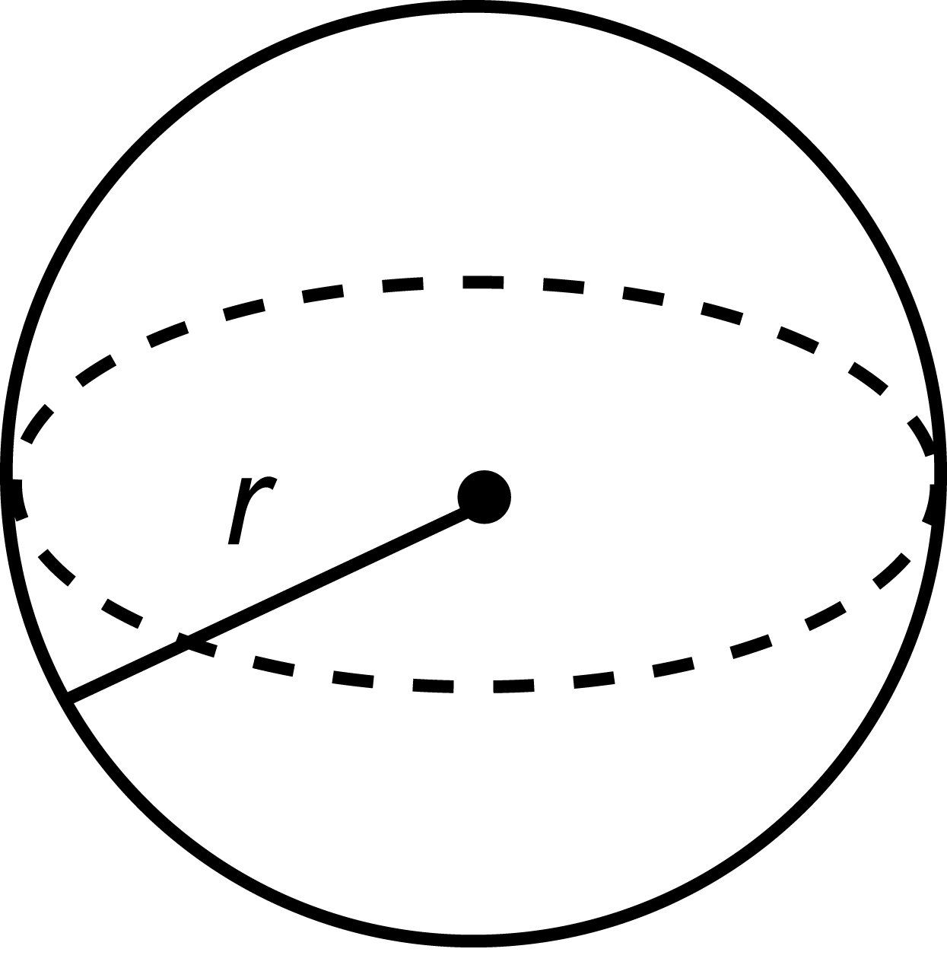
b)

Surface Area = 452.4 cm²
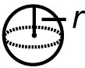
c)

Surface Area = 40.7 cm²
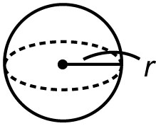
d)

Surface Area = 201.1 cm²

4. The surface area of sphere A is double the surface area of sphere B. The radius of sphere B is 7 cm.
a) What is the surface area of sphere B?
b) What is the surface area of sphere A?
c) What is the radius of sphere A?

