Practice: Volume of a Sphere

For all questions, round your answer to the nearest tenth of a unit when necessary.

1. Find the volume of each sphere.
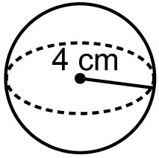
a)

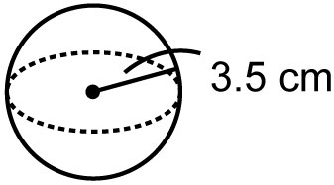
b)

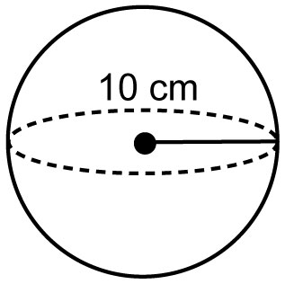
c)

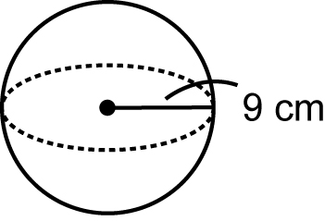
d)

2. Find the volume of each sphere.
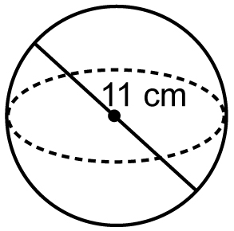
a)

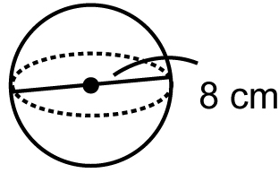
b)

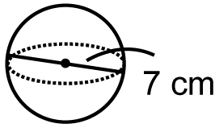
c)

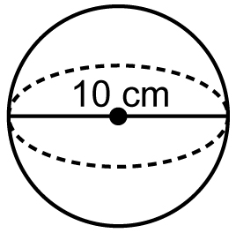
d)

3. Find the radius of each sphere.
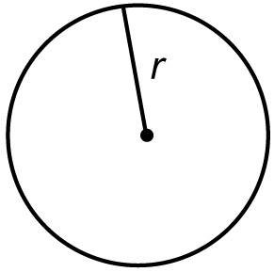
a)

Volume = 113.1 cm³

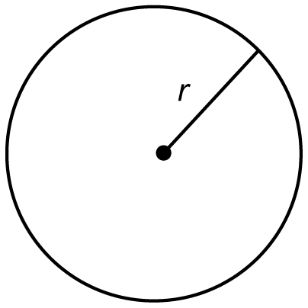
b)

Volume = 524 cm³

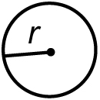
c)

Volume = 7.2 cm³

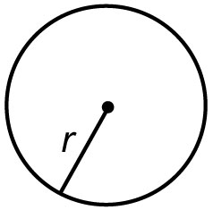
d)

Volume = 73.6 cm³

4. A sphere just fits inside a cube with edges 18 cm long.
a) Find the volume of the sphere.
b) What is the volume of the cube?
c) How much empty space is there in
the cube?

5. Sphere A has radius 5 cm. Its volume is double the volume of sphere B.
a) Find the volume of sphere A.
b) What is the volume of sphere B?
c) What is the radius of sphere B?

