Chapter 8 Review

For all questions, round your answer to the nearest tenth of a unit when necessary.

8.1 Apply the Pythagorean Theorem,
pages 418–425

1. Find the length of each indicated side.
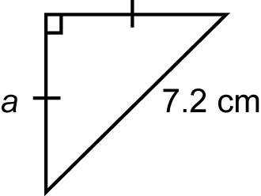
a)

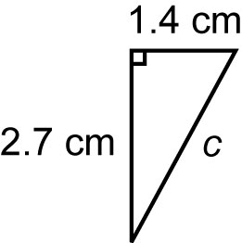
b)

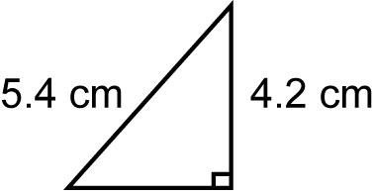
2. Find the area of this triangle.

8.2 Perimeter and Area of Composite
Figures, pages 426–435

3. Find the perimeter and area of each figure.
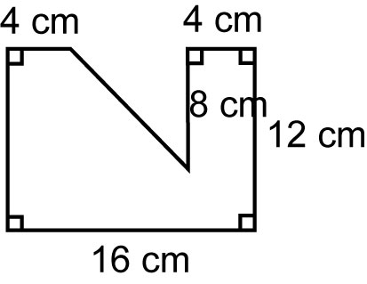
a)

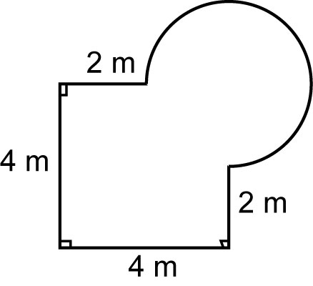
b)

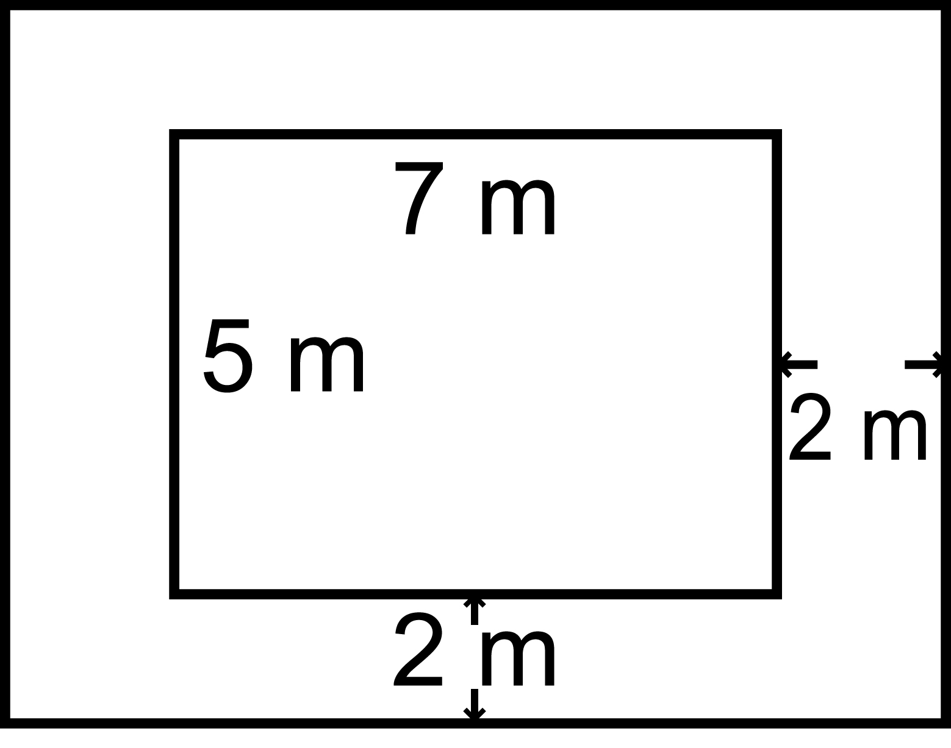
4. A pool is 5 m wide by 7 m long. It is surrounded by a deck 2 m wide. What is the area of the deck?

8.3 Surface Area and Volume of Prisms and
Pyramids, pages 436–443

5. Find the surface area and volume of each object.
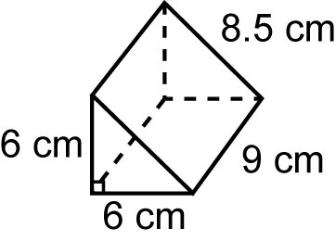
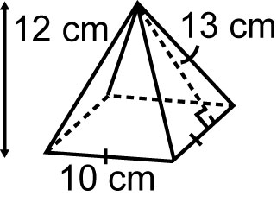
a) b)

6. Find the side length of each cube.
a) a cube with volume 3375 cm³
b) a cube with surface area 864 cm²

8.4 Surface Area of a Cone, pages 444–450

7. Calculate the surface area of each cone.
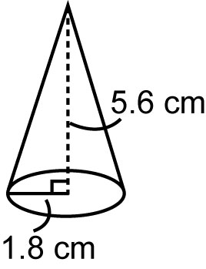
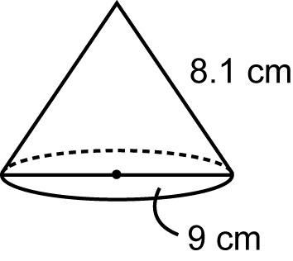
a) b)

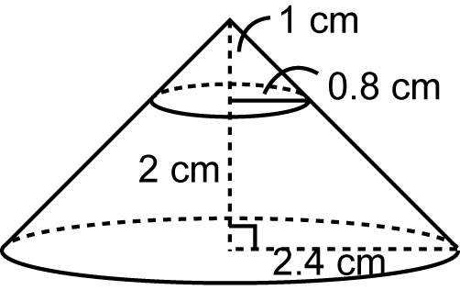
8. Find the surface area of this frustum.

8.5 Volume of a Cone, pages 451–456

9. Find the volume of each cone.

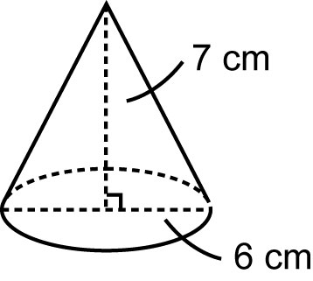
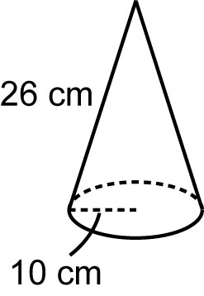
a) b)

10. Find the volume of the largest cone that fits inside a cube with edges 15 cm long.

8.6 Surface Area of a Sphere, pages 457–461

11. Find the surface area of each sphere.

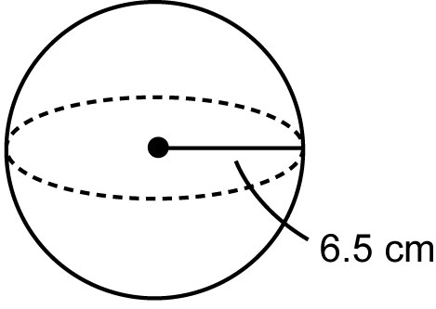
a)

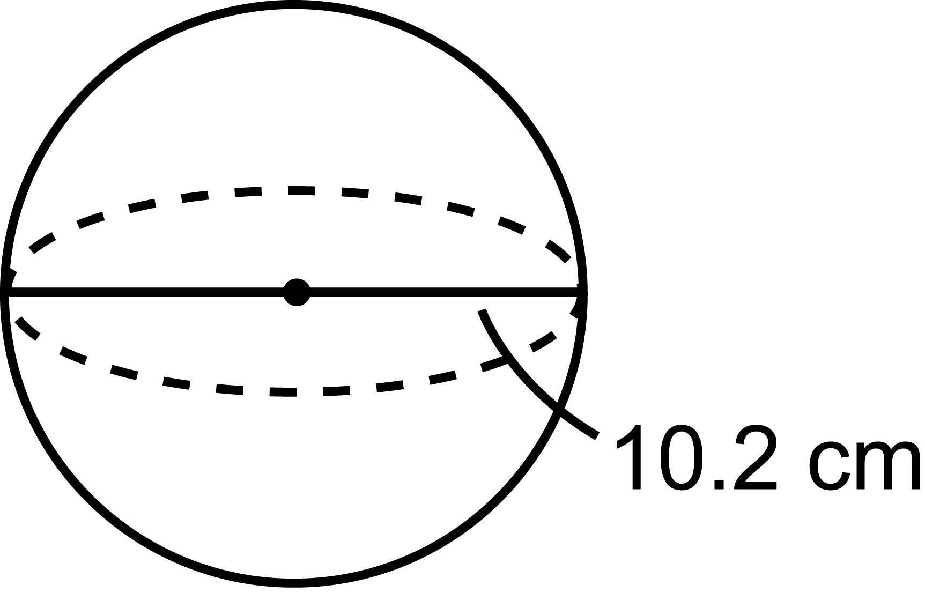
b)

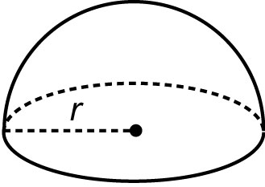
12. The surface area of this hemisphere is
1062 cm². What is its radius?

8.7 Volume of a Sphere, pages 462–469

13. Find the volume of each sphere.
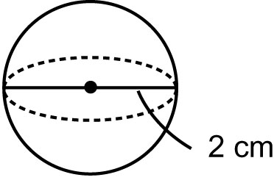
a)

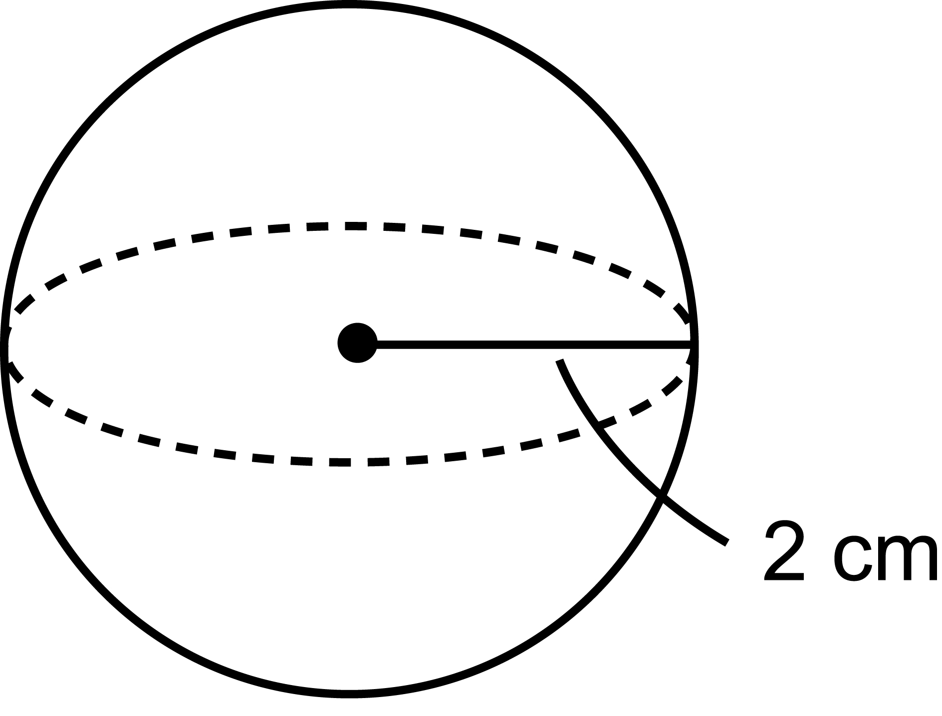
b)

14. Which has greater volume?
A a hemisphere with radius 12 cm
B a sphere with radius 8 cm
How do you know?

