Chapter 8 Test

Multiple Choice

For questions 1 to 5, select the best answer.

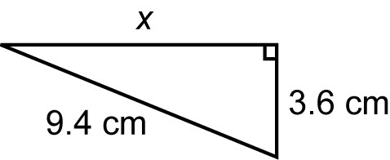
1. What is the length of the unknown side, to the nearest tenth of a centimetre?

A 10.1 cm B 75.4 cm
C 5.8 cm D 8.7 cm

2. What is the area of this figure, to the nearest tenth of a square centimetre?
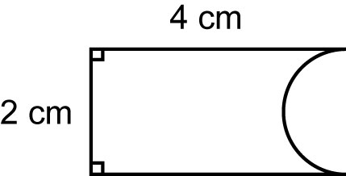

A 11.1 cm² B 6.4 cm²
C 4.9 cm² D 9.6 cm²

3. A cone has radius 8 cm and slant height 10 cm. What is the surface area of the cone to the nearest tenth of a square centimetre?
A 670.2 cm² B 804.2 cm²
C 452.4 cm² D 640 cm²

4. What is the volume of this pyramid, to the nearest tenth of a cubic centimetre?
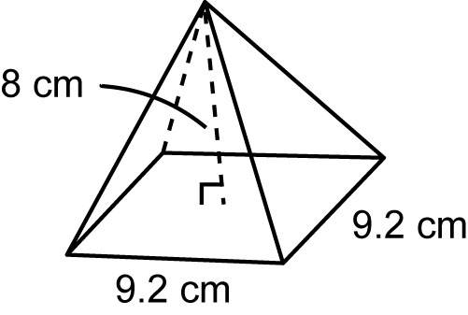

A 677.1 cm³ B 231.8 cm³
C 338.6 cm³ D 225.7 cm³

5. A sphere has radius 7 cm. What is the volume of the sphere to the nearest tenth of a cubic centimetre?
A 1436.8 cm³ B 615.8 cm³
C 4310.3 cm³ D 205.3 cm³
Short Response

Show all steps to your solution.

6. Find the surface area and volume of each object. Round your answers to one decimal place.
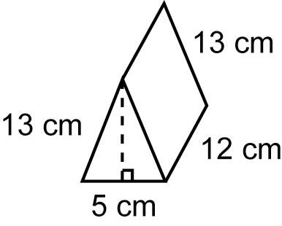
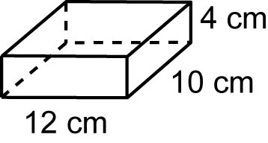
a) b)

7. Find the perimeter and area of this figure.
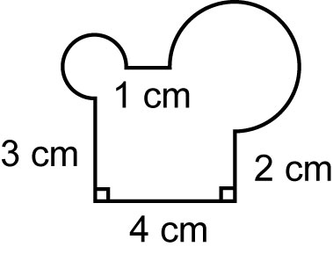

8. What is the maximum volume of a cone that would fit in this box?
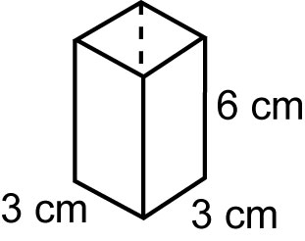

Extend

Provide complete solutions.

9. Carmine is packing 27 superballs in
3 square layers. Each ball has diameter 4 cm.
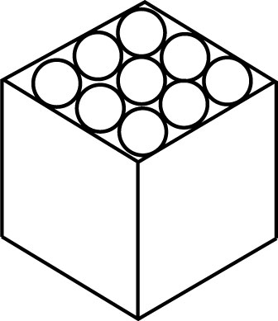

a) What is the minimum volume of
the box?
b) What is the surface area of the box?
c) How much empty space is in the box?

