Practice: Get Ready

Calculate Perimeter and Circumference

1. Find the perimeter of each figure.
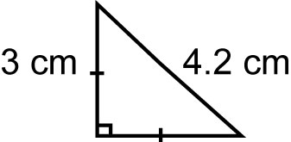
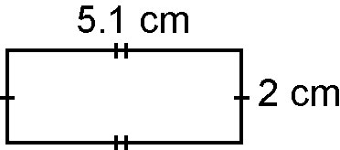
a) b)

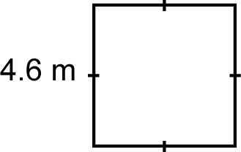
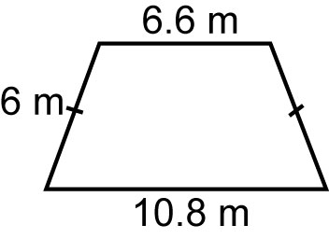
c) d)

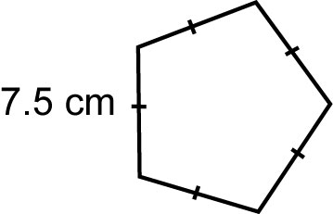
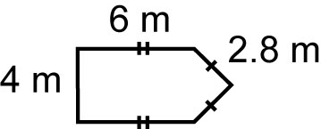
e) f)

2. Find the circumference of each circle, to the nearest tenth of a unit.
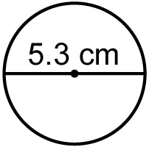
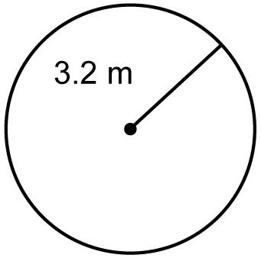
a) b)

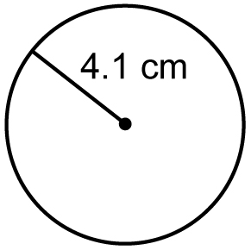
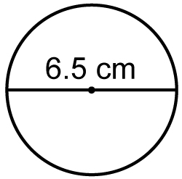
c) d)

3. How much fencing is required to enclose this yard?
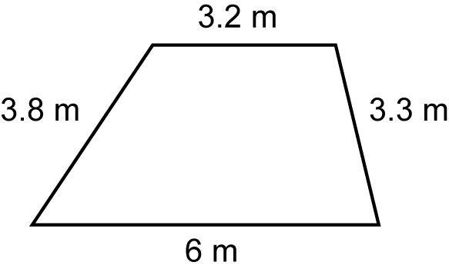

Apply Area Formulas

4. Find the area of each figure to the nearest tenth of a square unit.
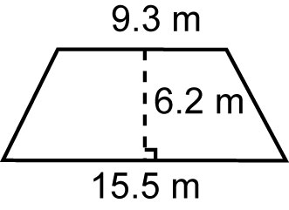
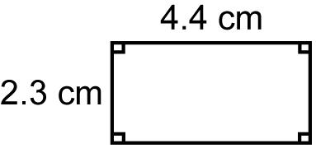
a) b)

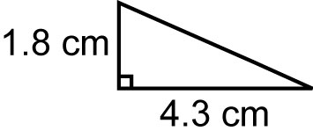
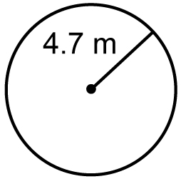
c) d)

Calculate Surface Area and Volume

5. Find the surface area of each object. Give answers to the nearest tenth of a square unit.
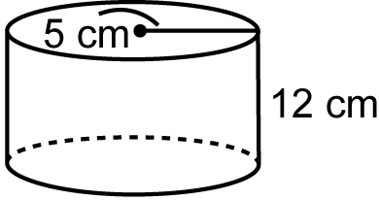
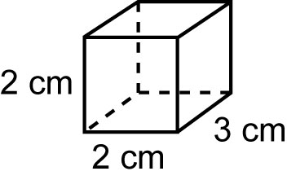
a) b)

6. Find the volume of each object in question 5 to the nearest tenth of a cubic unit.

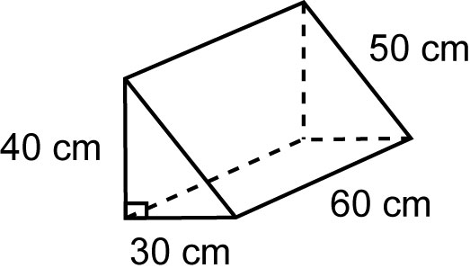
7. a) Draw and label a net for the triangular prism.

b) Find the surface area of the prism.
c) Find the volume of the prism.

Use The Geometer’s Sketchpad®

8. Use The Geometer’s Sketchpad® to create a triangle with perimeter 20 cm.
9. Use The Geometer’s Sketchpad® to create a circle with area 50 cm².

