Practice: Perimeter and Area Relationships
of a Rectangle
1. A rectangle has perimeter 16 units.
a) List all the possible whole-number dimensions of the rectangle.
b) Which dimensions produce the rectangle with maximum area?
c) Describe the shape of the rectangle with maximum area.

2. List all the possible whole-number dimensions for a rectangle with each perimeter. Circle the dimensions that produce the rectangle with the maximum area.
a) 28 units b) 12 units
c) 22 units d) 8 units
e) 14 units f) 26 units

3. What whole-number dimensions will produce the rectangle with maximum area given each perimeter?
a) 96 m b) 110 m
c) 68 m d) 72 m

4. What whole-number dimensions produce the rectangle with the least perimeter given each area?
a) 20 m² b) 32 m²
c) 64 m² d) 54 m²
e) 120 m² f) 48 m²

5. Nicole has 8 m of fencing. She plans to build a pen for her dog. The pen will have fence on three sides. The fourth side will be against the wall of her house. Nicole is considering making the pen 1 m by 6 m as shown.
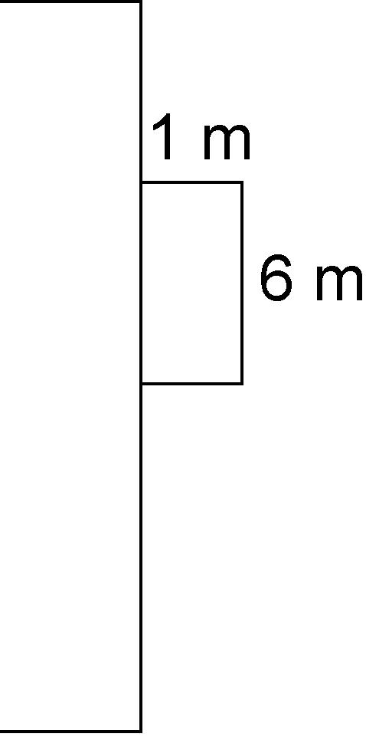

a) What are the other possible whole-number lengths for the fenced sides of the pen?
b) Which side lengths produce the pen with the greatest area?

6. Cam is building a fenced-in play yard for his small children against one wall of his house. He has 12 m of fencing. What whole-number dimensions produce the play yard with the greatest area?

