Practice: Minimize the Surface Area of a
Square-Based Prism
For all questions, round your answer to the nearest tenth of a unit when necessary.

1. Each of these square-based prisms has volume 64 cm³.
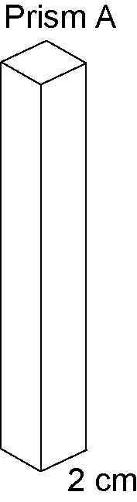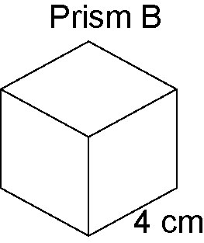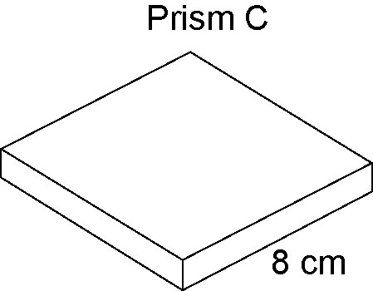

a) Find the height of each prism.
b) Find the surface area of each prism.
c) Order the prisms from least to greatest surface area.

2. Each of these square-based prisms has the same volume. Order the prisms from least to greatest surface area.
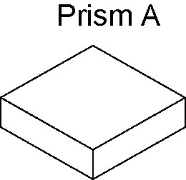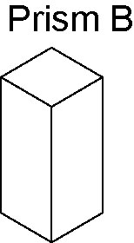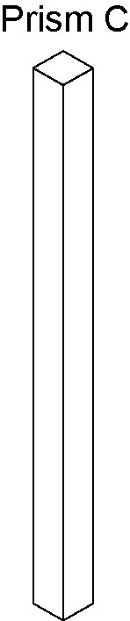

3. A square-based prism has volume 512 cm³.
a) What are the possible whole-number dimensions of the prism?
b) Which dimensions produce the prism with the least surface area?

4. Find the dimensions of the square-based prism with minimum surface area, given each volume.
a) 216 cm³ b) 864 cm³
c) 111 cm³ d) 1331 cm³

