Investigate: The Geometer’s Sketchpad ®
Method

Technology Tools

• The Geometer’s

Sketchpad ®

• computers

Use The Geometer’s Sketchpad ® to create a model of a square-based prism and control the dimensions with sliders. Since the base is square, you will need one slider to control the base length, and another slider to control the height.

1. On the Edit menu, click Preferences. Click the Text tab. Ensure that For All New Points is checked. Click OK.

2. Construct a slider to control the base length.
• Construct a horizontal line segment AB.
• Construct a point C on the line between A and B.
• Select points A, B, and C, in that order. On the Measure menu, click Ratio. The ratio of AC:AB will appear on the screen.
• To change the label of AC:AB, select this ratio measurement. Right-click and on the menu click Label Measurement. Type in the new label Base Slider.
• Drag the point C back and forth. Note how the ratio changes.

3. Create another slider in the same way. Label this slider Height Slider.
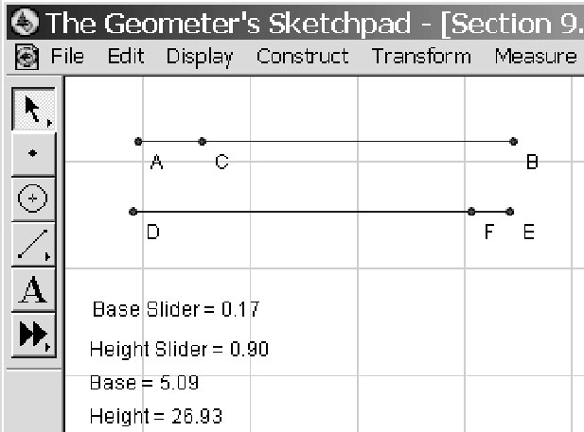

4. Select the measurement Base Slider. On the Measure menu, click Calculate. Enter the formula 30*Base Slider, by selecting Base Slider from the Values menu on the calculator. Change the label to Base.

5. Select the measurement Height Slider. On the Measure menu, click Calculate. Enter the formula 30*Height Slider. Change the label to Height.

6. Construct a point G in the workspace. Select point G. On the Measure menu, click Abscissa (x). Select point G again. Then, on the Measure menu click Ordinate (y). These are the coordinates of point G.

7. Select x_{G} and Base. On the Measure menu, click Calculate. Enter the formula x_{G} + Base, by selecting these values from the Values menu on the calculator.

8. Select y_{G} and Height. On the Measure menu, click Calculate. Enter the formula y_{G} + Height.

9. Plot the remaining points to form the vertices of a rectangle GHIJ.
• Select x_{G} + Base and y_{G}, in that order. On the Graph menu, click Plot As (x, y). This will be the point H. If point H is not visible on your screen, drag the unit point to adjust the scale of your sketch. Deselect the point.
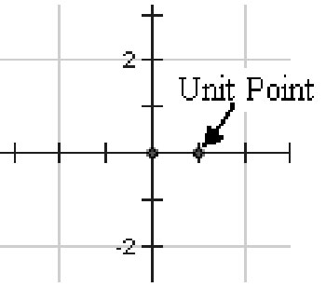
• Select x_{G} + Base and y_{G} + Height. On the Graph menu, click Plot As (x, y).
• Finally, select x_{G} and y_{G} + Height. On the Graph menu, click Plot As (x, y).
• You may need to relocate your rectangle in the workspace by clicking and dragging the rectangle.

10. Select points G, H, I, and J, in that order. On the Construct menu, click Quadrilateral Interior. Move your sliders. Notice how the dimensions of the rectangle change.

11. Select Base and Height. On the Measure menu, click Calculate. Enter the formula 2*Base*
Base + 4*Base*Height. Change the label to Surface Area.

12. Select Base and Height. On the Measure menu, click Calculate. Enter the formula Base*Base*Height. Change the label to Volume.

13. Create a table.
• Select, in order, Base, Height, Surface Area, and Volume. On the Graph menu, click Tabulate.
• Adjust Base to 5 cm, using the base slider. Adjust the height slider until Surface Area is
600 cm². Select the table. On the Graph menu, click Add Table Data…. Click OK.
• Adjust Base to 6 cm. Adjust the height slider until Surface Area is 600 cm². Add the data to the table.
• Continue increasing the base by 1 cm each time, until you are sure that you have passed the maximum volume.
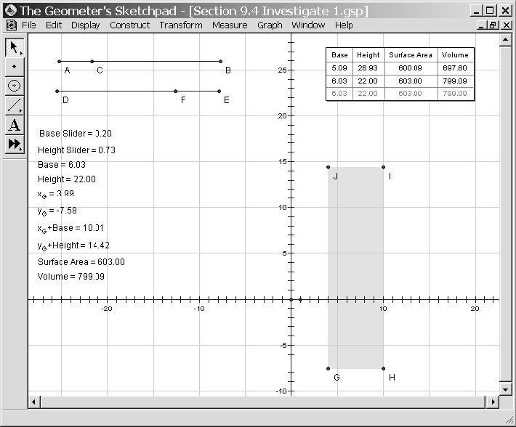
14. Next, try to refine the values of the base and the height until you have the maximum volume. What base and height dimensions produce the maximum volume? Describe the shape of this square-based prism.

15. a) Predict the dimensions of the square-based prism with maximum volume if the surface area is 384 cm².
b) Use the GSP sketch to check your prediction. What shape is this prism?

16. Repeat question 15 for a square-based prism with surface area 864 cm².

17. Reflect What conclusion can you make about the maximum volume of a square-based prism with a given surface area?

18. Save this sketch for use in future investigations.

