Practice: Maximize the Volume of a Cylinder

For all questions, round your answer to the nearest tenth of a unit when necessary.

1. Each cylinder has surface area 302 cm².
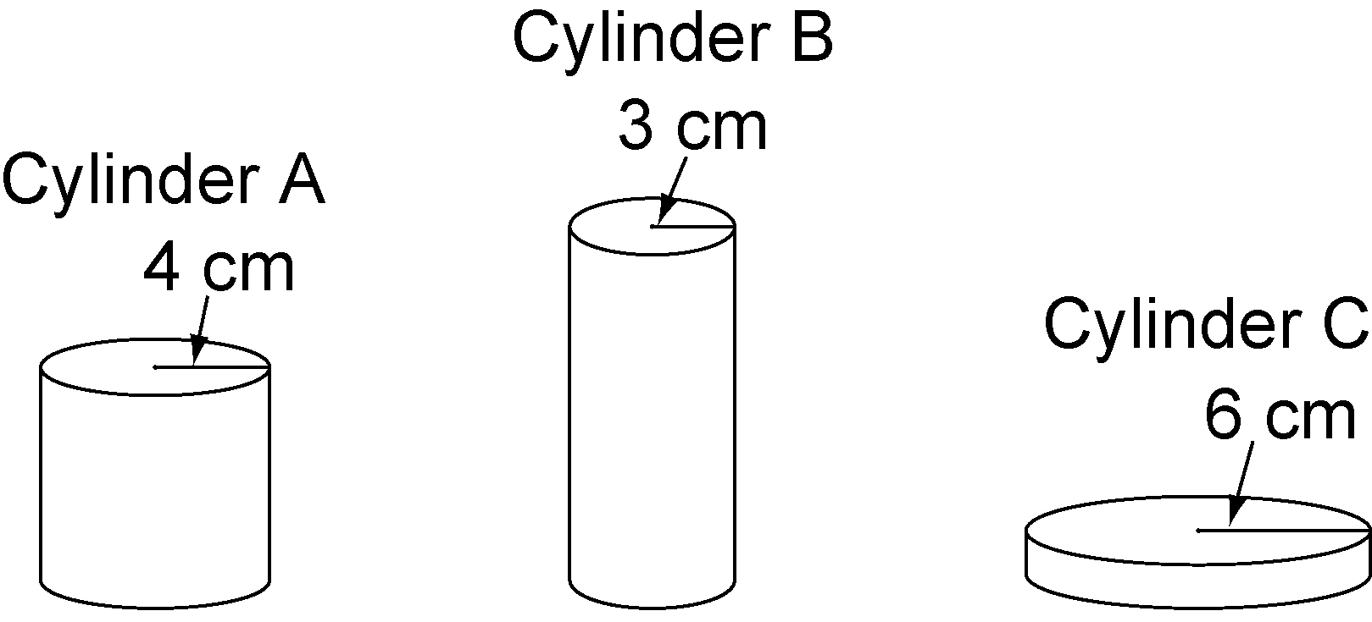

a) Find the height of each cylinder.
b) Find the volume of each cylinder.
c) Order the cylinders from greatest to least volume.

2. Each cylinder has surface area 75.4 cm². Order the cylinders from greatest to least volume.
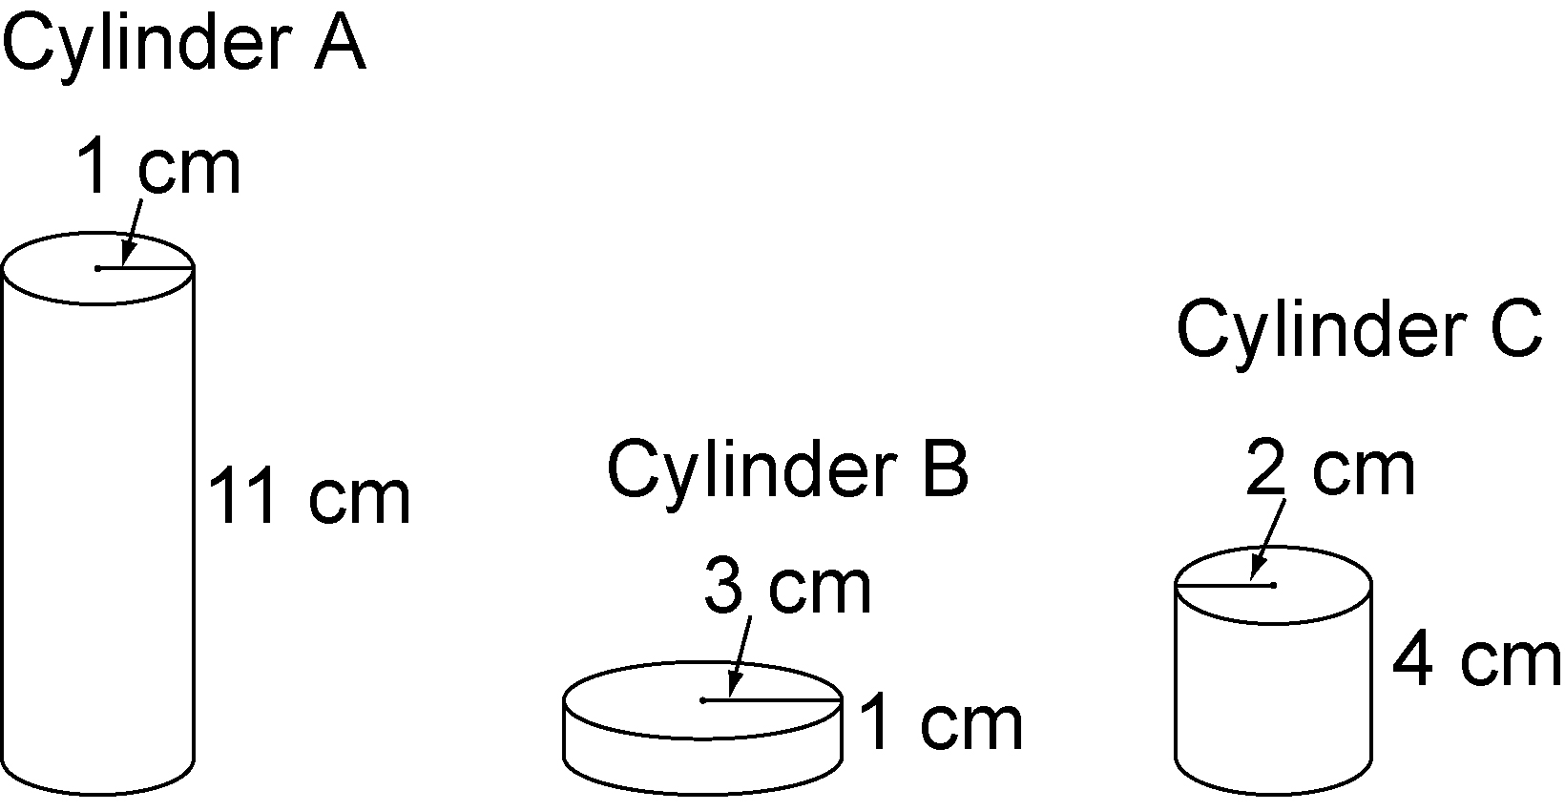

3. Each cylinder has the same surface area. Order the cylinders from greatest to least volume.
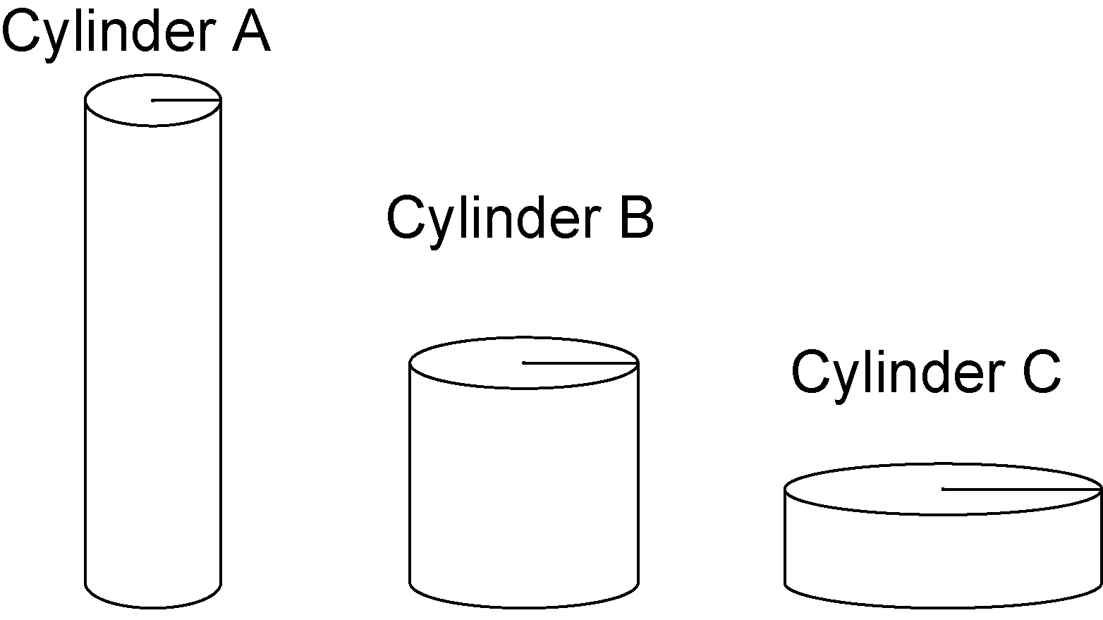

4. Find the radius and height of the cylinder with maximum volume, given the surface area.
a) 250 cm² b) 500 cm²
c) 40 cm² d) 475 cm²
e) 750 cm² f) 1000 cm²

