Practice: Minimize the Surface Area
of a Cylinder

For all questions, round your answer to the nearest tenth of a unit when necessary.

1. Each cylinder has volume 50.3 cm³.
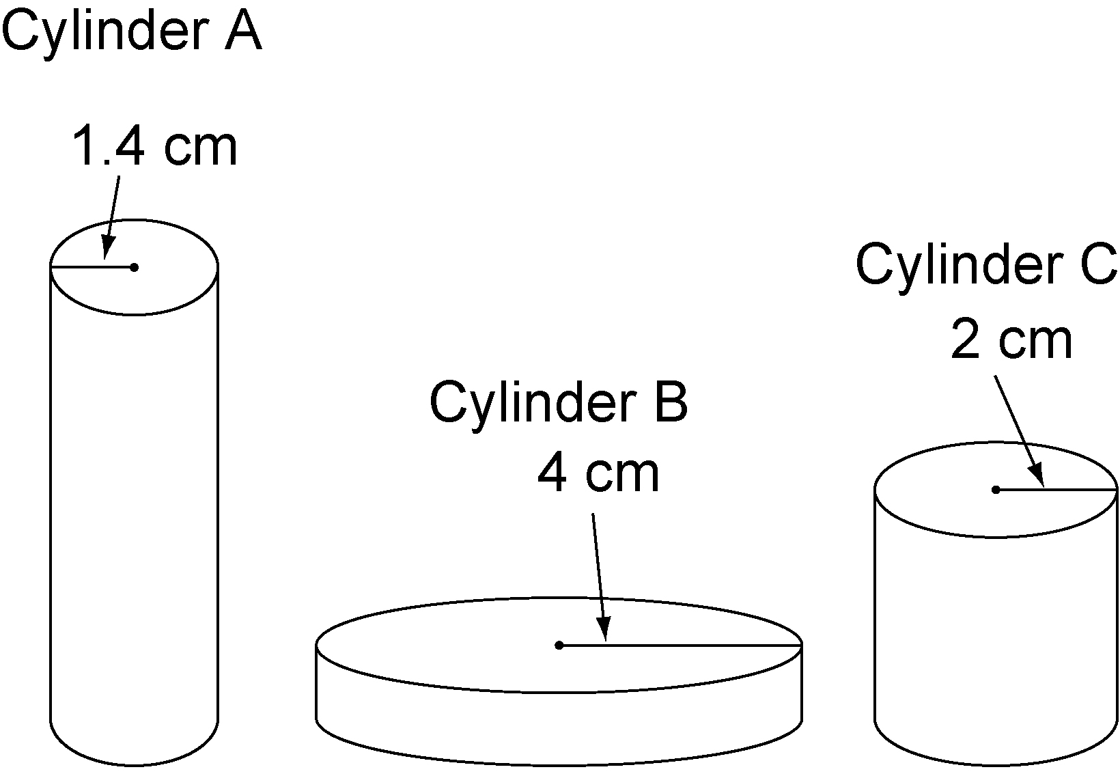
a) Find the height of each cylinder.
b) Find the surface area of each cylinder.
c) Order the cylinders from least to greatest surface area.

2. Each cylinder has volume 402 cm³. Order the cylinders from least to greatest surface area.
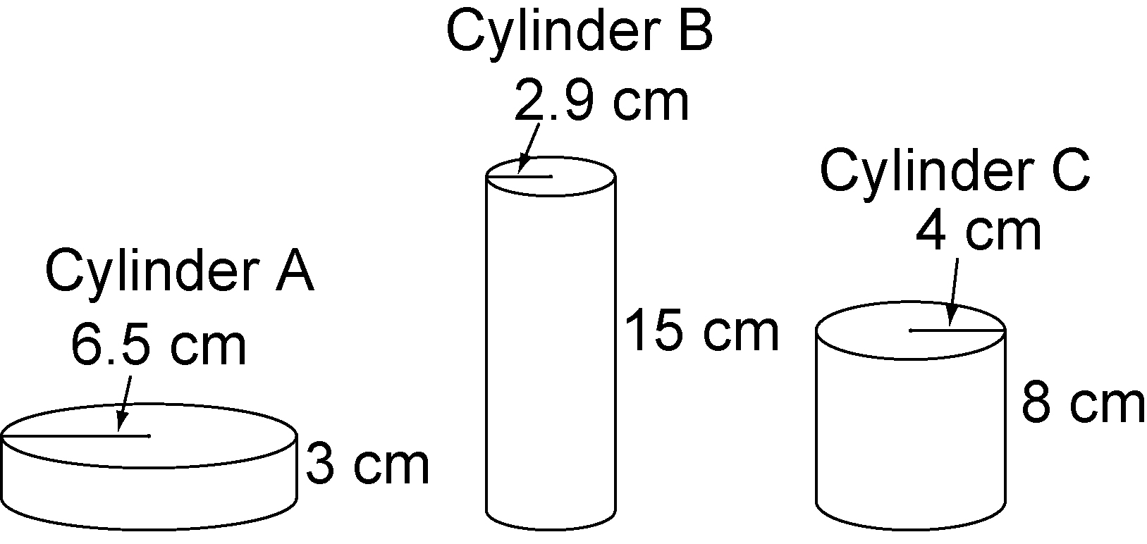

3. Each cylinder has the same volume. Order the cylinders from least to greatest surface area.
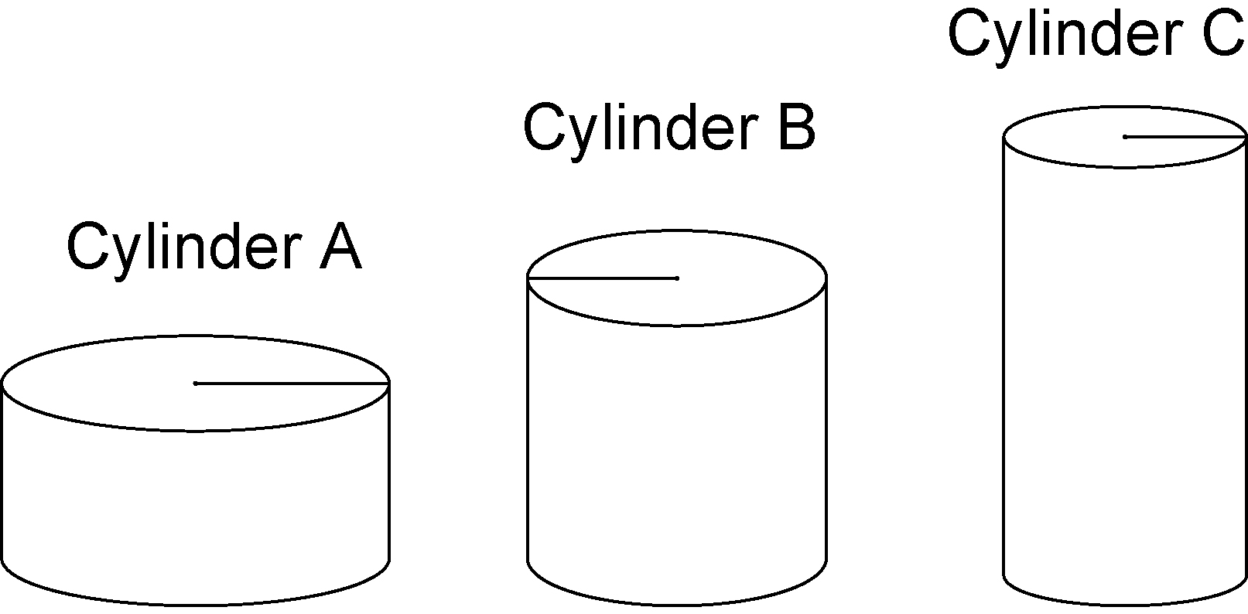

4. Find the radius and height of the cylinder with minimum surface area, given the volume.
a) 1500 cm³ b) 400 cm³
c) 80 cm³ d) 12 cm³
e) 650 cm³ f) 440 cm³

