Chapter 9 Review

For all questions, round your answer to the nearest tenth of a unit when necessary.

9.1 Investigate Measurement Concepts, pages 478–483

1. Copy and complete the table for a rectangle with an area of 32 cm².
Rectangle | Width | Length | Perimeter | Area
1 |  |  |  | 32
2 |  |  |  | 32
3 |  |  |  | 32
4 |  |  |  | 32

9.2 Perimeter and Area Relationships of a Rectangle, pages 484–490

2. A rectangle has a perimeter of 36 cm.
a) What might the dimensions of the rectangle be? Give as many different whole-number answers as you can.
b) Which dimensions produce the rectangle with the greatest area?

3. A rectangle has an area of 48 cm².
a) What might the dimensions of the rectangle be? Give as many different whole-number answers as you can.
b) Which dimensions produce the rectangle with the least perimeter?

9.3 Minimize the Surface Area of a
Square-Based Prism, pages 491–497

4. Find the dimensions of the square-based prism with the least surface area given each volume.
a) 1200 cm³ b) 850 cm³
9.4 Maximize the Volume of a Square-Based Prism, pages 498–503

5. Find the dimensions of the square-based prism with the greatest volume given each surface area.
a) 700 cm² b) 280 cm²

9.5 Maximize the Volume of a Cylinder, pages 504–509

6. A cylinder has a surface area of 925 cm² and the greatest volume possible. What are the dimensions of the cylinder?

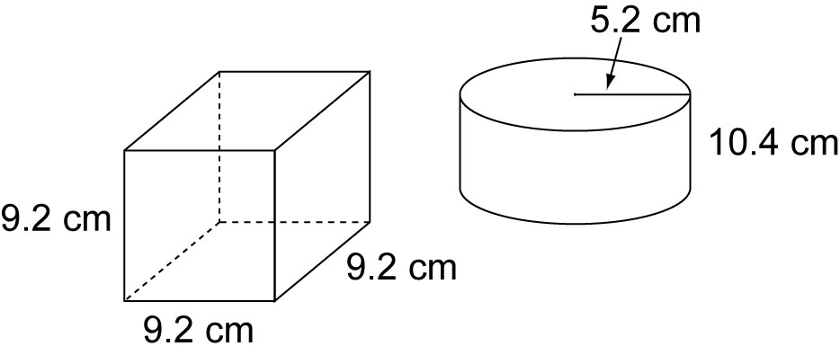
7. The surface are of the box is 384 cm³, while the surface area of the cylinder is 437.3 cm³, which object has the greater volume?

9.6 Minimize the Surface Area of a Cylinder, pages 510–515

8. A cylinder has a volume of 1200 cm³ and the least surface area possible. What are the dimensions of the cylinder?

