Chapter 9 Test

Multiple Choice
For questions 1 to 4, select the best answer.

1. Heather wants to build a rectangular pen. She has 24 1-m sections of fencing. What are the dimensions of the pen with the greatest area?
A 1 m by 11 m B 2 m by 10 m
C 3 m by 9 m D 4 m by 8 m

2. A square-based prism has a surface area of 600 cm². What are the dimensions of the prism if it has maximum volume?
A 15 cm by 2.5 cm by 2.5 cm
B 8.4 cm by 8.4 cm by 8.4 cm
C 10 cm by 10 cm by 10 cm
D 8 cm by 8 cm by 15 cm

3. These square-based prisms all have the same volume. Which prism has the least surface area?
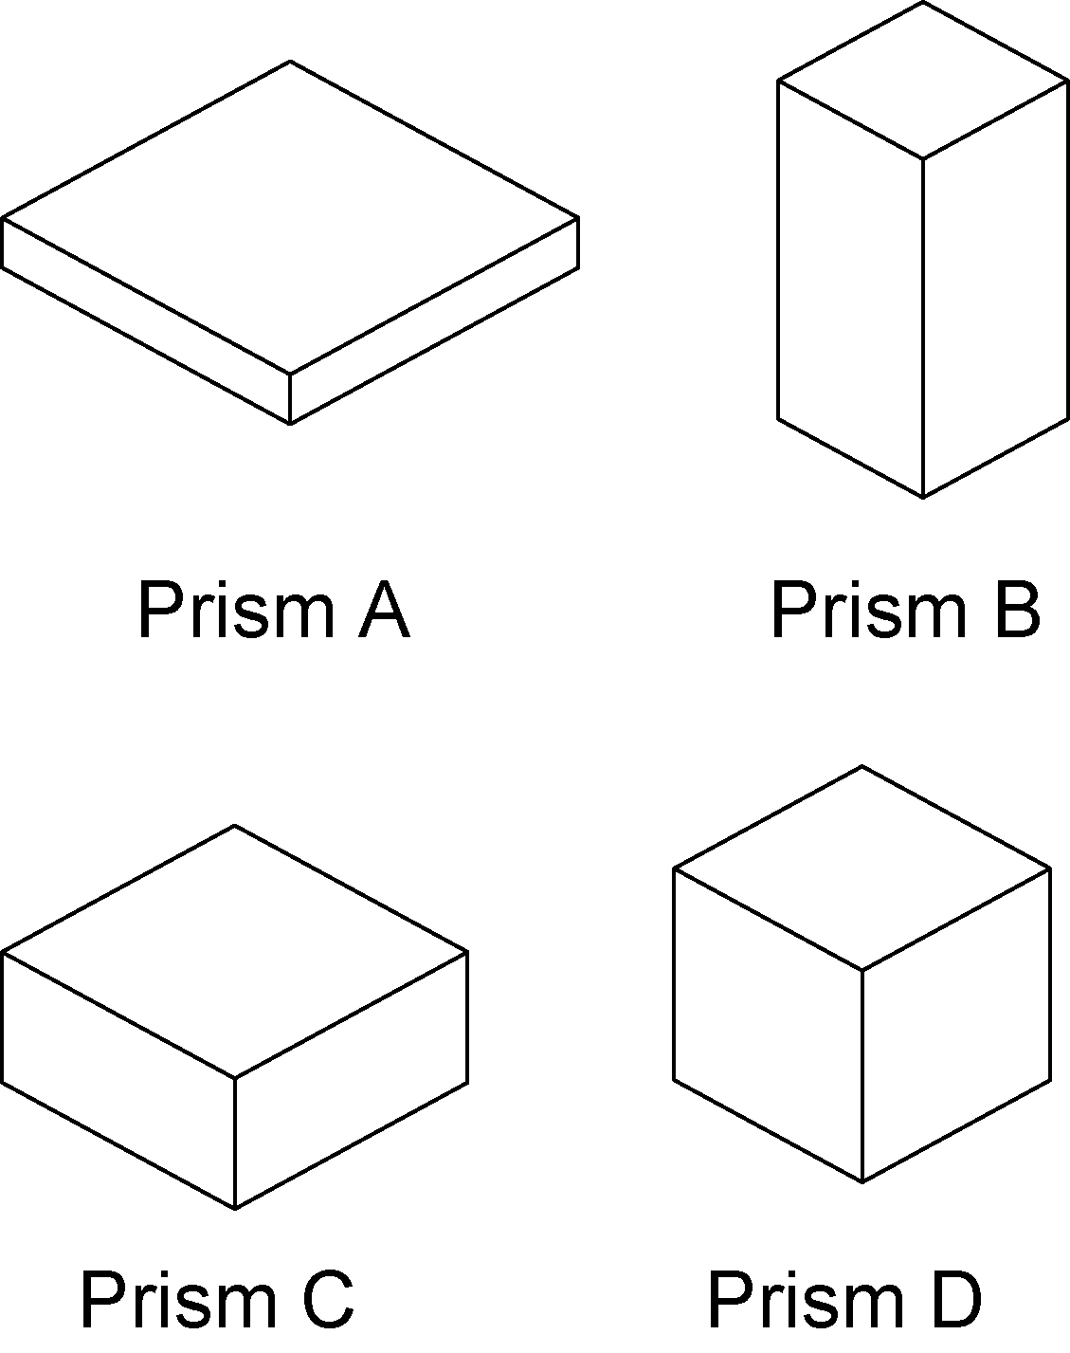

A Prism A B Prism B
C Prism C D Prism D

4. The volume of a cylinder is 700 cm³. What are the radius and height of the cylinder if it has the least surface area possible?
A r = 5 cm, h = 8.9 cm
B r = 4.8 cm, h = 9.6 cm
C r = 4.8 cm, h = 4.8 cm
D r = 5.2 cm, h = 8.2 cm

Short Response
Show all steps to your solution. When necessary, round your answer to one decimal place.

5. Wendy has 20 m of fencing. She plans to enclose an area in her yard. The fourth side of the area has a hedge, so she only needs to fence three sides. What is the greatest area Wendy can enclose?

6. Suppose you plan to build a box with a volume of 120 cm³.
- What are the dimensions of the box?
b) What is the least amount of material required to build the box?

7. Amy is building a cylindrical storage tank to hold 800 cm³ of road salt. Find the radius and height of the tank that requires the least amount of material.

Extend
Provide complete solutions.

8. Engla wishes to make a container
with a volume of 500 cm³ using the least amount of material. Should the box be a square-based prism or a cylinder? Why?

