Practice: Get Ready
For all questions, round your answer to the nearest tenth of a unit when necessary.

Measurement Concepts: Perimeter, Circumference, Area, Surface Area, and Volume
1. Find the perimeter and area of each figure.
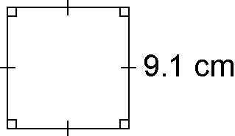
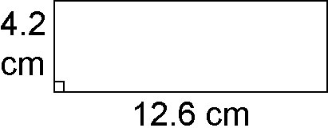
a) b)

2. Find the circumference and area of each circle.
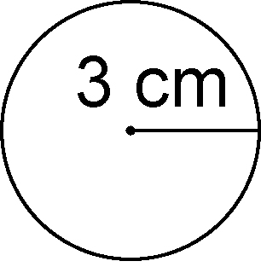
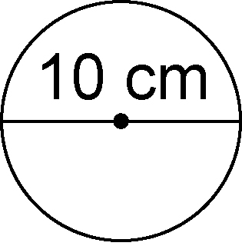
a) b)

3. Calculate the surface area and volume of each rectangular prism.
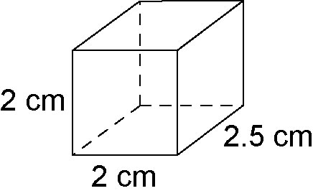
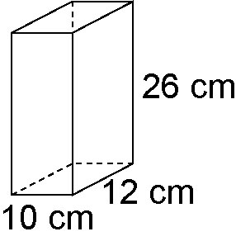
a) b)

4. Calculate the surface area and volume of each cylinder.
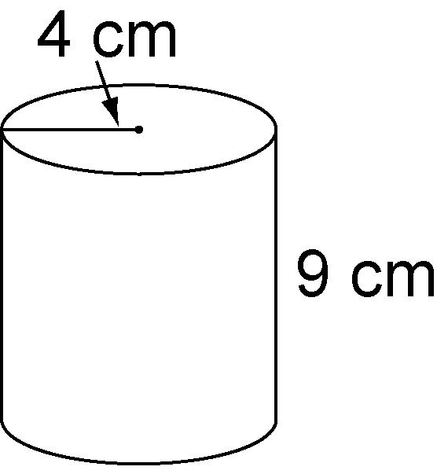
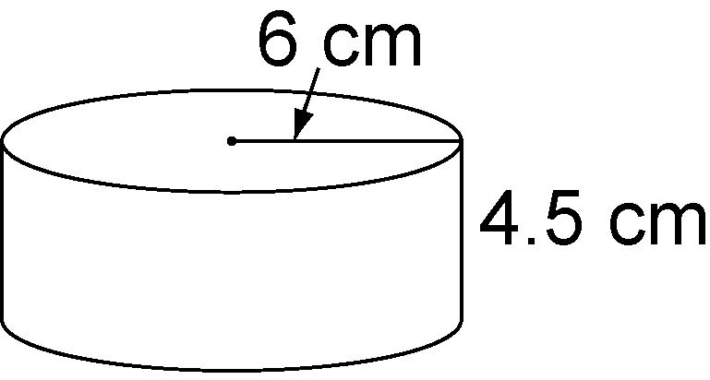
a) b)

Compare Figures
5. a) Which container has the greater volume? How much greater?
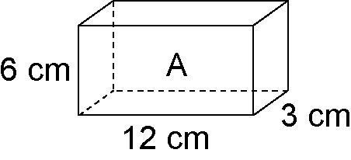
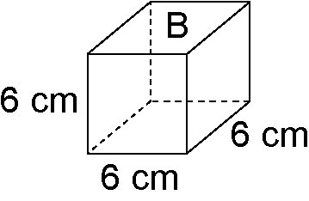

b) Which container has the greater surface area? How much greater?
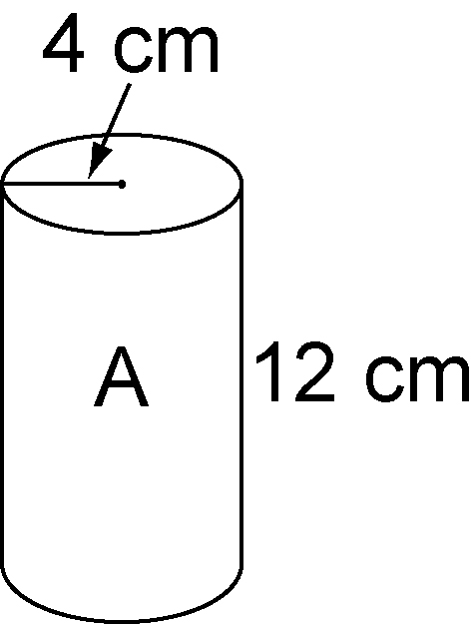
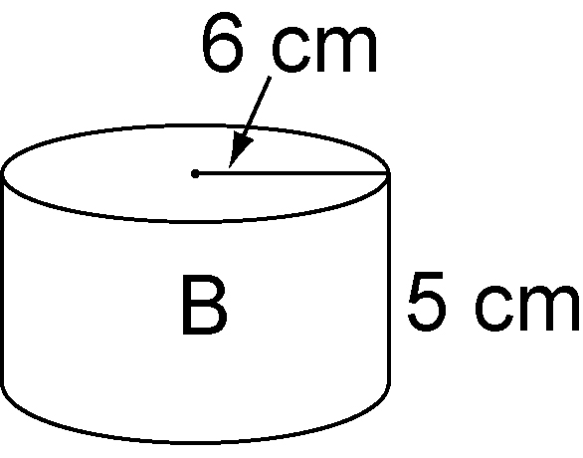
6. a) Calculate the surface area and volume of each container.

b) Which container will hold more?
c) Which container requires less material?

