Chapter 9 Practice Test

Multiple Choice
For questions 1 to 4, select the best answer.

1. Angus wants to build a pen against one wall of his house. He has 16 m of fencing. Which dimensions will give him the pen with greatest area?
A 4 m by 4 m B 4 m by 8 m
C 2 m by 8 m D 3 m by 10 m

2. A square-based prism has volume
27 000 cm³. What are the dimensions of the prism if it has minimum surface area?
A 46 cm by 30 cm by 20 cm
B 90 cm by 30 cm by 10 cm
C 27 cm by 10 cm by 10 cm
D 30 cm by 30 cm by 30 cm

3. These square-based prisms all have the same surface area. Which prism has the greatest volume?
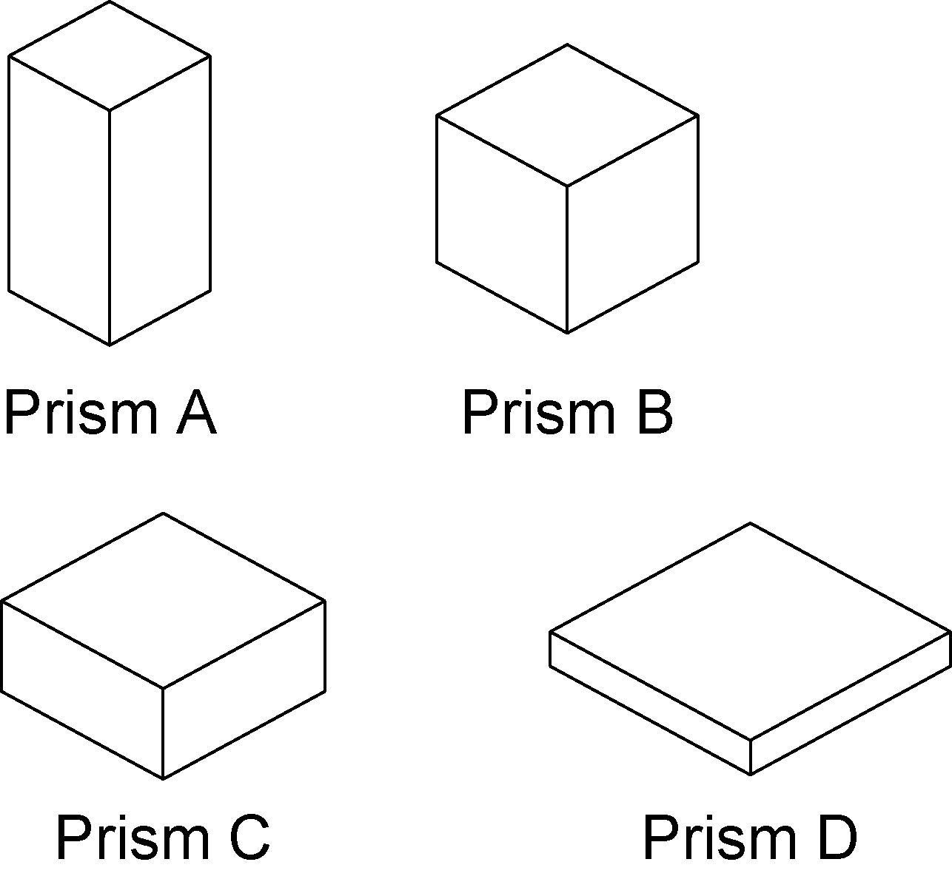

A Prism A B Prism B
C Prism C D Prism D

4. The surface area of a cylinder is 800 cm². What are the radius and height of the cylinder if it has the greatest volume possible?
A r = 8 cm, h = 8 cm
B r = 6.5 cm, h = 6.5 cm
C r = 6.5 cm, h = 13 cm
D r = 4 cm, h = 28 cm

Short Response
Show all steps to your solution.

5. Walter wants to fence an area 400 m². What is the least amount of fencing he will require?

6. Suppose you are allowed to use a maximum of 1350 cm² of cardboard to build a square-based box. What are the dimensions of the largest box you can build?

7. A cylindrical storage tank must hold 70 L of cleaning fluid. Find the radius and height of the tank that requires the least amount of metal. Express your answers to the nearest tenth of a centimetre.

Extend
Provide complete solutions. Round all answers to one decimal place.

8. Solvig has 100 cm² of cardboard to make a box with the greatest possible volume.
a) Should the box be a square-based prism or a cylinder? Why?
b) What assumptions did you make?

