BLM 9.GR.1 Practice: Get Ready
1. a) perimeter: 33.6 cm; area 52.9 cm²
b) perimeter: 36.4 cm; area 82.8 cm²
2. a) circumference: 18.8 cm; area 28.3 cm²
b) circumference: 31.4 cm; area 78.5 cm²
3. a) surface area: 28 cm²; volume: 10 cm³
b) surface area: 1384 cm²; volume: 3120 cm³
4. a) surface area: 326.7 cm²; volume: 452.4 cm³
b) surface area: 395.8 cm²; volume: 508.9 cm³
5. a) They have the same volume, 216 cm³.
b) container A; 36 cm²
6. a) container A: surface area = 402.1 cm² ,
volume = 603.2 cm³
container B: surface area = 414.7 cm²,
volume = 565.5 cm³
b) container A
c) container A
BLM 9.1.1 Practice: Investigate Measurement Concepts
1. a)
Rectangle | Width | Length | Perimeter | Area
1 | 1 | 8 | 18 | 8
2 | 2 | 7 | 18 | 14
3 | 3 | 6 | 18 | 18
4 | 4 | 5 | 18 | 20
5 | 5 | 4 | 18 | 20
6 | 6 | 3 | 18 | 18
7 | 7 | 2 | 18 | 14
8 | 8 | 1 | 18 | 8
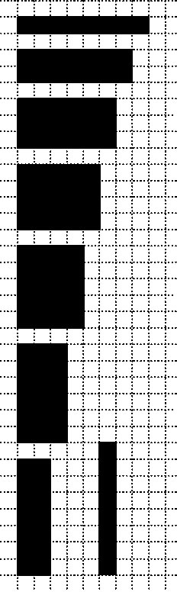
b)

2. | Rectangle | Width | Length | Perimeter | Area
 | 1 | 1 | 10 | 22 | 10
 | 2 | 2 | 9 | 22 | 18
 | 3 | 3 | 8 | 22 | 24
 | 4 | 4 | 7 | 22 | 28
 | 5 | 5 | 6 | 22 | 30
 | 6 | 6 | 5 | 22 | 30
 | 7 | 7 | 4 | 22 | 28
 | 8 | 8 | 3 | 22 | 24
 | 9 | 9 | 2 | 22 | 18
 | 10 | 10 | 1 | 22 | 10
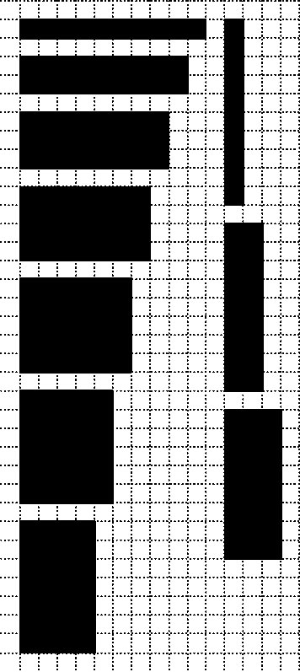
3. a)
Rectangle | Width | Length | Perimeter | Area
1 | 1 | 24 | 50 | 24
2 | 2 | 12 | 28 | 24
3 | 3 | 8 | 22 | 24
4 | 4 | 6 | 20 | 24
5 | 6 | 4 | 20 | 24
6 | 8 | 3 | 22 | 24
7 | 12 | 2 | 28 | 24
8 | 24 | 1 | 50 | 24

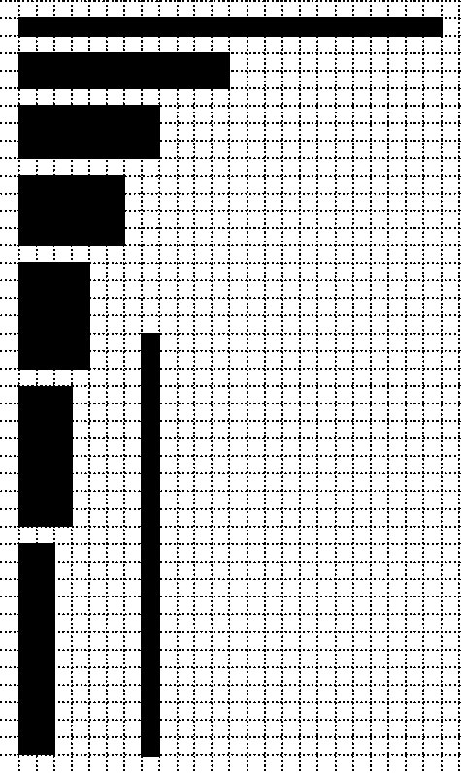
b)

4. | Rectangle | Width | Length | Perimeter | Area
 | 1 | 1 | 12 | 26 | 12
 | 2 | 2 | 6 | 16 | 12
 | 3 | 3 | 4 | 14 | 12
 | 4 | 4 | 3 | 14 | 12
 | 5 | 6 | 2 | 16 | 12
 | 6 | 12 | 1 | 26 | 12
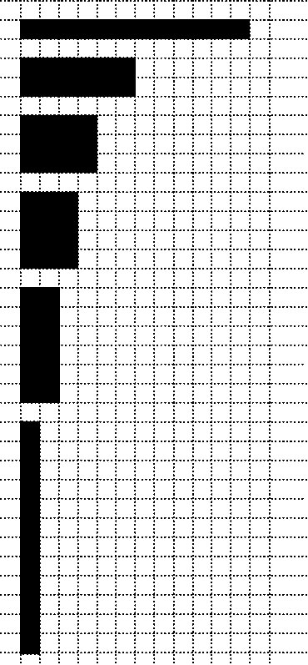
BLM 9.2.1 Practice: Perimeter and Area Relationships of a Rectangle
1. a) 1 by 7; 2 by 6; 3 by 5; 4 by 4
b) 4 by 4
c) It is a square.
2. a) 1 by 13, 2 by 12, 3 by 11, 4 by 10, 5 by 9,
6 by 8, 7 by 7
b) 1 by 5, 3 by 3, 2 by 4
c) 1 by 10, 2 by 9, 3 by 8, 4 by 7, 5 by 6
d) 1 by 3, 2 by 2
e) 1 by 6, 2 by 5, 3 by 4
f) 1 by 12, 2 by 11, 3 by 10, 4 by 9, 5 by 8,
6 by 7
3. a) 24 m by 24 m
b) 27 m by 28 m
c) 17 m by 17 m
d) 18 m by 18 m
4. a) 4 m by 5 m
b) 4 m by 8 m
c) 8 m by 8 m
d) 6 m by 9 m
e) 10 m by 12 m
f) 6 m by 8 m
5. a) 4 m, 2 m, 2 m or 2 m, 3 m, 3 m
b) 4 m, 2 m, 2 m
6. 6 m by 3 m

BLM 9.3.2 Practice: Minimize the Surface Area of a Square-Based Prism
1. a) A: 16 cm; B: 4 cm; C: 1 cm
b) A: 136 cm²; B: 96 cm²; C: 160 cm²
c) B, A, C
2. B, C, A
3. a) 8 by 8 by 8, 16 by 16 by 2, 4 by 4 by 32,
1 by 1 by 512, 2 by 2 by 128
b) 8 by 8 by 8
4. a) 6 by 6 by 6
b) 9.5 by 9.5 by 9.5
c) 4.8 by 4.8 by 4.8
d) 11 by 11 by 11
BLM 9.4.2 Practice: Maximize the Volume of a Square-Based Prism
1. a) A: 40 cm³; B: 216 cm³; C: 184 cm³
b) B, C, A
2. B, A, C
3. C, B, A
4. a) 7 cm by 7 cm by 7 cm
b) 9 cm by 9 cm by 9 cm
c) 14 cm by 14 cm by 14 cm
d) 15 cm by 15 cm by 15 cm
e) 9.1 cm by 9.1 cm by 9.1 cm
f) 10.5 cm by 10.5 cm by 10.5 cm
BLM 9.5.2 Practice: Maximize the Volume of a Cylinder
1. a) A: 8 cm; B: 13 cm; C: 2 cm
b) A: 402.1 cm³; B: 367.6 cm³; C: 226.2 cm³
c) A, B, C
2. C, A, B
3. B, A, C
4. a) r = 3.6 cm; h = 7.2 cm
b) r = 5.2 cm; h = 10.3 cm
c) r = 1.5 cm; h = 2.9 cm
d) r = 5 cm; h = 10 cm
e) r = 6.3 cm; h = 12.6 cm
f) r = 7.3 cm; h = 14.6 cm
BLM 9.6.1 Practice: Minimize the Surface Area of a Cylinder
1. a) A: 8.2 cm; B: 1 cm; C: 4 cm
b) A: 84.4 cm²; B: 125.7 cm²; C: 75.4 cm²
c) C, A, B
2. C, B, A
3. B, C, A
4. a) r = 6.2 cm; h = 12.4 cm
b) r = 4 cm; h = 8 cm
c) r = 2.3 cm; h = 4.7 cm
d) r = 1.2 cm; h = 2.5 cm
e) r = 4.7 cm; h = 9.4 cm
f) r = 4.1 cm; h = 8.2 cm
BLM 9.CR.1 Chapter 9 Review
1. | Rectangle | Width | Length | Perimeter | Area
 | 1 | 1 | 32 | 66 | 32
 | 2 | 2 | 16 | 36 | 32
 | 3 | 4 | 8 | 24 | 32
 | 4 | 8 | 4 | 24 | 32
 | 5 | 16 | 2 | 36 | 32
 | 6 | 32 | 1 | 66 | 32
2. a) 1 by 17, 2 by 16, 3 by 15, 4 by 14, 5 by 13,
6 by 12, 7 by 11, 8 by 10, 9 by 9
b) 9 cm by 9 cm
3. a) 1 by 48, 2 by 24, 3 by 16, 4 by 12, 6 by 8
b) 6 cm by 8 cm
4. a) l = w = h = 10.6 cm
b) l = w = h = 9.5 cm
5. a) l = w = h = 10.8 cm
b) l = w = h = 6.8 cm
6. r = 7 cm; h = 14 cm
7. The cylinder has volume 788.3 cm³ and the cube has volume 889.5 cm³. The cylinder has greater volume.
8. r = 5.8 cm; h = 11.5 cm
BLM 9.PT.1 Chapter 9 Practice Test
1. B
2. D
3. B
4. C
5. 80 m
6. 15 m by 15 m by 15 m
7. r = 2.2 cm; h = 4.5 cm
8. a) The dimensions of the square-based prism
with the greatest volume are 4.1 cm by 4.1 cm by 4.1 cm. The volume of this prism is 68.9 cm³. The cylinder with the greatest volume has
a radius of 2.3 cm, a height of 4.6 cm, and a volume of 76.4 cm³. Solvig should make a cylinder.
b) I assumed I would be able to use all of the cardboard to make the box. There would be no waste.

BLM.CT.1 Chapter 9 Test
1. D
2. C
3. D
4. B
5. 50 m²
6. a) 4.9 cm by 4.9 cm by 4.9 cm
b) 144.1 cm²
7. r = 5 cm; h = 10.1 cm
8. The dimensions of the square-based prism with a volume of 500 cm³ are 7.9 cm by 7.9 cm by 7.9 cm. The surface area of this prism is 374.5 cm².
A cylinder with volume 500 cm cubed has a radius of 4.3 cm, a height of 8.6 cm, and a surface area
of 348.5 cm². Engla should make a cylinder.

