The Geometer’s Sketchpad® 4
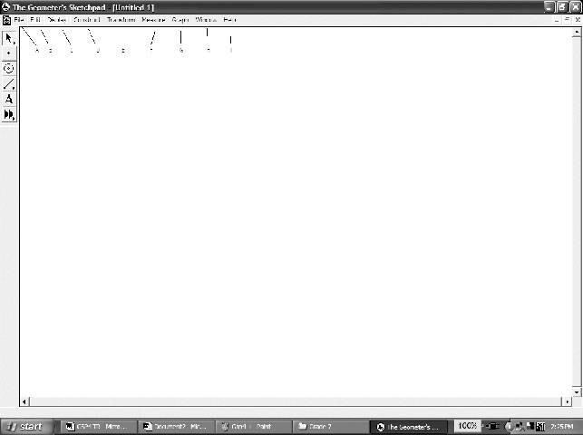
The Menus
File: Used to open, save, close, and print documents.
Edit: Used to undo and redo actions.
Display: Used to control an object’s appearance, and to
label/hide/animate objects.
Construct: Used to construct new geometric objects
based on selected objects in your sketch.
Transform: Used to apply geometric transformations to selected objects.
Measure: Used to give various measures based on selected objects in a sketch.
Graph: Used to create grids and axes for plotting points.
Window: Used to manipulate windows within The Geometer’s Sketchpad®.
Help: Used to access the available help files.
The Toolbox
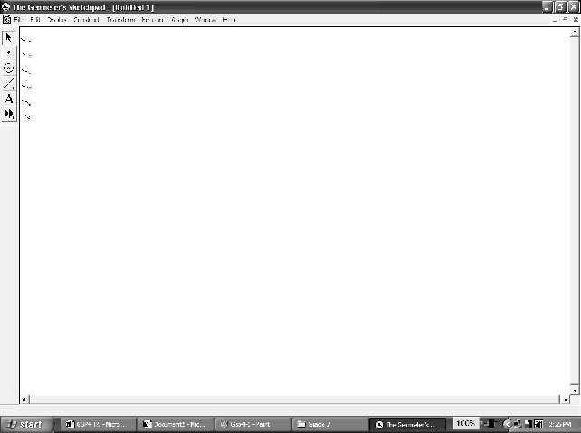
Selection Arrow Tool: Used to select, move, and
transform objects in a sketch.
Point Tool: Used to draw and plot points.
Compass Tool: Used to draw circles.
Straightedge Tool: Used to draw line segments, lines,
and rays.
Text Tool: Used to label/unlabel points and lines, and
to write text or captions within a sketch.
Custom Tool: Allows you to define and use custom tools.
Creating a New Sketch
• To create a new sketch window, on the File menu, click New Sketch.
The Geometer’s Sketchpad® 4
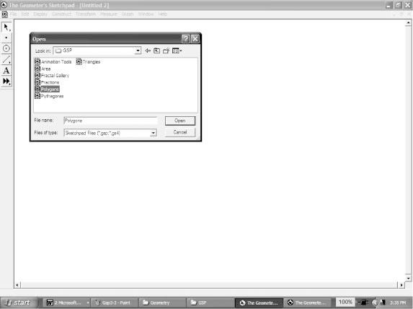
Opening an Existing Sketch
• On the File menu, click Open….
• Navigate to the directory in which the sketch you wish to open
is saved.
• Click the name of the sketch you wish to open. Click Open.
Saving a Sketch
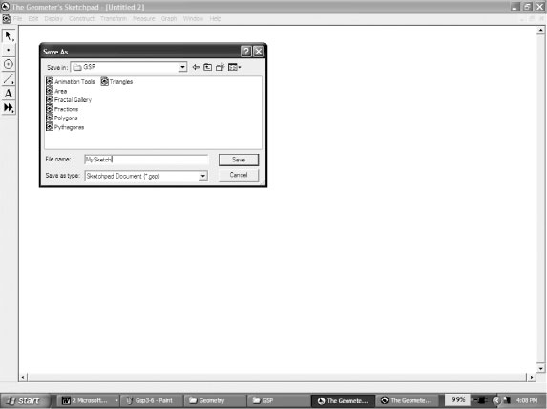
To save a sketch for the first time:
• on the File menu, click Save
• navigate to the directory in which you wish to save the sketch
• The Geometer’s Sketchpad® will give the sketch a name in
the Filename text box. To use that one, click Save.
OR
• to give the sketch the name you wish, delete the given name,
and type the name you want into the Filename text box.
Click Save.
To resave a previously saved sketch:
• on the File menu, click Save.
Closing a Sketch Without Exiting The Geometer’s Sketchpad®
• On the File menu, click Close.
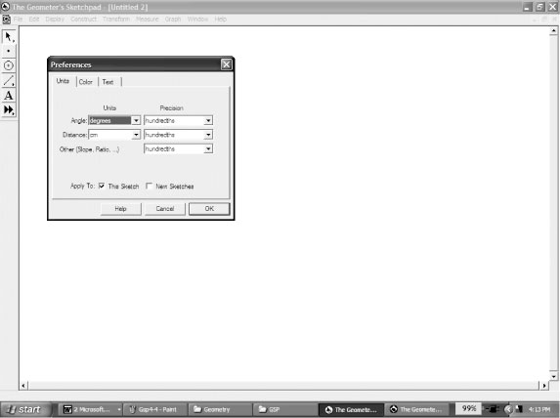
Exiting The Geometer’s Sketchpad®
• On the File menu, click Quit.
Setting Preferences
• On the Display menu, click Preferences….
• Click the Units tab.
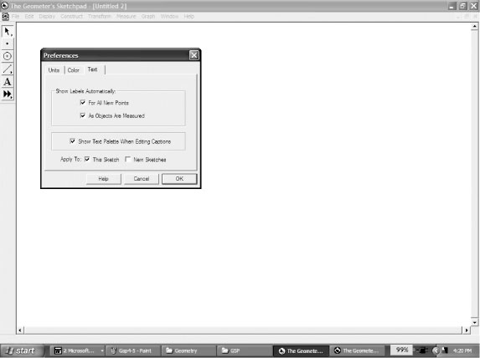
• Select the desired units and precision for Angle, Distance,
and Other.
• If you select Show Labels Automatically/For All New
Points, The Geometer’s Sketchpad® will automatically
label points as you create them.
• If you select Show Labels Automatically/As Objects Are Measured, The Geometer’s Sketchpad® will automatically label measurements you define.

The Geometer’s Sketchpad® 4
By clicking the appropriate box(es) next to Apply To:, you can also choose whether
your selected preferences for Units/Text will apply to only this sketch, or to this sketch
as well as all new sketches.
Selecting Points and Segments
• Click the Selection Arrow Tool. The mouse cursor appears as an arrow.
• Move the cursor to the point or segment you wish to select. When the cursor becomes a horizontal arrow, click the point, and it will be selected.
• To select more than one point or segment, repeat the above step for each item.
Deselecting
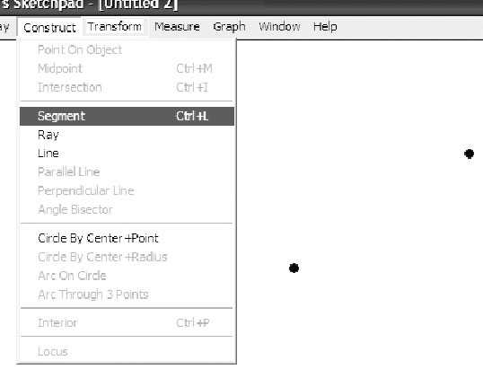
• To deselect a single point or segment, move the cursor to the point or segment you wish to deselect. When the cursor becomes a horizontal arrow, click and the point or object will be deselected.
• To deselect all selected items, click any white space.
Constructing Line Segments
• Click the Point Tool, and create two points in the workspace.
• Click the Selection Arrow Tool, and select both points.
• On the Construct menu, click Line Segment.
OR
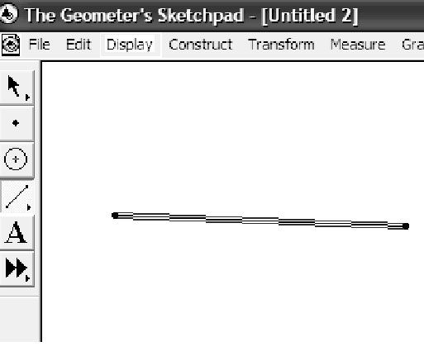
• Click the Straightedge Tool.
• Move the cursor to the workspace.
• Click and hold the left mouse button.
• Drag the cursor to form the segment.
• Release the mouse button.
Constructing Triangles
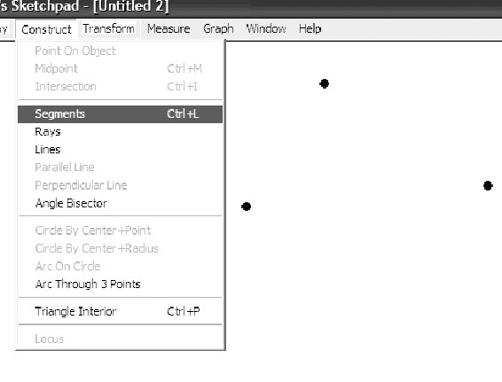
• Click the Point Tool, and draw three points in a triangular
shape in the workspace.
• Click the Selection Arrow Tool, and select the three points.
• On the Construct menu, click Segment.
The Geometer’s Sketchpad® 4
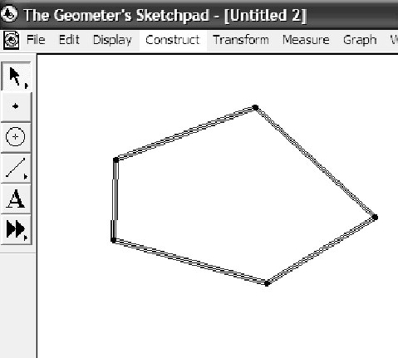
Constructing Polygons
• Click the Point Tool. Draw four or more points in the workspace.
• Click the Selection Arrow Tool, and select all the points in either clockwise or counterclockwise order.
• On the Construct menu, click Segment.
Constructing Parallel Lines
To construct a line parallel to an existing line:
• click the Point Tool, and place a point above or below the existing line
• click the Selection Arrow Tool, and select the point and the line
• on the Construct menu, click Parallel Line.
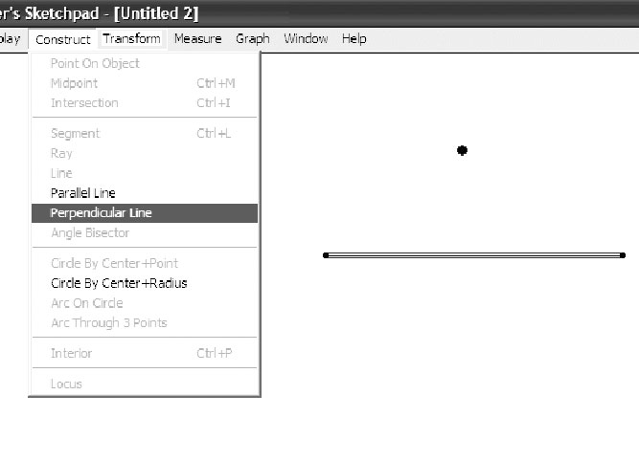 | 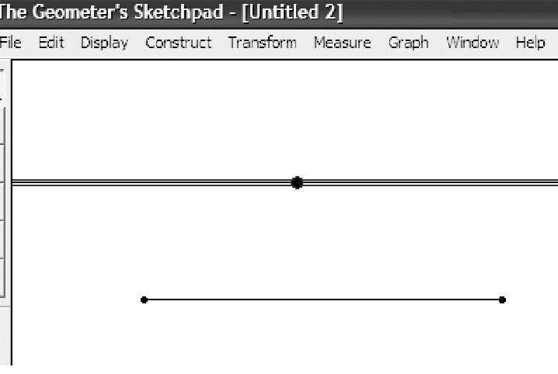
Constructing Perpendicular Lines
To construct a line perpendicular to an existing line:
• click the Point Tool, and place a point above or below the existing line
• click the Selection Arrow Tool, and select the point and the line
• on the Construct menu, click Perpendicular Line.
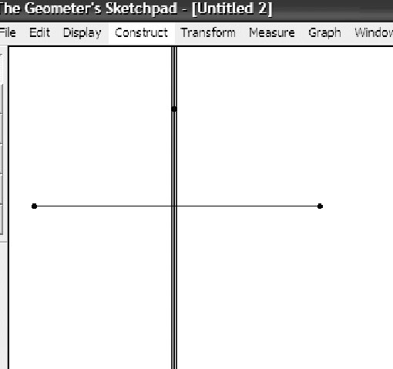
The Geometer’s Sketchpad® 4
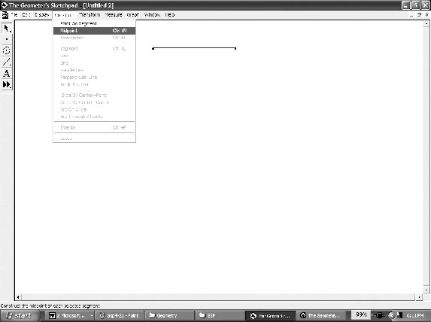
Constructing a Midpoint
To construct a midpoint on an existing line:
• click the Selection Arrow Tool, and select the line
• on the Construct menu, click Midpoint, and a point will
appear on the line. That point will be fixed at the middle
of the line.
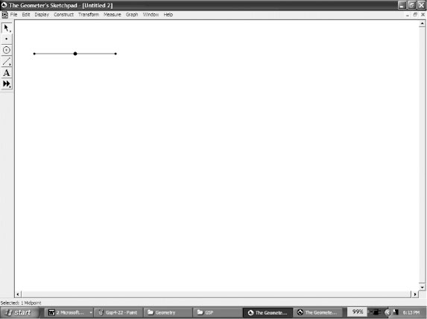
Finding Measures
For all measures, The Geometer’s Sketchpad® will display
the desired measure using the units and precision selected
in Preferences… on the Edit menu.
To measure the distance between two points:
• ensure nothing is selected
• select the two points
• on the Measure menu, click Distance.
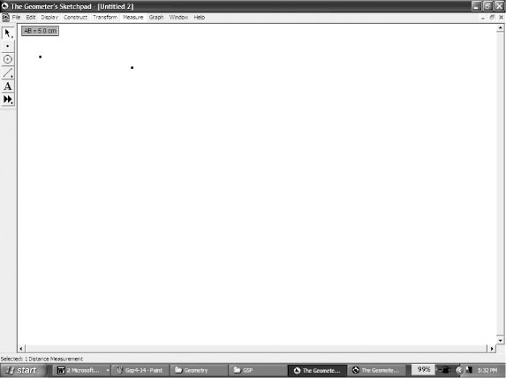
To measure the length of a line segment:
• ensure nothing is selected
• select the two points
• on the Measure menu, click Length.
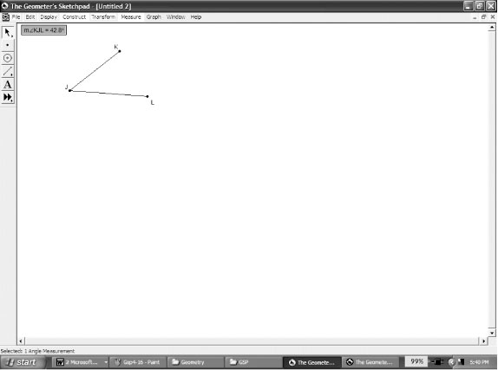 | 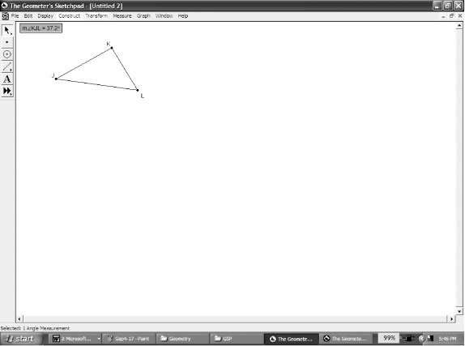
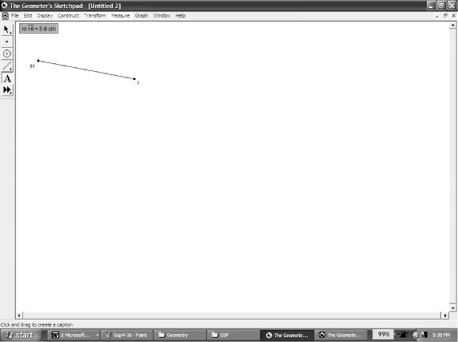
To measure an angle:
• ensure nothing is selected
• select the three points that form the angle. Make sure that the second point selected is the vertex of the angle.
• on the Measure menu, click Angle.
The Geometer’s Sketchpad® 4
Constructing and Measuring Polygon Interiors
The Geometer’s Sketchpad® will measure the perimeter and area of a polygon.
However, you must construct the interior of the polygon first.
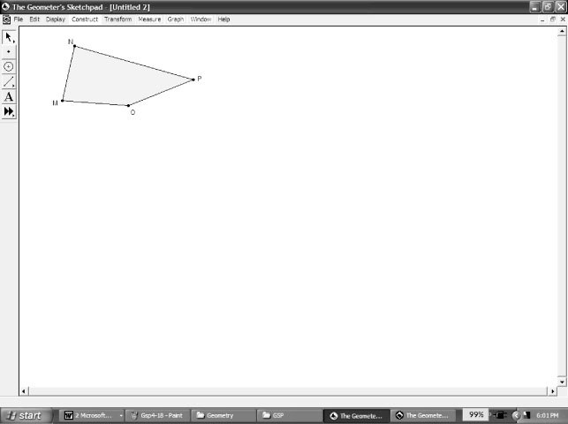
To construct the interior:
• select all the points representing the vertices of the polygon. Here we have a quadrilateral, so four points were selected
• on the Construct menu, click Quadrilateral Interior.
The Geometer’s Sketchpad® will call the polygon by its correct name up to five sides, after which it will use Polygon Interior in the Construct menu.
To measure the perimeter and area:
• click the polygon’s interior
• on the Measure menu, click Perimeter
• click the polygon’s interior
• on the Measure menu, click Area.
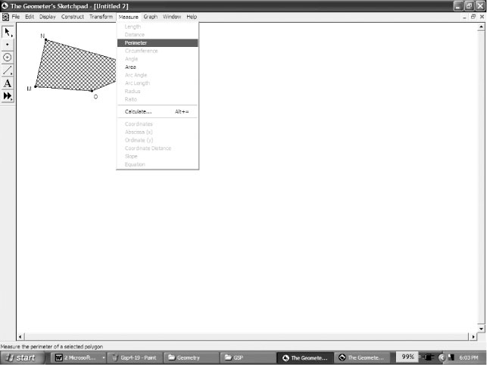 | 