Fathom™
Fathom™ is a dynamic statistical software package. It will allow you to enter, modify,
graph, and analyse data. The following overview will provide you with what you need to
use Fathom™. The instructions work for Fathom™ 1 and Fathom™ 2. Screens shown here were created using Fathom™ 1.

Start Fathom™
To access Fathom™, double-click the Fathom™ icon . This is located either
on your desktop or on the Start menu.
The Menu Bar
The menu bar contains all the standard Fathom™ functions.
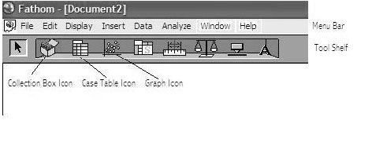
File Menu
Use this menu to open and save a Fathom™ document.
The Tool Shelf
Edit Menu
Use this menu to copy or cut selected items, and to paste previously copied items.
You can also use this menu to undo operations you have performed in Fathom™.
The toolbar contains icons of the key objects. You can place new objects in the workspace
by clicking on the desired icon, and dragging.
Case Table
To create and enter data into a case table:
• drag the Case Table icon from the Tool Shelf into the workspace
• click <new>. Type the attribute name you would like for the data, and press enter.
The example used Marks.
• click in the box below the name, enter your data, and press enter
• continue until you have entered all the data items.
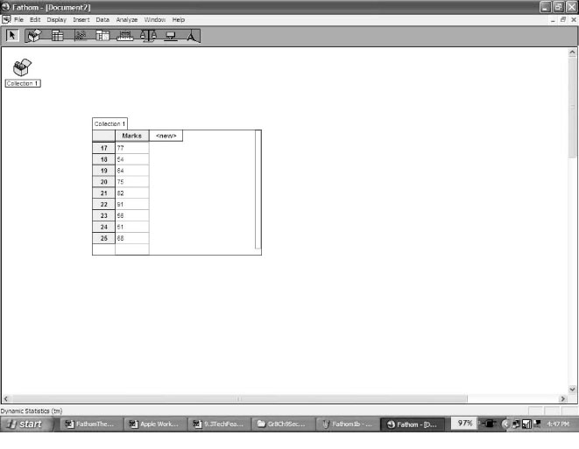
Collection Box
As you enter data into the case table, a small treasure chest
will appear automatically and fill with gold balls. This is
called a Collection Box. Each gold ball represents one row of data in the collection box.
Fathom™
Graph Box
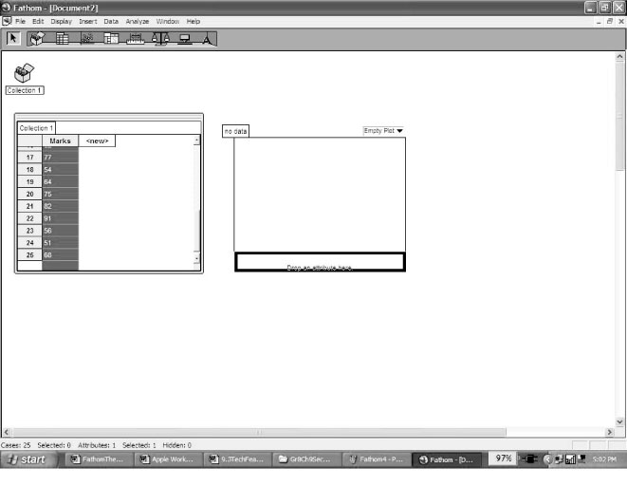
To create a graph of the data you have entered:
• Drag the Graph icon from the Tool Shelf into the workspace.
• Place the cursor over the name attribute you gave your
data. The cursor will change to a hand. Click and the hand
will change to a fist; all the data will be highlighted.
• Drag the fist over to the Drop an attribute here line, which
is along the horizontal axis of the graph. Let go of the
mouse button.
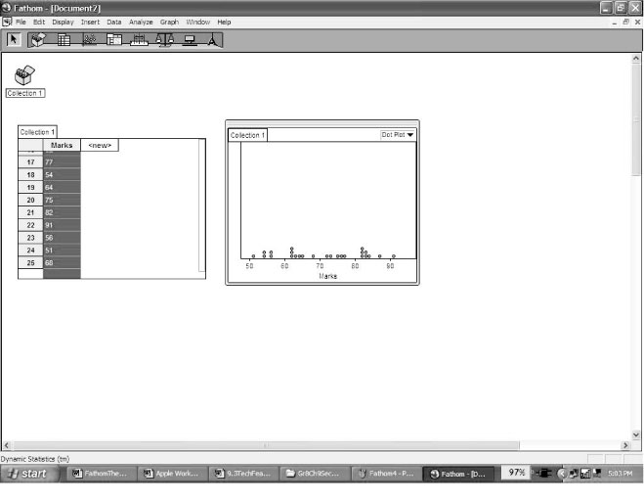
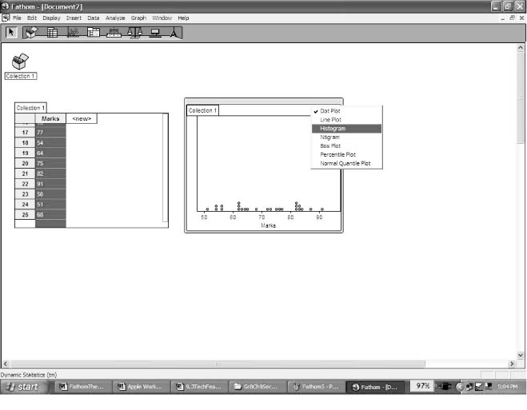
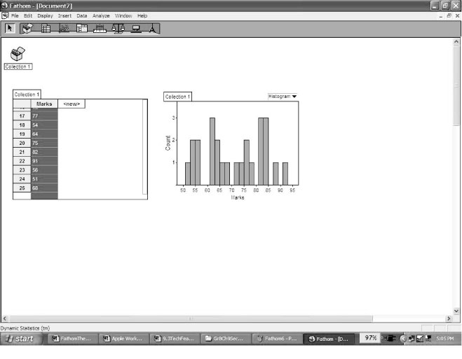
• A dot plot of the data will appear. To change this to a histogram, click the words “dot plot” in the right corner of the graph box and select histogram from the list.
• To change the appearance of your graph, double-click the body of the graph.
An information box will appear. You can edit any item that is in blue.
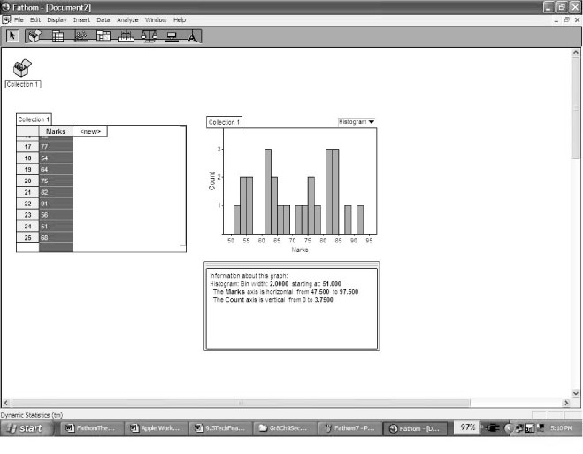 | 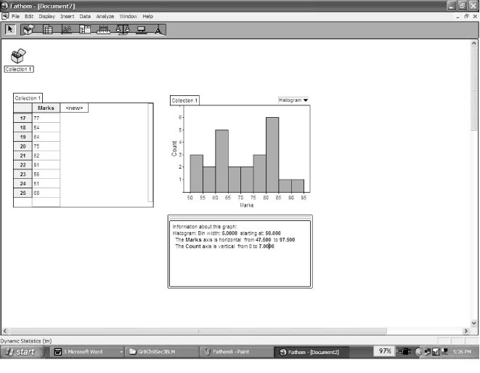

Fathom™
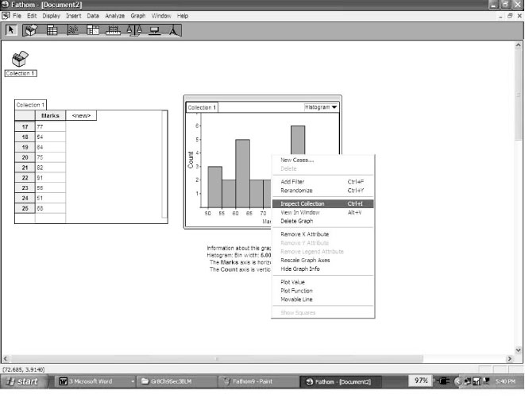
To Find the Mean and Median
Mean
• Right-click either the graph or the case table, and
click Inspect Collection on the pop-up menu.
• On the Measure tab, click <new>, and type Mean.
• Right-click under the formula heading, and click
Edit Formula on the pop-up menu.
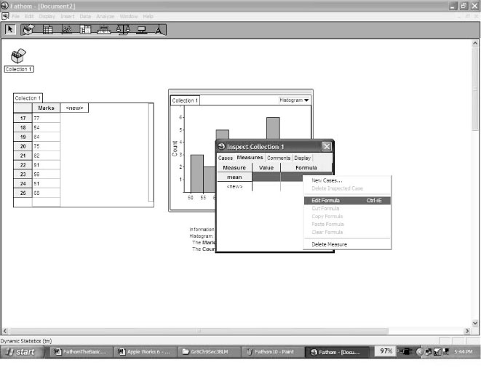
• A box resembling a calculator will appear. Click the
+ next to Function, then the + next to Statistical, and
finally the + next to One Attribute.
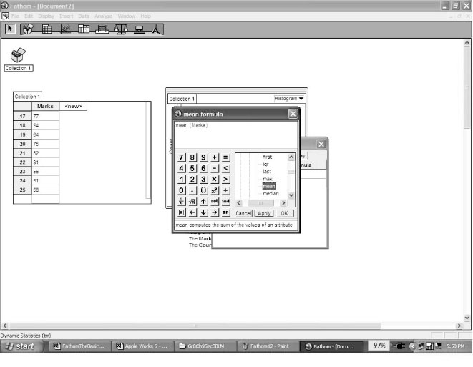
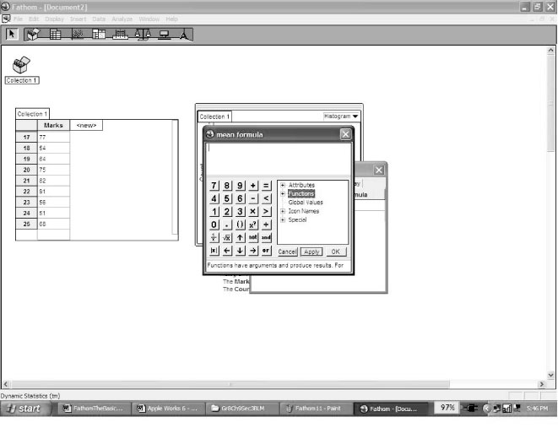
• Scroll down the list of functions, and double-click
Mean. The word mean, followed by a pair of brackets,
will appear in the display.
• Type the name of the attribute inside the brackets.
Click OK.
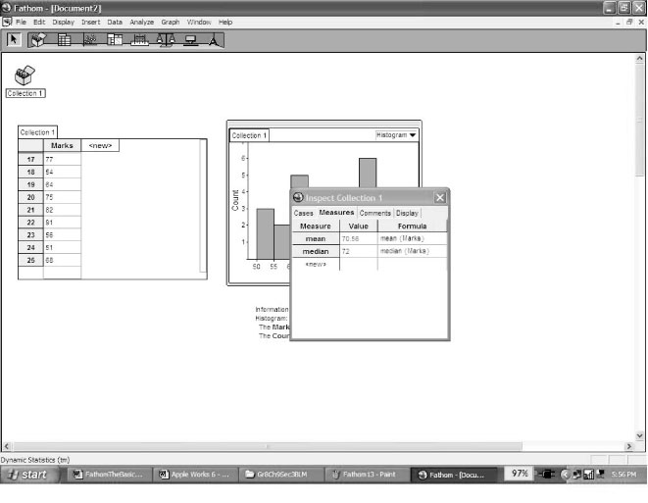
Median
• Click <new> under Mean, and type Median.
• Follow the above steps, beginning with “Right-click under the Formula heading... .” This time, enter median.
Fathom™
Sorting to Find the Mode
• Right-click the name attribute of your data. The data will be highlighted.
• Right-click the highlighted data, and click either Sort Ascending or Sort
Descending.
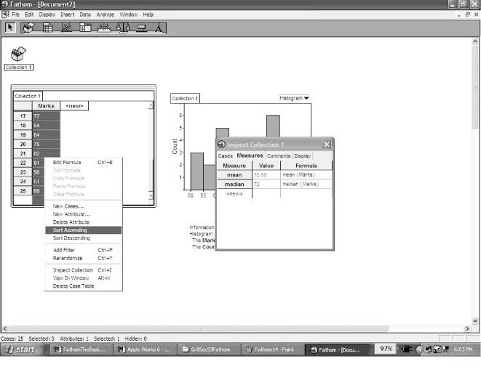
• To find the mode, scan your data list for repeated
values. The value that repeats the most often will be
your mode.
Helping Hints
• If you make an error, you can use the Undo command
on the Edit menu to undo as many steps as you need to
correct the error.
• You can move Case Table, graphs, or any other object in the workspace by clicking the object and dragging it.
• If you click a single set of attributes in a histogram, the set will turn red. If you look in
the Case Table, all the data items from that set will be highlighted blue.

