The Computer Algebra System (CAS)
on the TI-89 Calculator
The TI-89 calculator features a Computer Algebra System (CAS) engine that allows you
to perform algebraic operations, such as manipulating and solving algebraic equations.
The following overview will provide you with what you need to know to use the CAS on the TI-89 calculator.

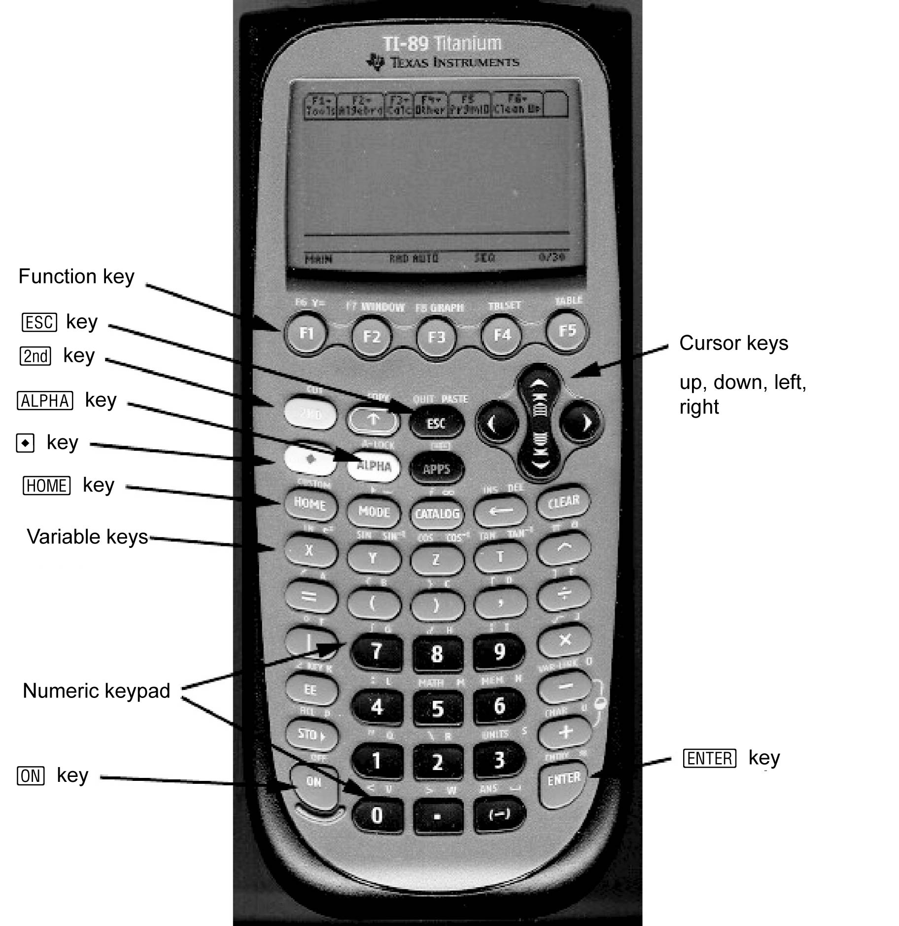

The Computer Algebra System (CAS)
on the TI-89 Calculator
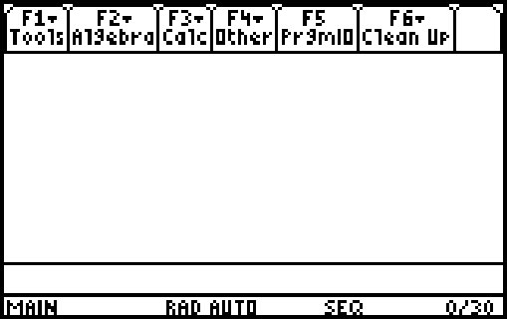
Starting the CAS
Turn on your TI-89 calculator by pressing the ´ key. If you don’t see the Home screen shown, press the " key.
The TI-89 Keyboard
Refer to the annotated picture of the TI-89 calculator. Most keys have a primary function, as well as one or two secondary functions. For example, the À key is usually pressed to enter the number 1. However, if the blue 2 key is pressed, and then 1, you will enter opening quotes “. If the white k key is pressed, and then 1, you will enter the letter q. Some keys have additional functions labelled in green. If the green ¥ key is pressed, and then the N (escape) key, you will access the PASTE function.
The Function Keys
The CAS uses the functions F1 through F6 to display menus. F1 through F5 are accessed by pressing the appropriate key. F6 is accessed by pressing 2, followed by ƒ. Press ƒ. Notice the menu. To close the menu without making a selection, press N. The N key is useful for cancelling a key that you may have pressed in error.
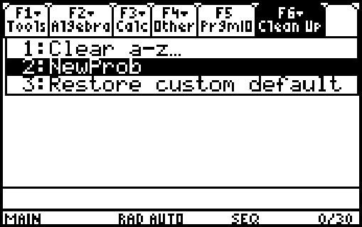
Starting a New Problem
It is wise to clear any data that you or another user may have stored in the memory before starting a new problem. To do this, press 2, then ƒ, to pull down the F6 menu. Select
2: NewProb (short for New Problem). Then, press the ¸ key. This procedure will clear the memory and reset all algebraic variables. If you don’t do this, you may see unexpected results as you work through CAS solutions. Note that NewProb also clears the Home screen.
The Computer Algebra System (CAS)
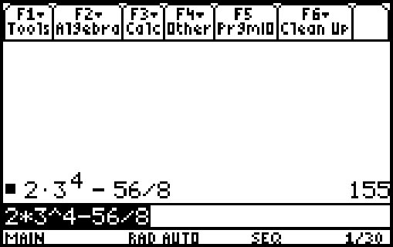
on the TI-89 Calculator
Entering Calculations
The numeric keypad on your TI-89 works just like the keypad
on other graphing calculators, such as the TI-83 Plus or TI-84 plus.
For example, consider the expression 2 × 3⁴ – 56 ÷ 8. Enter the keystrokes 2 p 3 Z 4 | 56 e 8. Then, press ¸. The answer is 155.
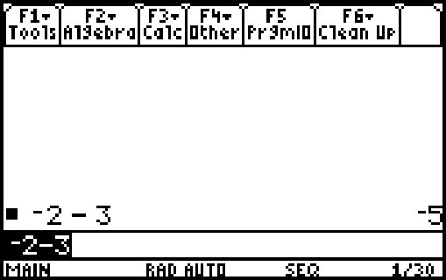
Like the TI-83 Plus and TI-84 plus, the TI-89 has two negative keys, the minus key · and the subtract key |. Use the subtract key when you are subtracting one expression from another, as in the example above. Use the minus key when you are making an expression negative. For example, consider the expression . When entering this expression into your calculator, use the minus key for the negative sign in front of the 2, but the subtract key for the negative sign in front of the 3. Note that the two negative signs appear differently on the Home screen.
Entering and Simplifying Algebraic Expressions
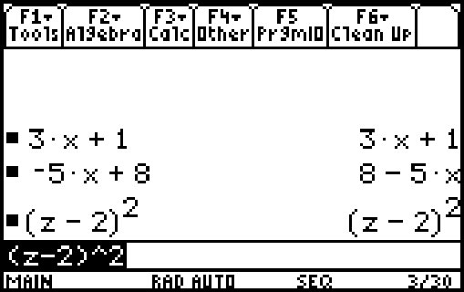
The real power of a CAS lies in an ability to enter and manipulate algebraic expressions. Four of the variable names have their own keys: Ù , Ú, Û, and Ü. Others are accessed using a combination of k and other keys.
Clear the Home screen if necessary, using NewProb. Then, enter the expression 3x + 1. Press ¸. Notice that the TI-89 enters the expression on the Home screen, and also retains it in the command line. Enter some more expressions, such as –5y + 8, and (z – 2)². Notice that the CAS sometimes changes the format of the expression.
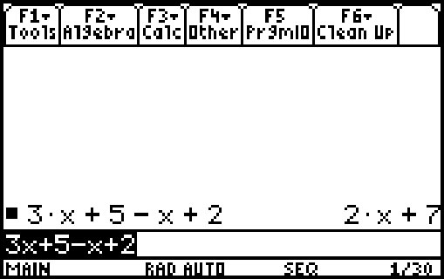
The CAS will simplify expressions by collecting like terms. As an example, enter the expression 3x + 5 – x + 2, and press ¸. Notice that like terms have been collected.
The Computer Algebra System (CAS)
on the TI-89 Calculator
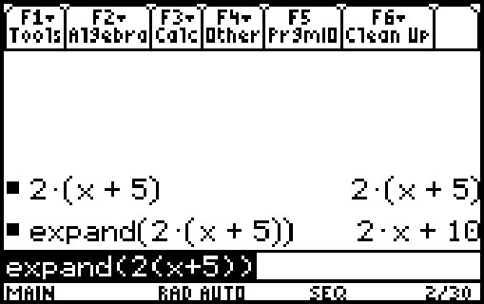
Expanding Expressions
The CAS can expand algebraic expressions using the distributive property. Enter the expression 2(x + 5), and press ¸. Notice that the expression remains unexpanded.
Now, press „ , and select 3:expand(. Type the expression 2(x + 5). Finally, add a close bracket, and press ¸. Notice that the CAS has expanded the expression.
Evaluating Expressions
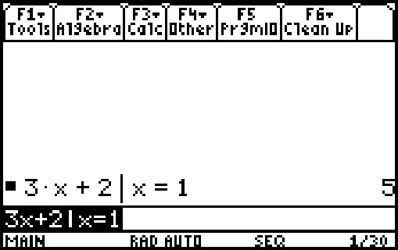
The CAS can evaluate an expression for a particular value of the variable. Enter the expression 3x + 2|x = 1, and press ¸. Notice that the CAS substituted the value of 1 for the variable x, and then evaluated the expression for an answer of 5.
Entering and Manipulating Equations
The CAS will let you enter an equation, and apply operators to both sides. For example, enter the equation 3x + 1 = 10. Press ¸.
The first step in solving this equation is the subtraction of 1 from both sides. You can do this by entering (3x + 1 = 10) – 1 and pressing ¸. However, you can also use the ¥ key to copy and paste the equation that you have already entered. This is a useful feature, especially for long or complicated expressions.
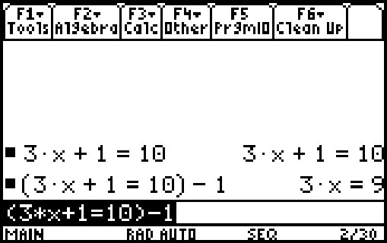
c Press the up cursor key. Press ¥, and then COPY (the ¤ key). Press the down cursor key. Press ¥, and then PASTE (the
N key). Notice that the equation has been pasted after the opening bracket.
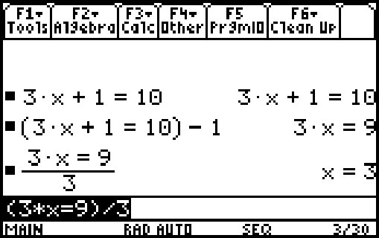
Close the bracket, and enter –1. Press ¸. Notice that 1 has been subtracted from both sides of the equation.
Use a similar procedure to divide both sides by 3. Notice that the CAS displays the value of x that satisfies the equation.
The Computer Algebra System (CAS)
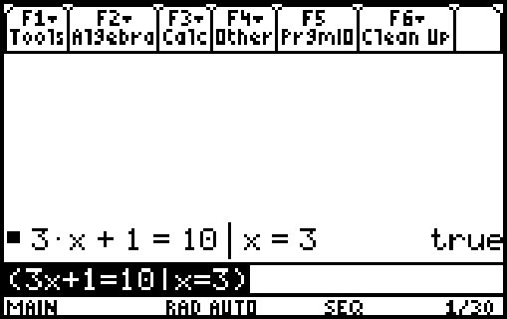
on the TI-89 Calculator
Checking a Solution
You can use the CAS to check a solution to an equation. Suppose that you solved the equation 3x + 1 = 10, and found that x = 3. Enter (3x + 1 = 10|x = 3), and press ¸. Notice that the CAS returns a value of “true” if the solution is correct.
Entering Other Variables
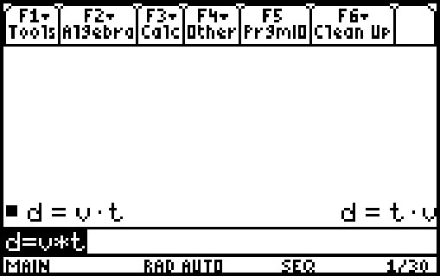
You may find a problem in which it is convenient to use variables other than Ù, Ú, Û, or Ü . You can access these using the k key. For example, suppose that you want to enter the equation d = vt.
• Press k, and then ¢.
• Press Á.
• Press k, and then 0.
• Press Ù.
• Press Ü, and then ¸.
Note: when you want to multiply two variables, such as v and t, you must put a multiplication operator between them.
Solving Variable Equations
You can use the CAS to solve equations for a particular variable. For example, suppose that you want to solve d = vt for v. You must divide both sides by t.
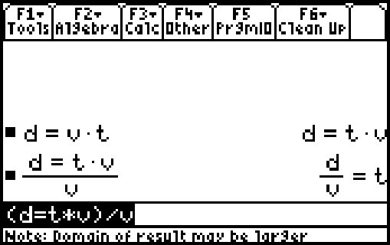
Enter the equation d = vt as shown in the section Entering Other Variables. Press ¸. Open a bracket, and use the ¥ key to cut and paste the equation, as shown in the section Entering and Manipulating Equations. Close the bracket. Enter , and press ¸.
For More Information
You can obtain more information on the operation of your TI-89 calculator in the calculator manual. You can also download an electronic version of the manual in PDF format at www.education.ti.com.

