.…T-8.…
(page 1)
Computer Algebra System (CAS)
on the TI-Nspire CAS Calculator
The TI-Nspire CAS calculator features a Computer Algebra System (CAS) engine that allows you to perform algebraic operations such as manipulating and solving algebraic equations. The following overview will provide you with what you need to know in order to use the CAS on the TI-Nspire CAS calculator.
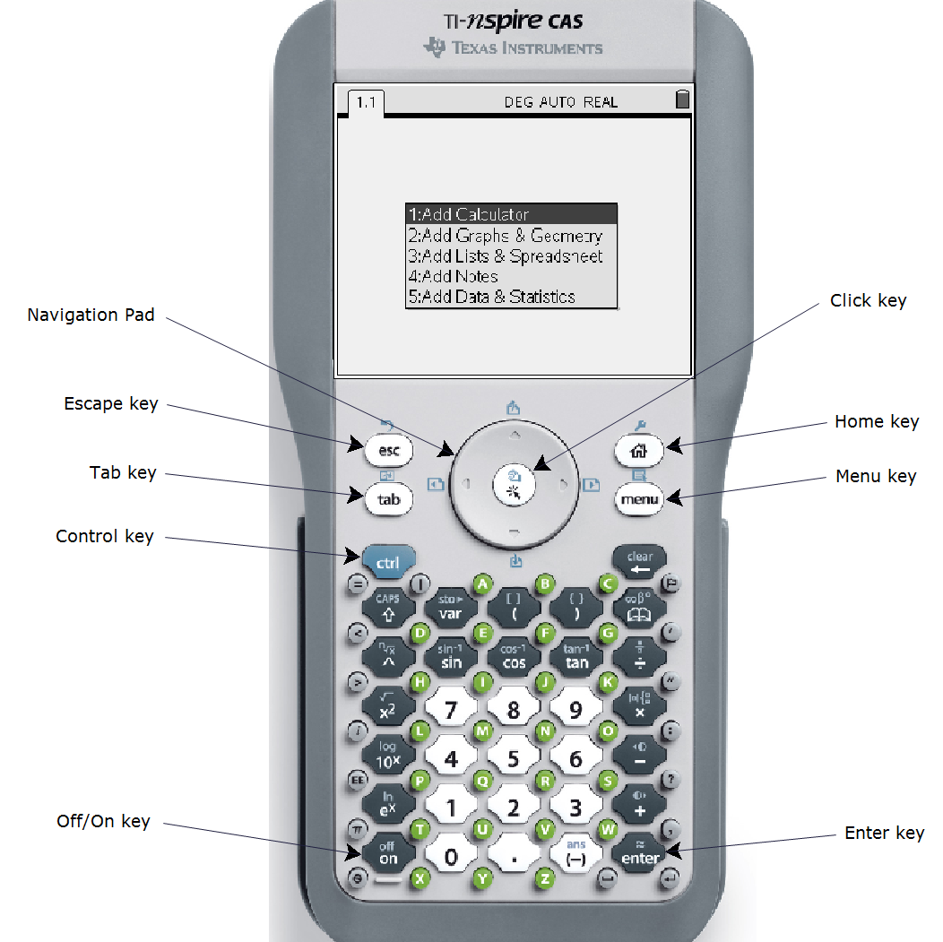

.…T-8…
(page 2)
Computer Algebra System (CAS)
on the TI-Nspire CAS Calculator
Start the CAS
Turn on your TI-Nspire CAS calculator by pressing the on key. Select option 1:Add Calculator to open a new page with the calculator application.
The TI-Nspire CAS Keyboard
Refer to the annotated picture of the TI-Nspire CAS calculator. Some keys have a primary function, as well as a/or secondary function. For example, the x² key is usually pressed to square an expression. However, if the blue ctrl key is pressed, and then the x² key, the square root function appears. Note that the
TI-Nspire has green keys to enter letters of the alphabet.
Special Keys
The esc (escape) key is useful for cancelling an operation.
The tab key moves the cursor from box to box in certain operations.
The ctrl (control) key invokes the secondary function of several other keys.
The NavPad (navigation pad) moves the cursor left, right, up, or down.
The click key makes a selection.
The home key brings up a general menu that lets you insert new pages or adjust the settings.
The menu key brings up a menu that applies to the current page.
The enter key initiates an action.

Entering Calculations
The numeric keypad on your TI-Nspire CAS works just like the keypad on other graphing calculators, such as the TI-83+ or TI-84+. For example, consider the expression . Enter the keystrokes . Then, press the enter key. The answer is 155.

.…T-8…
(page 3)
Computer Algebra System (CAS)
on the TI-Nspire CAS Calculator
Like the TI-83+ and TI-84+, the TI-Nspire CAS has two negative keys, the minus key (–) and the subtract key –. Use the subtract key when you are subtracting one expression from another, as in the example above. Use the minus key when you are making an expression negative. As an example, consider the expression . When entering this expression into your calculator, use the minus key for the negative sign in front of the 2, but the subtract key for the negative sign in front of the 3. Note that the two negative signs appear differently on the screen.

Entering and Simplifying Algebraic Expressions

The real power of a CAS lies in an ability to enter and manipulate algebraic expressions. Type the expression 3x + 1, using the green X key to enter the letter. Press the enter key.

Type some more expressions, such as –5y + 8, and
(z – 2)². Notice that the CAS sometimes changes the format of the expression.

The CAS will simplify expressions by collecting like terms. As an example, type the expression
3x + 5 – x + 2, and press enter. Notice that like terms have been collected.
.…T-8.…
(page 4)
Computer Algebra System (CAS)
on the TI-Nspire CAS Calculator
Expanding Expressions
The CAS can expand algebraic expressions using the distributive property. Press the menu key, and select 3:Algebra. Then, select 3:Expand.

Type the expression 2(x + 5) between the brackets, and press enter. Notice that the CAS has expanded the expression.

Evaluating Expressions
The CAS can evaluate an expression for a particular value of the variable. Type the expression 3x + 2|x = 1, and press enter. Notice that the CAS substitutes the value of 1 for the variable x, and then evaluates the expression for an answer of 5.

.…T-8.…
(page 5)
Computer Algebra System (CAS)
on the TI-Nspire CAS Calculator
Entering and Manipulating Equations
The CAS will let you enter an equation, and apply operators to both sides. As an example, enter the equation 3x + 1 = 10. Press enter.

The first step in solving this equation is the subtraction of 1 from both sides. You can do this by entering (3x + 1 = 10) – 1 and pressing enter. However, you can also use the NavPad to copy and paste the equation that you have already entered. This is a useful feature, especially for long or complicated expressions.

Enter an open bracket (. Press the UP arrow key on the NavPad to highlight the equation on the previous line. Press the enter key. Notice that the equation has been pasted after the opening bracket.

Type –1 outside the brackets, and press enter. Notice that 1 has been subtracted from both sides of the equation.

Use a similar procedure to divide both sides by 3. Notice that the CAS displays the value of x that satisfies the equation.

Checking a Solution
You can use the CAS to check a solution to an equation. Suppose that you solved the equation 3x + 1 = 10, and found that x = 3. Enter 3x + 1 = 10|x=3, and press enter. Notice that the CAS returns a value of “true” if the solution is correct.

.…T-8.…
(page 6)
Computer Algebra System (CAS)
on the TI-Nspire CAS Calculator
Entering Formulas
Suppose that you want to enter the equation d = vt.

Press D.
Press the = key.
Press V.
Press the key.
Press T, and then enter.

Note: when you want to multiply two variables, such as v and t, you must put a multiplication operator between them. Otherwise, the CAS will interpret vt as a single variable.

Solving Variable Equations
You can use the CAS to solve equations for a particular variable. As an example, suppose that you want to solve d = vt for v. You must divide both sides by t.

Enter the equation d = vt. Open a bracket. Copy the equation between the brackets. Enter outside the brackets, and press enter.

For More Information…
You can obtain more information on the operation of your TI-Nspire CAS graphing calculator in the calculator manual. You can download an electronic version of the manual in PDF format at education.ti.com.

