TI-Navigator™ Suggestions for Chapter 2
Get Ready – There is a Learn Check entitled “Chapter 2 Get Ready” that teachers can use as they see fit to check understanding of basic concepts needed for this chapter. The True-False questions can be used as Quick Poll questions.

Section 2-1 Midpoint formula
There is a Learn Check entitled “2-1 Midpoint formula” that teachers can use as they see fit to check understanding of this section. The True-False questions could be used as Quick Poll questions during the lesson.
The investigation can be simulated on TI-Navigator™ through the Activity Center. From the TI-Navigator™ home screen, click on the Activity Center icon. Click on File> Load>Load Activity Settings and find the file “Section 2-1 Investigation Activity Settings”. This will set the contribute drop-down box to “Points” and set up the Configuration settings for you. Click on Edit>Clear Activity Data.
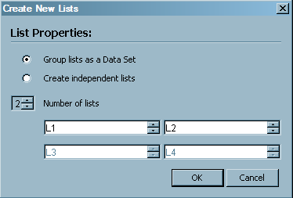
Click on the List tab. Click on the Create New Lists button. Set the number of lists to 2 and click on the radio button for “Group lists as a Data Set”.

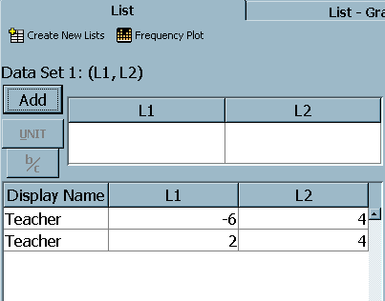
As you click on OK, a new data set will be created on the left side of the screen. Enter data into the boxes for L1 and L2 and click on the Add button. Each time that you do this a new entry line will be added to the data set. Add data for two points which will serve as endpoints for a line segment. The software does not allow you to physically construct a line segment, so graphing points is the best that we can do at this time.

Click on the List-Graph tab and start the activity. Students should be instructed to move to the midpoint of the line segment and press MARK. On a good day, all students will move to the same point.

Repeat the process with two points that form a vertical line (using points (2, -5) and (2, 7)) and then a third time with a diagonal line segment (using points (-4, -5) and (6, 3)). These sets of points are saved in folders entitled “Vertical Data Set”, “Horizontal Data Set”, and “Diagonal Data Set 1” respectively, and can be loaded into the activities to save time. Use File>Load>Load Lists and then locate the appropriate folder.
The data set entitled “Diagonal Data Set 2” will be a bit of a challenge since the midpoint will involve decimal values.

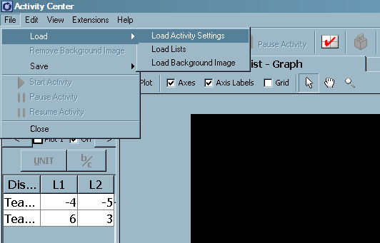
To assist with the loading of data sets, Activity Center files have been prepared. To set up Activity Center on your computer, click on File>Load>Load Activity Settings. A Windows dialog box will open to allow you to locate the file. Click on OK, and the file will load the data set and the appropriate window settings. There is a file for each of the four data sets.

Section 2-2 Length of a Line Segment
There is a Learn Check entitled “2-2 Length of a Line Segment” that teachers can use as they see fit to check understanding of this section.
One idea from this section that could be explored through Activity Center is to provide two points as in the previous unit. The line segment formed by these points would be the hypotenuse of a right angled triangle. Students would then mark a third point which would be the vertex of a right-angle. Hopefully, they will come up with two different points, although most students would choose the point below the triangle rather than above the triangle.
Two data sets are provided for this exercise. You can use the activity settings from unit 2-1.
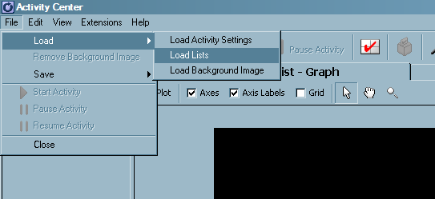
To load in the lists, click on File>Load>Load Lists. A Windows dialog box will open. Locate the lists, highlight both L1 and L2 and click on OK. Adjust the Activity Center window settings if necessary.

Section 2-3 Apply Midpoint, Slope and Length Formulas
The work in this section is simply a repetition of the work done in previous units. There does not seem to be anything which is new that could be done through TI-Navigator™.

Section 2-4 Equation for a Circle
There is a Learn Check entitled “2-4 Equation for a Circle” that teachers can use as they see fit to check understanding of this section. The True-False questions could be used as Quick Poll questions during the lesson.
For this unit, give students the equation of a circle with centre at the origin and radius 5. Provide each student with a number from -5 to +5. Decimal values can and should be used. This value is to serve as their x-value. Their job is to find the y-value(s) to the nearest tenth. Once they have found these points, they should write the values down on paper and enter the Activity Center. (Note: unless they get either -5 or +5, each student should find two points). To get around this, let one student submit (-5,0) and (5, 0).
As each student enters the Activity Center, a form will be displayed on their screens. This form will ask them to enter an x-coordinate and a y-coordinate. The do this for their first point, press NEXT (the GRAPH softkey), enter the coordinates for their second point and press SEND (the ZOOM softkey).
The file “Section 4 Activity Settings.act” has been constructed to allow students to enter their data into the Activity Center. It has students contribute to a form which converts their data into lists and graphs it in the activity center.
When the activity is finished, the lists can be saved for possible future use. To do this, click on the List tab and move the cursor over the title L1. When the cursor changes from a pointer to a hand, click on the list name. Hold the CTRL key and repeat this for L2. With both lists highlighted, click on File>Save>Save Selected Lists.

Review
There is a Learn Check entitled “Chapter 2 Review” that teachers can use as they see fit to check understanding of this chapter. It is made up of a variety of questions from the other sections. The True-False questions could be used as Quick Poll questions during the lesson.

