TI-Navigator™ Suggestions for Chapter 6

Get Ready
There is a Learn Check entitled “Chapter 6 Get Ready” that teachers can use as they see fit to check understanding of basic concepts needed for this chapter.

Section 6-1 Maxima and Minima
There is a Learn Check entitled “6-1 Maxima and Minima” that teachers can use as they see fit to check understanding of this section.

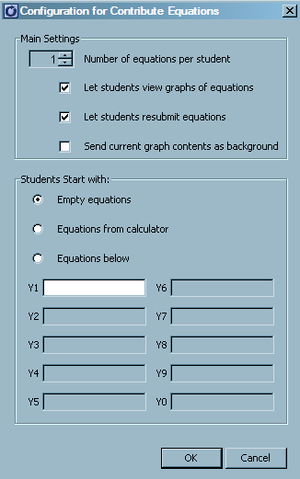
An interesting exercise to wrap up this section and check the students’ understanding of vertex form could be to have students submit an equation in the Activity Center that has a given maximum or minimum value.
Set up the Activity Center to have students contribute points. The configuration window is shown to the right. Start the activity with the instruction “Submit an equation that has a maximum value of 75”. There will be a variety of responses, all of which might be correct.
Once completed, discuss the results with the class and clear the activity data. Repeat for a minimum of say, 35. Repeat as often as the teacher thinks is necessary.

Section 6-2 Solve Quadratic Equations
There is a Learn Check entitled “6-2 Solve Quadratic Equations” that teachers can use as they see fit to check understanding of this section. The True-False questions could be used as Quick Poll questions during the lesson.

Section 6-3 Graphing Using the x-intercepts
There is a Learn Check entitled “6-3 Graphing Using the x-intercepts” that teachers can use as they see fit to check understanding of this section. The True-False questions could be used as Quick Poll questions during the lesson.
As with section 6-1, the lesson could be enhanced by setting up the Activity Center to have students enter equations with given x-intercepts. Using the same setup as in section 6-1, ask students to contribute equations and use the same configuration as shown above. Then ask each student to enter an equation that has x-intercepts at x = -2 and x = 3. To avoid getting the same equation from each student, assign each student a value of k that they must use for y = k(x – a)(x – b). The results could be used to discuss the concept of a vertical stretch, even though this is not a concept for this unit.

Section 6-4 The Quadratic Formula
There is a Learn Check entitled “6-4 The Quadratic Formula” that teachers can use as they see fit to check understanding of this section. The True-False questions could be used as Quick Poll questions during the lesson.

Section 6-5 Problem solving
This section does lend itself to any work with Navigator

Review
There is a Learn Check entitled “Chapter 6 Review” that teachers can use as they see fit to check understanding of this chapter. It is made up of a variety of questions from the other sections. The True-False questions could be used as Quick Poll questions during the lesson.

