Chapter 10 Warm-Up
Section 10.1

1. Make a table of values for
3a − 5 = b. Use five integer values for a.
2. Graph the values in #1.
3. Is the equation in #1 a linear relation? Justify your response.
4. Evaluate y = −5x if x = −3.
5. If a horse moves at an average speed of 7 km/h, how far will the horse go in 2.5 h?
Mental Math
For #6 and #7, use integers to complete the statement in as many ways as possible.
6. × = 9
7. 45 ÷ =
8. Estimate the volume of the following prism.
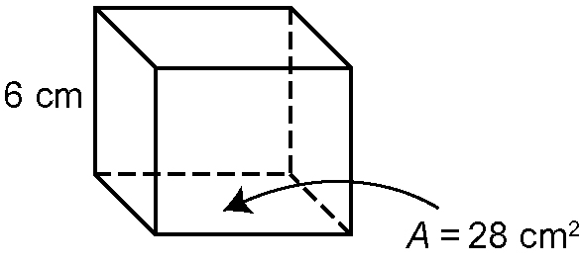
9. Mentally calculate the surface area of the prism in #8. Show your thinking.
10. Estimate .

Section 10.2

1. Write the equation modelled by the algebra tiles.
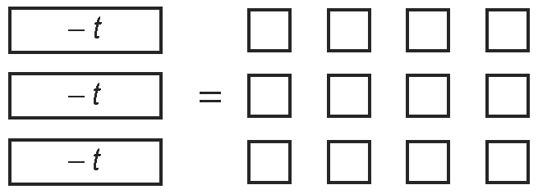
2. By what number would you divide each side of the equation in #1 to solve it?
3. Solve the equation in #1.
4. Solve .
5. Verify your answer for #4.

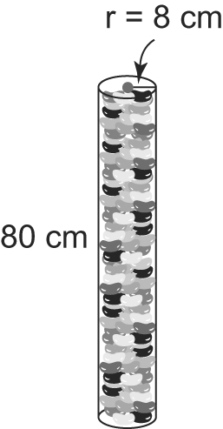
Mental Math
6. Mentally estimate the
volume of the prism.
Show your thinking.

7. Solve 6 × .
8. Show as an improper fraction.
9. Evaluate × .
10. Evaluate 2 ÷ .

Section 10.3

1. Solve the equation modelled by the balance.
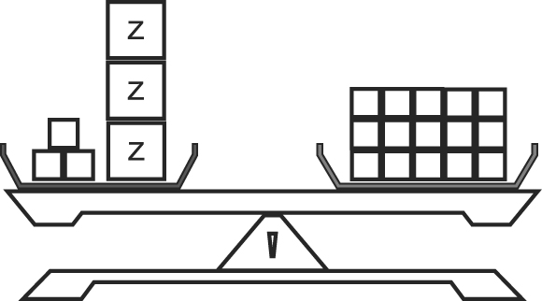
2. Verify your solution to #1.
3. What is the first operation you should perform to solve each equation?
a) 28 = −5n + 3
b) 3r − 6 = 48
4. Solve and verify each of the equations in #3.
5. Is the relationship in this table linear? Explain how you know.
a | 5 | 10 | 15 | 25
b | 1 | 2 | 3 | 4

Mental Math
6. Convert 3. to a percent and a fraction.
7. Convert 524% to a decimal and a fraction.
8. Convert to a decimal and a percent.
9. You scored two baskets in the first game. In the final game, you scored 150% of this number. How many baskets did you score in the final game?
10. Estimate the following values. Show your thinking.
a) b)

Section 10.4

1. Solve the equation represented by the diagram.
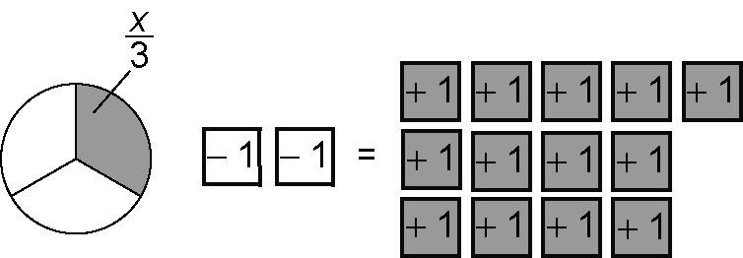
2. What is the first operation you should perform to solve each equation?
a)
b) −22 =
3. What is the second operation you should perform to solve each equation from #2?
4. Solve and verify each of the equations in #2.
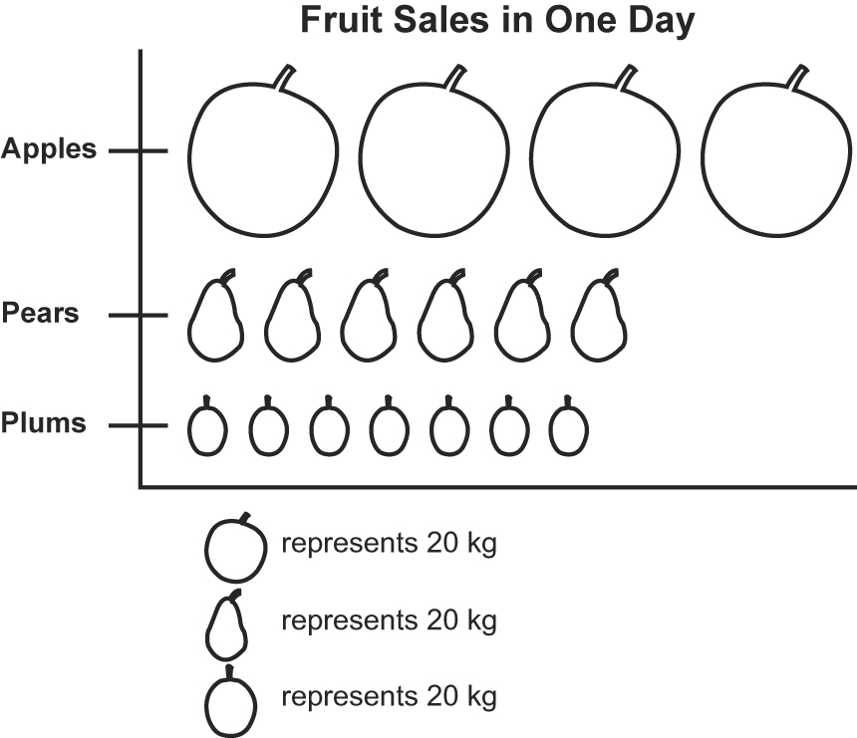
5.

a) From the pictograph, which fruit seems to sell the best? Explain.
b) Redraw the pictograph to represent the data more accurately.
Mental Math
For #6 to #10, determine the missing value.
6.
7.
8.
9.
10.

