Chapter 10 Problems of the Week
1. To keep the mobile balanced, each side of each arm must have the same value. Determine the value of each shape. Note: Each shape has a different value.
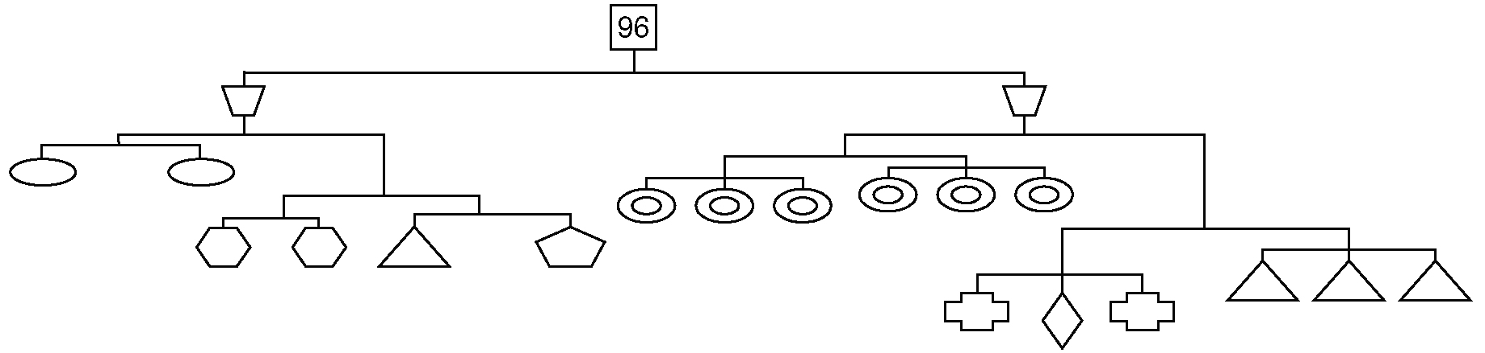
2. Is the following solution correct? Justify your answer.  x − 3 = 7  x − 3 + 3 = 7 + 3  x − 6 = 10  x = 10 − 6  x = 4 | 3. Aunt Katrina had a child on the same date for three consecutive years. If the sum of the children’s ages is 36, how old are Aunt Katrina's children?
4. Every time my bicycle wheel makes one full revolution,  I hear a click. I have heard  100 clicks. I have travelled 173 m. What is the diameter of my bicycle wheel? Give your answer to the nearest centimetre.  1 m= 100 cm | 5. During a competition drill at your basketball practice, you and a partner are given 5 min to sink as many three-point shots as you can. Players score three points for every successful shot and lose two points for every missed shot. Your partner does not miss a shot but sinks six fewer shots than you do and ends up with a score of 30 points.  a) How many successful shots did you make?  b) You missed 10 shots during the drill. Did you win the game?  c) How might your answer in part b) affect your game strategy?  d) Can you create a combination that results in a tied score for two players?
6. Rod’s Limousine Service charges $8/person plus $3/km driven. If four people had a total bill of $143, how far was the ride? | 7. Create a story problem that uses two operations and that has 17 as its answer. Note: The two operations cannot be opposite operations.

