Section 10.3 Math Link
This worksheet will help you with the Math Link on page 393.

The troposphere is the lowest layer of the atmosphere, where humans live and where weather occurs.
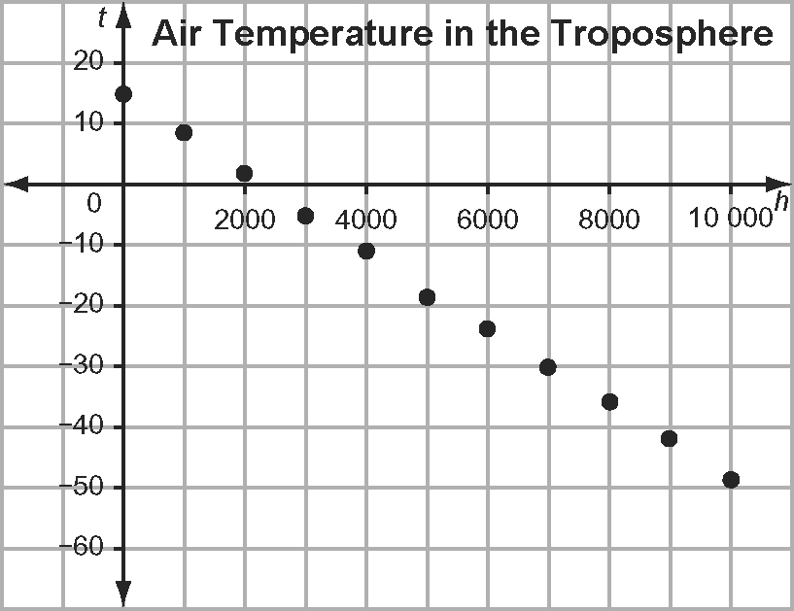

1. a) Examine the graph. What do you notice about how the points lie?
______________________________________________________________
b) What other patterns do you see in the graph?
______________________________________________________________
______________________________________________________________

2. Use the graph to complete the table.
Using the Graph
Temperature, t (ºC) | Height, h (m)
15
 | 3000
0
 | 7000
−50

3. The equation that models air temperature change in the troposphere is
t = 15 − , where t is the temperature, in degree Celsius, and h is the altitude, in metres. Check the accuracy of your graph reading by substituting each of the given values into the equation.
• For example, for part a), substitute t = 15 into the equation and solve for h.
• For part b), substitute h = 3000 into the equation and solve for t.
Show your work on a separate piece of paper.
Using the Equation t = 15 −
Temperature, t (ºC) | Height, h (m)
a) 15 | What value goes in the box? = 15 −  What do you need to do to isolate the variable?  Step 1 15 = 15 −  Step 2 What is the value of h? ____
b) | 3000
c) 0
d) | 7000
e) −50

4. What connections do you see between the graph and the equation?
______________________________________________________________
______________________________________________________________

5. At what height in the troposphere is the temperature 0 ºC?
Hint: Look at the table in #3. ____________________

