Chapter 10 Test
For #1 to #5, select the best answer.
1. What is the result of applying the distributive property to 3(a + 2)?
A 3a − 2 B 3a + 2 C 3a − 6 D 3a + 6

2. What is the opposite operation of addition?
A addition B subtraction C multiplication D division

3. For which of the equations would you add 12 as the first step in the solution?
A 2(m − 12) = 3 B 14 = C 13 = y − 12 D 12w − 5 = 7

4. For which of the equations would you divide by 3 as the first step in the solution?
A 15 = 3h B 4m − 3 = 5 C 2a − 1 = 3 D = 7

5. Which equation is modelled by this diagram?
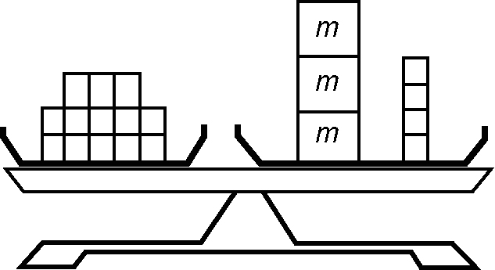
A 13 + 3m = 4 B 13 = 3m + 4 C 13 = 3m − 4 D 13 − 3m = 4

Short Answer
6. Solve.

a) x + 2 = 7
c) 24 = 2a
e) = −3
g) −17 = −5 + h

b) = 8
d) −4y = 16
f) −9 =
h) −5k = −30

7. Solve. Check your answers.

a) 3x + 2 = 11
c) −16 = −5a − 6
e) − 14 = −2(n − 6)
b) 4 = − 1
d) 3(c + 5) = 12
f) −4 − = −7

8. a) Draw a diagram that models the equation 7 = 5x − 3.
b) What is the solution to this equation?

9. Lisa is 6 years older than twice her sister's age. Lisa is 12. Write and then solve an equation to determine the age of Lisa's sister.

10. a) Solve for x in the equation x + 9 = 16.
b) Use the value of x to find y in the equation 11 = y − x.
c) Use the values of x and y to find m in the equation 2m + y = 3(x − 5).

Extended Response

11. a) What is wrong with the method used to solve the following equation?
−2 = 11 −
−2 − 11 = 11 − 11 −
−13 =
−39 = x
b) What is the correct method?

