Chapter 10 BLM Answers

BLM 10–1 Chapter 10 Math Link Introduction
1. y = 3(5) + 2, y = 17; y = 3(1) + 2, y = 5;
y = 3(20) + 2, y = 62; y = 3(8) + 2, y = 26;
y= 3(5) + 2, y = 17; y = 3 (18) + 2; y= 56.
The encrypted form of weather is 71, 17, 5, 62, 26, 17, 56.
2.
Encrypted Form (y) | Number (x) | Letter
59 | 59 = 3x + 2  59 − 2 = 3x − 2  57 = 3x  =  19 = x | 19 = s
29 | 29 = 3x + 2  29 − 2 = 3x − 2  27 = 3x  =  9 = x | 9 = i
38 | 38 = 3x + 2  38 − 2 = 3x − 2  36 = 3x  =  12 = x | 12 = l
38 | 38 = 3x + 2  38 − 2 = 3x − 2  36 = 3x  =  12 = x | 12 = l
77 | 77 = 3x + 2  77 − 2 = 3x − 2  75 = 3x  =  25 = x | 25 = y
Password: silly
3. Answers will vary. Example: Password: guitar; Linear equation: y = 2x − 3

Letter | Number From Chart (x) | Encrypted Form  y = 2x − 3
g | 7 | y = 2(7) − 3  y = 14 − 3  y = 11
u | 21 | y = 2(21) − 3  y = 42 − 3  y = 39
i | 9 | y = 2(9) − 3  y = 18 − 3  y = 15
t | 20 | y = 2(20) − 3  y = 40 − 3  y = 37
a | 1 | y = 2(1) − 3  y = 2 − 3  y = −1
r | 18 | y = 2(18) − 3  y = 36 − 3  y = 33
BLM 10–2 Chapter 10 Get Ready
1. a) 19 b) 23 c) 53
2. a) 494 cm² b) 408 cm² c) 396 cm²
3. a) p + 7 = 12 b) x – 3 = 11
c) 4s =28 d) = 9
4. a) $5 b) 139 cm c) $18 d) 25 min
5. a) 2n + 4 = 18 b) 3x + 5 = 17
c) 8y − 70 = 94 d) 27 = 7q + 6
6. a) j = 8 b) t = 3 c) x = 3 d) p = 6
7. 50 cm
BLM 10–3 Chapter 10 Warm-Up
Section 10.1
1.
a | 0 | 1 | 2 | 3 | 4
b | −5 | −2 | 1 | 4 | 7

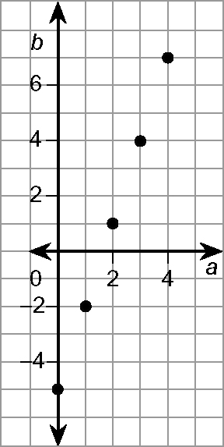
2.

3. Yes, it is a linear relation. The difference in consecutive values of a is the same, and the difference in consecutive values of b is the same. Also, the points on the graph lie along a straight line.
4. y = 15 5. 17.5 km
6. 9 × 1 = 9, −9 × (−1) = 9, 3 × 3 = 9, −3
× (−3) = 9
7. 45 ÷ 1 = 45, 45 ÷ (−1) = −45,
45 ÷ 3 = 15, 45 ÷ (−3) = −15,
45 ÷ 5 = 9, 45 ÷ (−5) = −9,
45 ÷ 9 = 5, 45 ÷ (−9) = −5,
45 ÷ 15 = 3, 45 ÷ (−15) = −3,
45 ÷ 45 = 1, 45 ÷ (−45) = −1
8. 6 × 30 = 180 cm³
9. (6 × 20) + (6 × 8) = 120 + 48 = 168 cm²
10. Answers may vary. Example: 9² = 81,
10² = 100, ≈ 9.7
Section 10.2
1. −3t = −12 2. −3 3. t = 4 4. b = 75
5. Left Side = Right Side = −15
=
= −15
Left Side = Right Side
6. Answers will vary. Example:
r² = 64, 64 ≈ 60, 60 × 3 = 180
100 × 80 + 80 × 80 = 8000 + 6400
= 14 400 cm³
7. 8. 9. 1 10. 14
Section 10.3
1. z = 4
2. Left Side = 3z + 3 Right Side = 15
= 3(4) + 3
= 15
Left Side = Right Side
3. a) Subtract 3 from both sides of the equal sign.
b) Add 6 to both sides of the equal sign.
4. a) n = −5
Left Side = 28 Right Side = −5n + 3
= −5(−5) + 3
= 28
Left Side = Right Side
b) r = 18
Left Side = 3r − 6 Right Side = 48
= 3(18) − 6
= 48
Left Side = Right Side
5. No, the difference in consecutive values of b is the same, but the difference in consecutive values of a is not the same.
6. 333%, 3 7. 5.24, 5
8. 0.375, 37.5% 9. 3
10. a) 10² = 100, 11² = 121, ≈ 10.8
b) 5² = 25, 6² = 36, ≈ 5.7
Section 10.4
1. x = 45
2. a) Subtract 4 from both sides of the equal sign.
b) Subtract 6 from both sides of the equal sign.
3. a) Multiply both sides of the equal sign by −2.
b) Multiply both sides of the equal sign by −7.
4. a) p = −16
Left Side = Right Side = 12
=
= 8 + 4
= 12
Left Side = Right Side
b) t = 196
Left Side = −22 Right Side =
= + 6
= −28 + 6
= −22
Left Side = Right Side
5. a) Answers will vary. Example: Apples seem to sell the best because they have the longest line on the pictograph.
b) Answers will vary. Example:
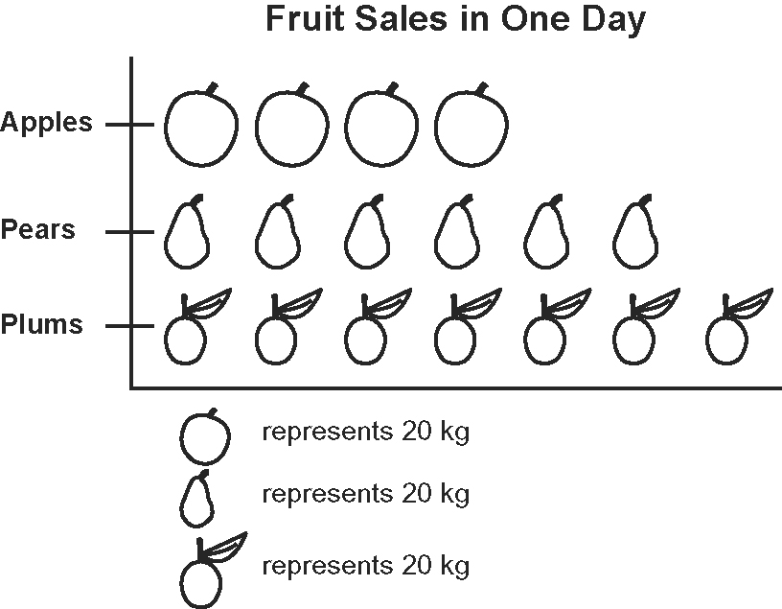
6. = 245 beats 7. = 1¢
8. = 17 9. = 7
10. =
BLM 10–4 Chapter 10 Problems of the Week



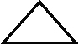
1. = 48 = 12 = 6 = 4





= 8 =3 = 5 = 2
2. The solution is incorrect.

x − 3 = 7
x − 3 + 3 = 7 + 3
x = 10

3. Methods may vary. Let x be the age of the first child, x + 1 the age of the second child, and x + 2 the age of the third child.
Solve by Guess and Check:
x = 10
10 + (10+ 1) + (10 + 2) = 33 Too Low
x = 11
11 + (11 +1) + (11+2) = 36 Correct
Aunt Katrina's children are 11 years old, 12 years old, and 13 years old.
4. 173 ÷ 100 = 1.73
1.73 m = 173 cm
3.14d ≈ 173
d ≈ 173 ÷ 3.14
d ≈ 55
The diameter of my bicycle wheel is approximately 55 cm.
5. a) Let x be my successful shots and x − 6 be my partner’s successful shots.
3(x − 6) = 30
x − 6 = 10
x = 16
I made 16 successful shots.
b) My score was 16(3) − 10(2) = 28 points.
My partner scored 30 points.I did not win.
c) It is better to throw fewer shots that are more accurate. I should take my time when I shoot.
d) Answers may vary. Example: If one person makes 10 successful shots and misses one shot, and the other person makes 16 successful shots and misses 10 shots, they will be tied.
6. 4(8) + 3x = 143
32 + 3x = 143
3x = 111
x = 37
The ride was 37 km.
7. Answers will vary.
BLM 10–5 Section 10.1 Extra Practice
1. a) n = −4 b) r = −20 c) y = 54 d) c = −3
2. a) x = 3 b) x = 8 c) x = −12 d) x = 1
3. a) d = 8 b) p = 176 c) e = −112 d) y = 12
4. a) yes b) yes c) no d) no
5. a) 4w = 79, where w is the width of the skateboard
b) 4w = 79
w = 19.75
Mika’s skateboard has a length of 19.75 cm.
Check: 4(19.75) = 79
BLM 10–7 Section 10.2 Extra Practice
1. a) x = 2 b) x = 3 c) x = 1 d) x = 3
2. a) x = 3 b) x = 4 c) x = −1 d) x = 2
3. a) t = 4 b) f = −7 c) w = −9 d) q = 1
4. a) yes b) yes c) no d) yes
5. 7c + 12 = 47, where c represents converted touchdowns
7c = 35
c = 5
The Spartans scored five converted touchdowns.

BLM 10–8 Section 10.2 Math Link
1.
Starting Speed (m/s) | Amount of Time the Object Falls (s) | Speed at Which It Hits the Ground (m/s)
0 | 5 | 10 × 5 = 50
5 | 4 | 5 + (10 × 4) = 45
10 | 1 | 10 + (10 × 1) = 20
0 | 12 | 10 × 12 = 120
15 | 3 | 15 + (10 × 3)= 45
2. 5 + 10t = 45
3. 5 + 10t = 45
10t = 40
t = 4
The stone fell for 4 s.
BLM 10–9 Section 10.3 Extra Practice
1. a) r = 8 b) q = 27 c) v = 40 d) z = −25
2. a) n = 28 b) a = −16 c) x = 33 d) e = 30
3. a) no b) yes c) no d) yes
4. + 2 = 11, where x is Xien’s age
= 9
x = 18
Xien is 18 years old.
5. Instead of dividing by 4, Alex should have added 5 to both sides of the equation and then divided by 4.
BLM 10–10 Section 10.3 Math Link
1. a) The points lie along a straight line.
b) Answers will vary. Example: The highest temperature is 15 ºC, and the temperature steadily decreases to about 50 ºC. The altitude ranges from 0 m to 10 000 m.
2. Answers may vary. Example:
Using the Graph
Temperature, t (ºC) | Height, h (m)
15 | 0
−5 | 3000
0 | 2000
−30 | 7000
−50 | 10 000

3.
Using the Equation t = 15 −
Temperature, t (ºC) | Height, h (m)
a) 15 | 0
b) −4.5 | 3000
c) 0 | 2310
d) −30.5 | 7000
e) −50 | 10 010
4. Answers will vary. Example: The graph starts at t = 15, and 15 is the constant in the equation.
5. 2310 m
BLM 10–11 Section 10.4 Extra Practice
1. a) d = 1 b) k = 6 c) p = −1 d) s = 2
2. a) y = 2 b) c = 0 c) r = −8 d) j = 2
3. a) yes b) no c) yes d) yes
4. 2(p + 21) = 62, where p is the number of points scored in the first game
p + 21 = 31
p = 10
The Panthers scored 10 points in the first game.
5. 3(m + 165) = 1095, where m is the amount of money raised by Room 17
m + 165 = 365
m = 200
Room 17 raised $200.
BLM 10–12 Section 10.4 Math Link
1. 250 = 10(r+ 1) 2. 4560 = 30(110 + p)
BLM 10–13 Chapter 10 Test
1. D 2. B 3. C 4. A 5. B
6. a) x = 5 b) a = 32 c) a = 12 d) y = −4
e) m = −15 f) n = 63 g) h = −12 h) k = 6
7. a) x = 3 b) m = 15 c) a = 2
d) c = −1 e) n = 13 f) x = 24

8. a)
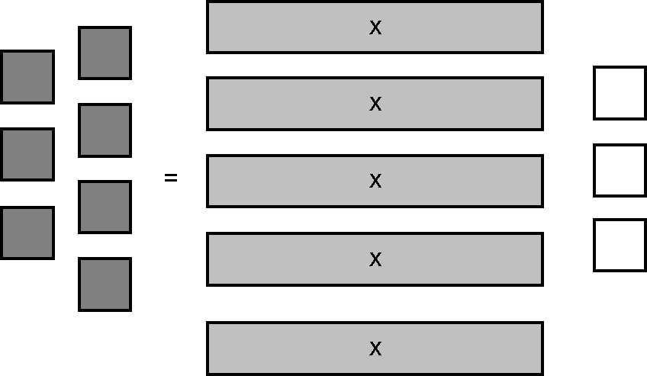
b) x = 2
9. 12 = 2a + 6, where a is the age of Lisa’s sister
6 = 2a
3 = a
Lisa’s sister is 3 years old.
10. a) x = 7 b) y = 18 c) m = −6
11. a) The negative sign was dropped from
−13 = . It should be −13 = −.
b) Methods may vary. Example:
−2 = 11 −
−2 − 11 = 11 − 11 −
−13 = −
−13 + = − +
−13 + = 0
−13 + 13 + = 0 + 13
= 13
x = 39

