Fractions, Decimals and Percents
To convert a fraction to a percent, convert the fraction to a decimal number by dividing the numerator by the denominator. Then, multiply the decimal by 100 and add a percent symbol.
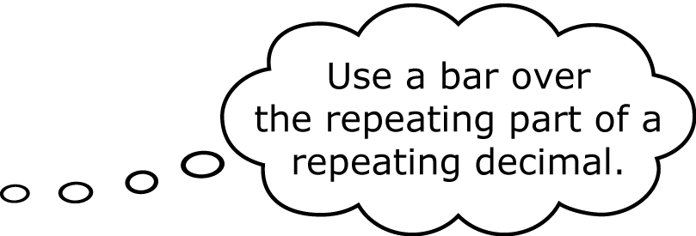
= 0.444 44…
= 0.444 44… × 100%
=

1. Write each fraction as a decimal and a percent.
a) b)
2. Complete the following table.

Fraction | Decimal | Percent
a)
b) | 0.66666….
c)
d)

Probability
The probability of an event is a measure of the likelihood that it will occur. The probability of an impossible event is 0 or 0%. The probability of a certain event is 1 or 100%.
A coin is flipped. What is the probability that it lands heads up, P(H)? Write your answer as a fraction, a decimal, and a percent.
P(H) =
=
The probability of heads is , 0.5, or 50%.

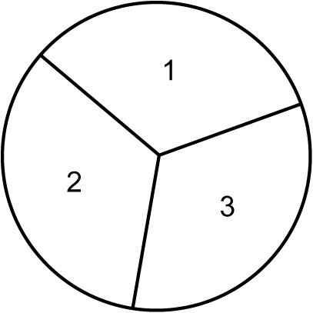
3. The spinner is spun once. Find the following
probabilities. Write each answer as a fraction,
a decimal, and a percent.
a) What is the probability of spinning 2, P(2)?
b) What is P(< 3)?
c) What is P(> 3)? Justify your response.

Using Tables and Tree Diagrams

Tables and tree diagrams are common ways to organize outcomes.
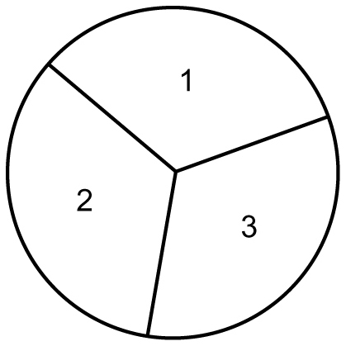
A coin is flipped and a spinner is spun.
a) What is the sample space or list of
all possible outcomes?
b) How many outcomes are there?
c) What is P(T, 3)?

a)
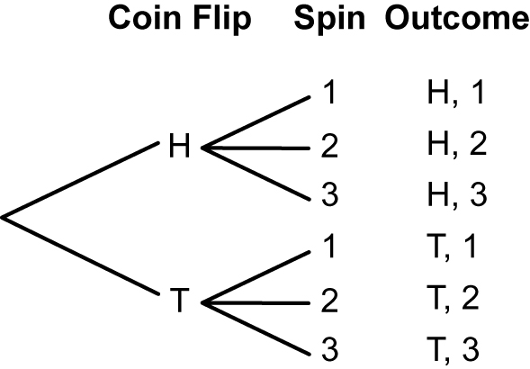
Table Tree Diagram
Coin | Spinner
Coin | 1 | 2 | 3
Heads (H) | H, 1 | H, 2 | H, 3
Tails (T) | T, 1 | T, 2 | T, 3

b) There are 6 favourable outcomes: (H, 1), (H, 2), (H, 3), (T, 1), (T, 2),
(T, 3).
c) P(T, 3) =
P(T, 3) is , , or .

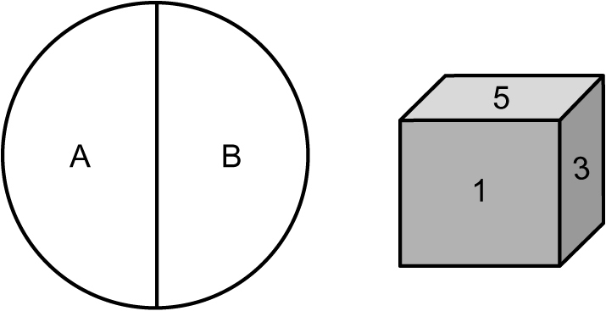
4. a) Create a table to show the sample space
for the spinner and the fair six–sided die.
b) List the sample space.
c) What is P(A, < 5)?

5. The following sample space represents all of the outcomes from flipping a coin and spinning a numbered spinner: (H, 1), (T, 1), (H, 2), (T, 2), (H, 3), (T, 3), (H, 4), (T, 4). | a) Draw the spinner.  b) Display the sample space in a tree diagram.  c) What is P(H or T, < 5)? Explain your thinking.

Multiplying Fractions

You can use paper folding to multiply proper fractions.

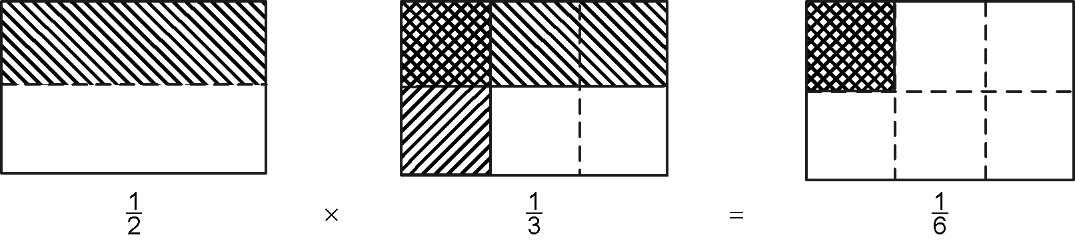

To multiply fractions without a diagram, multiply the numerators and multiply the denominators.

6. What multiplication statement does each diagram represent?  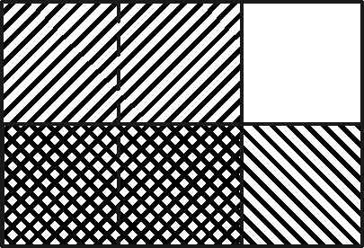  a)  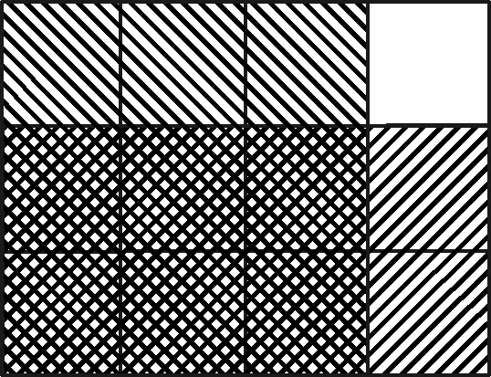  b) | 7. Multiply. Show your answer in lowest terms.  a) b) c)

