Chapter 11 Warm-Up
Section 11.1

1. Model and then solve 3(b − 5)
= −27.
For #2 to #5, solve each equation.
2. 3(7 + t) = –9
3. −20 = 4(m + −2)
4. + p = 12
5. 6 + = 3

Mental Math
For #6 to #10, solve for a.
6. 7a = 49
7. −7a = 49
8. −7a = −49
9. = 49
10. = −49

Section 11.2

For #1 to #5, use the following spinners. Express each probability as a fraction, a decimal, and a percent.
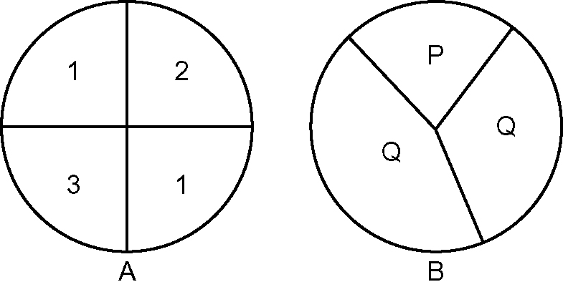
1. What is the probability of spinning 1 on Spinner A?
2. Draw a tree diagram to represent the sample space for spinning A then B.
3. What is P(3 then Q)?
4. What is P(2 then P)?
5. What is P(1 then Q)?

Mental Math
Use this prism to answer #6 to #10.
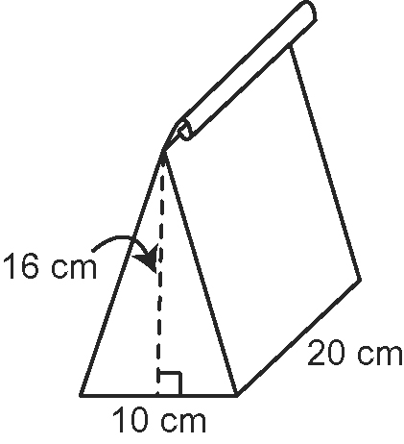
6. What type of prism does this closed paper bag make?
7. Show the base to the height of the triangle as a ratio in lowest terms.
8. Show the base of the prism to the base of the triangle to the height of the triangle as a three-part ratio in lowest terms.
9. What is the volume of this prism?
10. Estimate the surface area of the prism. The hypotenuse of the right triangle is about 17 cm.

Section 11.3

Use the following spinners and coin to answer #1 to #4.

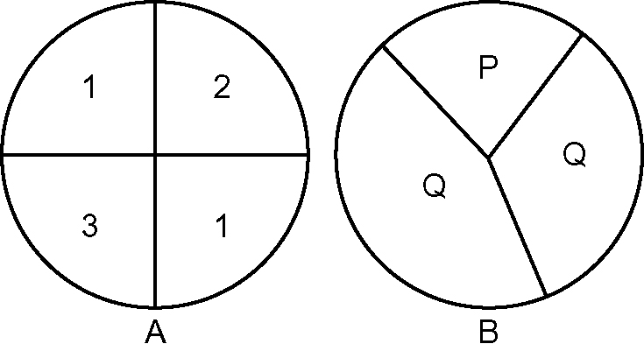

1. You spin Spinner A and then spin Spinner B. How many possible outcomes are there?
2. You spin Spinner B and flip the coin. How many possible outcomes are there?
3. Draw a tree diagram that shows all of the possible outcomes from both spinners and the coin.
4. Use another method to verify the number of outcomes from #3.
5. What is P(1, Q, H)?

Mental Math
6. Convert 2.24 to a percent and a reduced fraction.
7. Convert 981% to a decimal and a fraction.
8. Convert to a decimal and a percent.
9. There were 2000 fruit flies in a jar. The population decreased by 1.5% in 1 h. What is the new population? Show your thinking.
10. Calculate the following. Show your thinking.
a) b) c)

