Section 11.1 Math Link
This worksheet will help you with the Math Link on page 418.

1. Complete the following tree diagram to determine all the possible outcomes for a toss of four sticks.
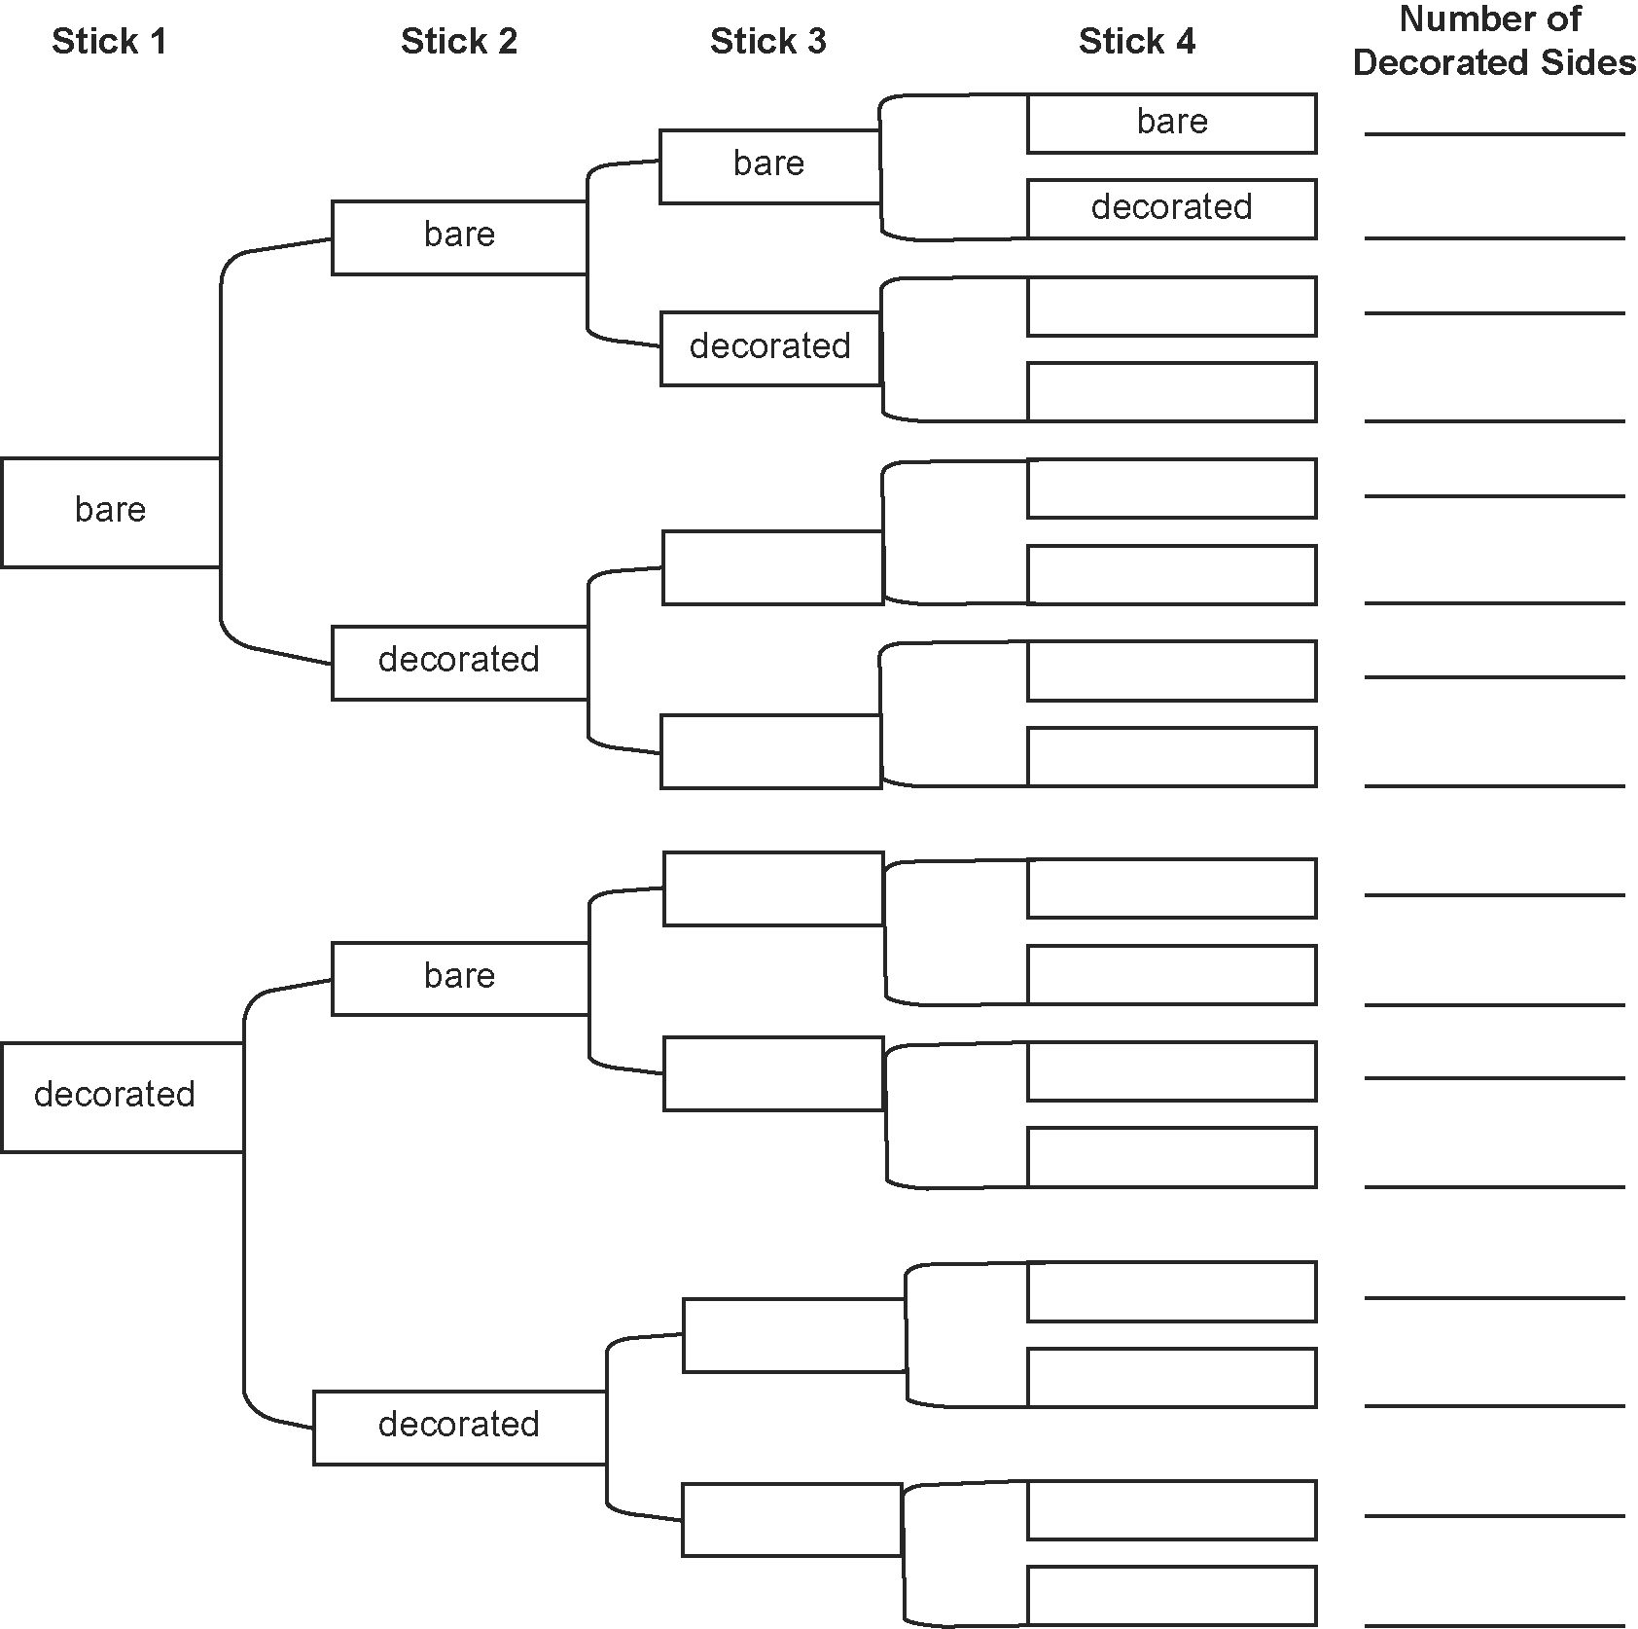

2. a) How many possible outcomes are there? ____ How many outcomes have
b) only one decorated side up? ____ c) two decorated sides up? ____
d) three decorated sides up? ____ e) four decorated sides up? ____
f) no decorated sides up? ____
3. What is the probability of exactly three sticks landing decorated side up? Give your answer as a fraction, a decimal, and a percent.

