Section 11.3 Extra Practice
Write your answers for #1 in your notebook.
1. Shea-Lee rolled a regular die and recorded the results in a tally chart.

a) How many times in total did
Shea-Lee roll the die?
b) What is the experimental probability of rolling a 3?
c) What is the theoretical probability of rolling a 3?
d) Which number’s experimental probability matches its theoretical probability?
e) What could Shea-Lee do to get all of
the numbers to match their theoretical probability better?

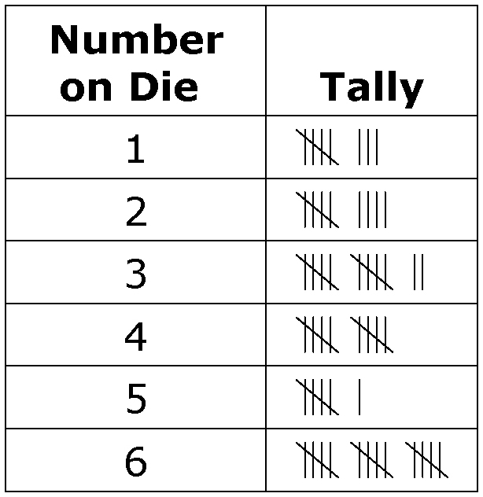

2. Mallory rolls a six-sided die and Rose flips a coin.
a) Draw a tree diagram in your notebook. What is the probability of the girls
getting tails and an odd number? ____
b) Use multiplication to get your answer. ____________________
c) What is this same probability written as a percent and as a decimal?
____________________

3. Bill and Ravi made two spinners, one with eight equal sectors each with a different colour, and one with 25 equal sectors each with a different number. Determine the probability of spinning black and 15 as quickly as possible.
a) Determine P(black, 15). ____________________
b) Write this probability as a fraction, a decimal, and a percent.
____________________
c) Why is calculating the answer easier than drawing a table or a tree diagram?
_____________________________________________________________
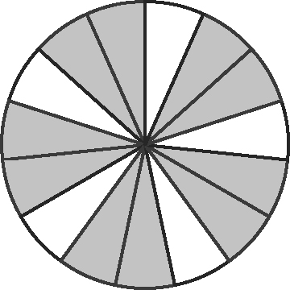
4. Ivan created a spinner for a simulation. He knew the
theoretical probability for an event was . This is the
spinner he created. Is this a fair spinner for the simulation?
Explain your thinking.
_______________________________________________________________

