Chapter 11 Test
For #1 to #5, select the best answer.

 | Bag 1
Bag 2 | Blue | Red | Yellow | Green
Blue | B, B | B, R | B, Y | B, G
Red | R, B | R, R | R, Y | R, G
Yellow | Y, B | Y, R | Y, Y | Y, G
Green | G, B | G, R | G, Y | G, G

Two bags each contain one blue, red, yellow, and green marble. One marble is drawn from each bag. The table represents the sample space for the possible outcomes. Use the table to answer #1 to #3.

1. What is the probability that one of the marbles is green?

A B C D

2. What is the probability that the two marbles are the same colour?

A B C D

3. What is the probability that one of the marbles is not red?

A B C D

Mark, Beth, and Terry have identical pencil cases. Each pencil case contains a pencil, an eraser, a pen, a marker, and a pencil sharpener. Mark’s pencil is red, Beth’s pencil is blue, and Terry’s pencil is green. The other items are identical. One day, their pencil cases are mixed up. They agree to choose one case and take out one item to find out who owns the case. Use this information to answer #4 and #5.

4. What is the total number of possible outcomes?

A 8 B 9 C 15 D 20

5. Which expression gives the probability that Mark’s case is chosen and the item chosen can be used to write with?

A × B × C + D +

Short Answer

6. Three frozen treats are flavoured raspberry, lemon, and orange. Without looking, Tara chose a treat, then decided she didn’t want it. She replaced it and without looking, chose another one. Create a table or tree diagram to show the sample space.

7. Allison has five pennies in her pocket. The chart shows Allison’s tally results of a probability experiment of 100 draws of one penny each time. Which penny’s date has an experimental
probability that matches the theoretical probability?

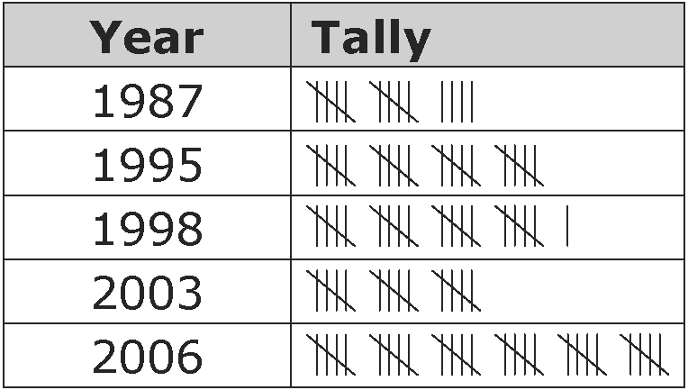

8. Determine the number of days Mark could wear a different combination of T-shirt, sweater, and pants.

T-shirt | Sweater | Pants
white | black | blue
green | grey | brown
orange | blue
brown

9. You roll a six-sided die with the sides numbered 1, 3, 3, 3, 4,
and 4, and spin this spinner.
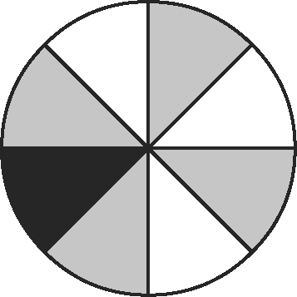
Express each answer as a fraction, a decimal, and a percent.
a) What is the probability of spinning white?
b) What is the probability of rolling a one?
c) What is the probability of rolling a two?
d) What is the probability of spinning grey and rolling a three?

10. As the number of coin tosses increases, does the experimental probability of heads get closer to the theoretical probability? Explain.

Extended Response

11. Ben wants to promote a school dance using a gumball machine that holds 120 gumballs. Students pay 30¢ for a gumball. If they receive an orange gumball, they win a free ticket to the dance worth $5.00. There are now 113 different coloured gumballs in the machine, but none are orange.
a) What is the least number of gumballs Ben must add and remove so that there is a 10% chance of selecting an orange gumball when he begins his promotion with a full machine?
b) Calculate the cost of this promotion if a gumball costs Ben 5¢. Does Ben make a profit? If so, how much?
c) If Ben wants the promotion to break even (no profit or loss), what should the probability of getting an orange gumball be?
d) Will the probability of receiving an orange gumball stay the same as people use the machine? Explain using at least one example.

