Chapter 11 BLM Answers

BLM 11–1 Chapter 11 Math Link Introduction
1. a) Answers will vary. Example: Likelihood refers to the chance or probability that you will win the game.
b) Answers will vary. Example: possibility, odds
2. Answers will vary. Card games may include Go Fish and Crazy Eights.
3. Answers will vary. Games that involve dice may include Yahtzee® and Game of Life®.
4.−6. Answers will vary depending on the game.
BLM 11–2 Chapter 11 Get Ready
1. a) = 0.75 = 75% b) = =
2.
Fraction | Decimal | Percent
a) | 0.8 | 80%
b) | 0.66666….
c) | 0.3636….
d) | 0.33333….
3. a) , , b) , ,
c) , 0.00, 0%. There are no numbers greater than 3 on the spinner so there is 0 probability.
4. a)
 | 1 | 2 | 3 | 4 | 5 | 6
A | A, 1 | A, 2 | A, 3 | A, 4 | A, 5 | A, 6
B | B, 1 | B, 2 | B, 3 | B, 4 | B, 5 | B, 6
b) (A, 1), (A, 2), (A, 3), (A, 4), (A, 5), (A, 6),
(B, 1), (B, 2), (B, 3), (B, 4), (B, 5), (B, 6)
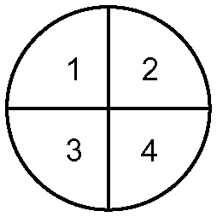
c) P(A, < 5) = 5. a)

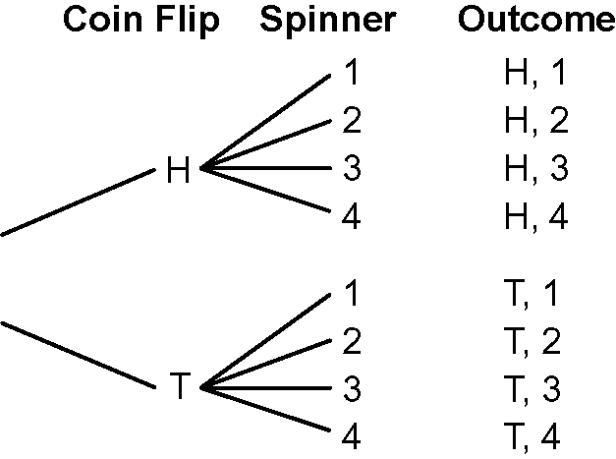
b)

c) P(H or T, < 5) = 100%. Every outcome in the sample space will consist of either a head or a tail and a spin of less than 5.
6. a) × = b) × =
7. a) b) c)
BLM 11–3 Chapter 11 Warm-Up
Section 11.1
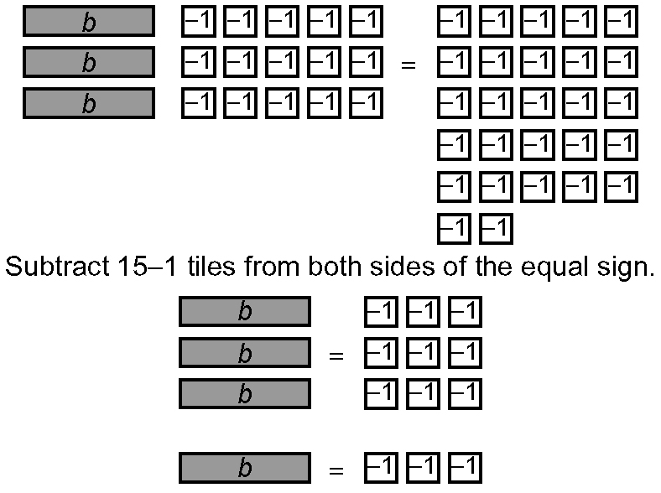
1.

b = 4
2. t = −10 3. m = −3 4. p = 14
5. d = −27 6. a = 7 7. a = −7
8. a = 7 9. a = 343 10. a = −343
Section 11.2
1. P(1) =, 0.5, or 50%
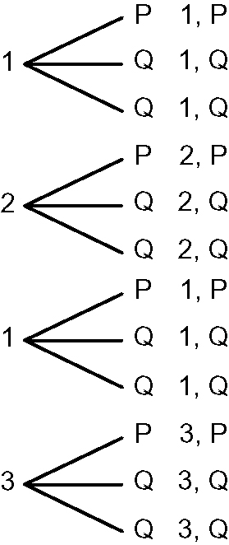
2.

3. P(3 then Q) =, or
4. P(2 then P) =, or
5. P(1 then Q) =, or
6. triangular prism 7. or 5 : 8
8. 10 : 5 : 8 9. 1600 cm³

10. Area of 2 triangles = (10 × 16 ÷ 2) × 2
= 160; Area of 2 sides = 20 × 17 × 2 = 680; Area of bottom = 20 × 10 = 200; Total surface area = 1040 cm²
Section 11.3
1. 12 2. 6
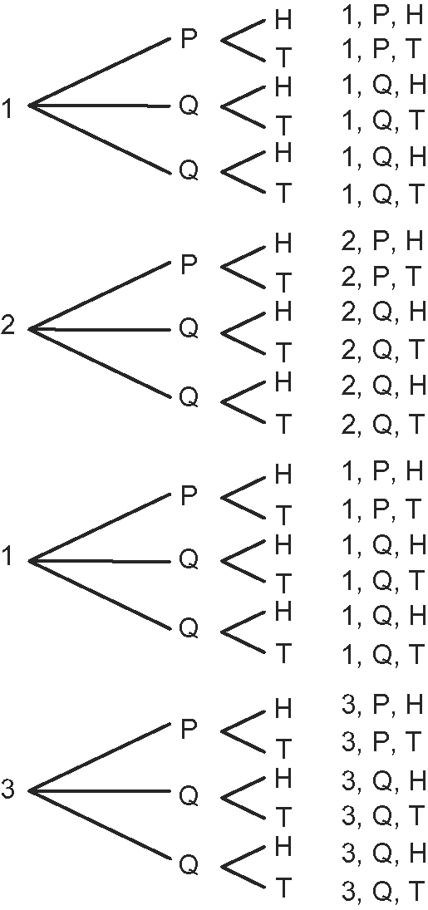
3.

24 possible outcomes
4. 4 × 3 × 2 = 24 5., , or
6. 224%, 2 7. 9.81, 9
8. ,
9. 1% of 2000 = 20; 0.5% of 2000 = 10;
1.5% of 2000 = 30. The new population is 1970.
10. a) 100 = 2 × 2 × 5 × 5; = 10
b) 12 × 12 = 144; 13 × 13 = 169;
≈ 12.2 or 12.3
c) 15 × 15 = 225; 16 × 16 = 256;
≈ 15.1 or 15.2
BLM 11–4 Chapter 11 Problems of the Week
1. Answers will vary. Example: With a 1 : 3600 chance, you are not likely to use this rule.
2. a) Answers will vary. Examples:
• The probability that a card with a value greater than five will be chosen is 0.50.
• Half the cards have a value greater than five.
b) Answers will vary. Example: 0.26 or have a value greater than seven.

3. 3 turns; 6 × 6 = 36, 6 × 6 = 36, and 5 × 6 = 30; 36 + 36 + 30 = 102. The least number of rolls needed to score 102 is three.
4. The possible answers are 47, 49, 61, 63, 65, 67, 69, 81, 83, 85, 87, and 89. The probability you will guess correctly on the first guess is .
5. Possible number of spins: 6 × 6 = 36; Favourable outcomes: or
 | 1 | 2 | 3 | 4 | 5 | 6
1 | 1, 1 | 2, 1 | 3, 1 | 4, 1 | 5, 1 | 6, 1
2 | 1, 2 | 2, 2 | 3, 2 | 4, 2 | 5, 2 | 6, 2
3 | 1, 3 | 2, 3 | 3, 3 | 4, 3 | 5, 3 | 6, 3
4 | 1, 4 | 2, 4 | 3, 4 | 4, 4 | 5, 4 | 6, 4
5 | 1, 5 | 2, 5 | 3, 5 | 4, 5 | 5, 5 | 6, 5
6 | 1, 6 | 2, 6 | 3, 6 | 4, 6 | 5, 6 | 6, 6
6. a) Answers will vary. Example: 70% chance of rain means that it will rain on seven out of ten days, or 0.7 days, with the same conditions in the atmosphere.
b) The probability that it will rain on both days is × = , 0.21, or 21%.
c) Answers will vary.
BLM 11–5 Section 11.1 Extra Practice
1.
Large | Massive | Gargantuan
Veggie Garden | Veggie Garden | Veggie Garden
Carnivore’s Delight | Carnivore’s Delight | Carnivore’s Delight
Cheesy Wheezy | Cheesy Wheezy | Cheesy Wheezy
Hawaiian Paradise | Hawaiian Paradise | Hawaiian Paradise

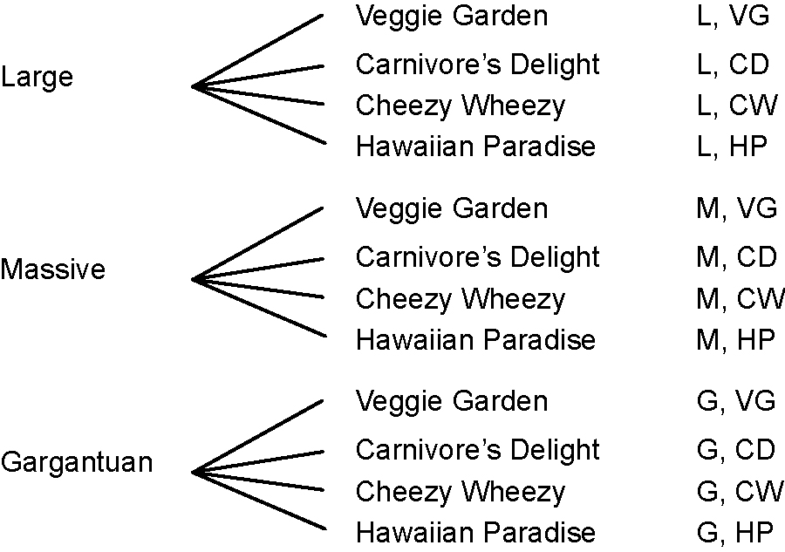

Possible number of choices: 12

2. a) Die 1: 2, 3, 5, 7, 11, 13; Die 2: A, B, C, D, E, F
b)
 | 2 | 3 | 5 | 7 | 11 | 13
A | A, 2 | A, 3 | A, 5 | A, 7 | A, 11 | A, 13
B | B, 2 | B, 3 | B, 5 | B, 7 | B, 11 | B, 13
C | C, 2 | C, 3 | C, 5 | C, 7 | C, 11 | C, 13
D | D, 2 | D, 3 | D, 5 | D, 7 | D, 11 | D, 13
E | E, 2 | E, 3 | E, 5 | E, 7 | E, 11 | E, 13
F | F, 2 | F, 3 | F, 5 | F, 7 | F, 11 | F, 13
c) 36 possible outcomes
d) P(E, 11) = = 0.02778 = 2.778%
e) P(vowel, even prime number) =
3. a) quarter head, nickel head; quarter head, nickel tail; quarter tail, nickel head; quarter tail, nickel tail b) P(H, T) =
c) P(H followed by T) =
d) Answers will vary. Example: P(H, T) and P(H then T) are different because the second one is more specific than the first. P(H, T) means that either the quarter or the nickel can be heads or tails, while P(H then T) means that the quarter must be heads and the nickel must then be tails.
4. a) , 0.077, 7.69% b) , 0.231, 23.1%
c) 7.78% d) second draw
BLM 11–6 Section 11.1 Math Link
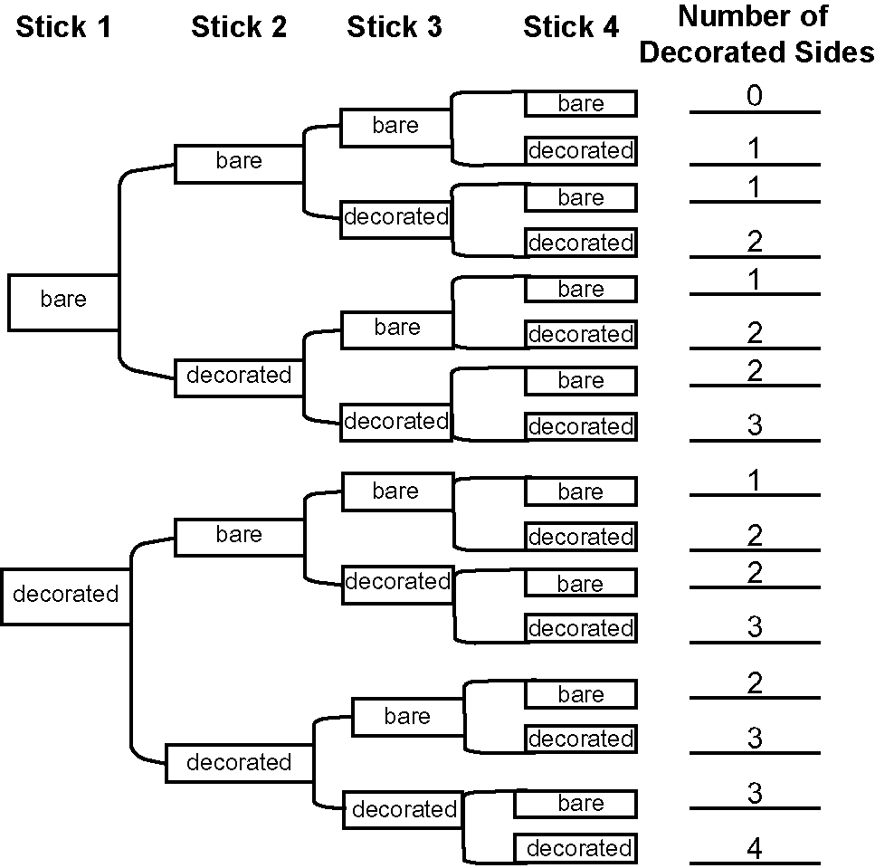
1.

2. a) 16 b) 4 c) 6 d) 4 e) 1 f) 1
3. , 0.25, or 25%
BLM 11–7 Section 11.2 Extra Practice
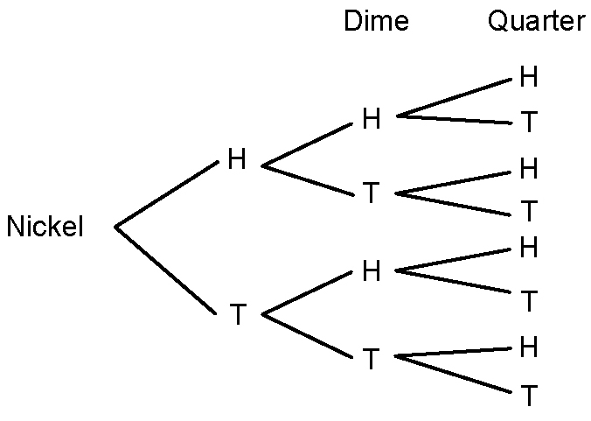
1. a)

b) 2 × 2 × 2 = 8
2. four kinds of blue, four kinds of green, two kinds of black = ten choices
3. 3 × 4 × = 72. There are six choices of
appetizers.
4. Answers will vary. Example: 7 days a week × 3 meals a day × 2 types of beverages = 42 beverage choices each week
5. 27
BLM 11–8 Section 11.2 Math Link
1.
Number of Sticks | Outcomes | Total Number of Outcomes
1 | (B, D) | 2
2 | (B, B), (B, D), (D, B), (D, D) | 4
3 | (B, B, B), (B, B, D), (B, D, B),  (B, D, D), (D, B, B), (D, B, D),  (D, D, B), (D, D, D) | 8
4 | (B, B, B, B), (B, B, B, D),  (B, B, D, B), (B, B, D, D),  (B, D, B, B), (B, D, B, D),  (B, D, D, B), (B, D, D, D),  (D, B, B, B), (D, B, B, D),  (D, B, D, B), (D, B, D, D),  (D, D, B, B), (D, D, B, D),  (D, D, D, B), (D, D, D, D) | 16
5 | (B, B, B, B, B), (B, B, B, B, D), (B, B, B, D, B), (B, B, B, D, D), (B, B, D, B, B), (B, B, D, B, D), (B, B, D, D, B), (B, B, D, D, D), (B, D, B, B, B), (B, D, B, B, D), (B, D, B, D, B), (B, D, B, D, D), (B, D, D, B, B), (B, D, D, B, D), (B, D, D, D, B), (B, D, D, D, D), (D, B, B, B, B), (D, B, B, B, D), (D, B, B, D, B), (D, B, B, D, D), (D, B, D, B, B), (D, B, D, B, D), (D, B, D, D, B), (D, B, D, D, D), (D, D, B, B, B), (D, D, B, B, D), (D, D, B, D, B), (D, D, B, D, D), (D, D, D, B, B), (D, D, D, B, D), (D, D, D, D, B), (D, D, D, D, D) | 32

2. Answers will vary. Example: The number of outcomes doubles when another stick is added to the game. 3. a) 64 b) 7
BLM 11–10 Section 11.3 Extra Practice
1. a) 60 b) = c) d) 4
e) Answers will vary. Example: Roll many more times.
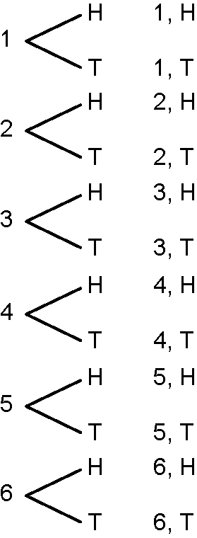
2. a)

b) × = or c) 25%, 0.25
3. a) × = b) , 0.005, 0.5%
c) Answers will vary. Example: A table or tree diagram would take too long to draw and be very complicated. Calculation is much quicker.
4. Answers will vary. Example: This is a fair spinner because 10 of the 15 sections are shaded. The probability of spinning a shaded section is .
BLM 11–11 Section 11.3 Math Link
1. , 0.25, 25% 2. , 0.125, 12.5%
3. a)−c) Answers will vary. Example: Using a coin, heads represent the decorated side and tails represent the plain side.
d) Answers for the student simulation will vary. The theoretical probability is as follows:
Four tails: ; Three tails and one head: ; Two tails and two heads: ; One tail and three heads:; Four heads: .
4. (four tails) and (four heads) have the same theoretical probabilities; (three tails and one head) and (one tail and three heads) have the same theoretical probabilities
5. Answers will vary.
6. Answers will vary. Usually, the greater the number of trials, the closer in value the two probabilities become.
7. Answers will vary. Example: The way each coin lands is independent of the way any other coin lands.
BLM 11–12 Chapter 11 Test
1. B 2. D 3. B 4. C 5. A
6. Look for a table or a tree diagram. Example:
 | Draw 2
Draw 1 | Raspberry | Lemon | Orange
Raspberry | R, R | R, L | R, O
Lemon | L, R | L, L | L, O
Orange | O, R | O, L | O, O
7. 1995
8. 4 shirts × 3 sweaters × 2 pants = 24 days
9. a) , 0.375, 37.5% b) ,
c) , 0.00, 0% d) , 0.25, 25
10. Answers may vary. Example: Yes, the more often you toss a coin, the closer the experimental probability of heads will approach the theoretical probability of 50%.
11. a) Take out five gumballs and add 12 orange gumballs.
b) Income from gumball sales: 120 × 0.30 = $36; Cost of gumballs: 120 × 0.05 = $6; Cost of dance tickets: 12 × $5 = $60; Total cost:$66. The promotion cost Ben $30. There was no profit.
c) If 5% of the gumballs were orange, then the income would equal the cost. Income from gumball sales: 120 × 0.30 = $36; Cost of gumballs: 120 × 0.05 = $6; Cost of dance tickets: 6 × $5 = $30; Total cost: $36
d) Answers will vary. Example: It will start at 10% and fluctuate depending on what colour of gumballs are bought and how many gumballs are left.
BLM 11–13 Chapter 11 Wrap It Up!
3. a) Answers to suggested scoring will vary.
The theoretical probability is as follows: Four decorated sides up:; Three decorated sides up and one down:; Two decorated sides up and two down:; One decorated side up and three down:; Four decorated sides down:
b) Answers may vary. Look for the idea that the scoring system is generally fair because the less probable combinations earn a player more points.
c), d) Answers will vary.

