Chapter 12 Math Link Introduction
This worksheet will help you with the Math Link on page 445.

Mosaics are pictures or designs made of small shapes of different colours. Mosaics are often made from tessellating a shape. Mosaics can be used to decorate shelves, table tops, mirrors, floors, walls, and other objects.

1. What is a regular polygon?
Hint: Check the Glossary of your student resource.
______________________________________________________________

2. What is an irregular polygon?
______________________________________________________________

3. If the tiles are congruent, they can be used to make a mosaic.
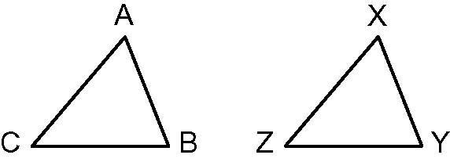
a) Measure the sides of each triangle. Record the measurements to the nearest millimetre.
side AC = ______ side AB = ______ side CB = ______
side ZX = ______ side XY = ______ side ZY = ______
Is there a relationship between triangle ABC and triangle XYZ? ______
If so, what is it?
_____________________________________________________________
b) Measure the angles of each triangle. Record the measurements to the nearest whole degree.
angle A = ______ angle B = ______ angle C = ______
angle X = ______ angle Y = ______ angle Z = ______
Is there a relationship between the angles of triangle ABC and triangle XYZ? ______
If so, what is it?
_____________________________________________________________
c) What does congruent mean?
_____________________________________________________________
d) Is ΔABC congruent to ΔXYZ? ______
Explain your reasoning.
_____________________________________________________________
4. a) Copy the shape of either ΔABC or ΔXYZ onto a piece of cardboard or construction paper.
b) Cut out the triangle to use as a pattern.
c) Create a design on a blank sheet of paper by tracing the triangle template in several places to make a pattern. Make sure that the sheet of paper is covered with no spaces between the triangles.
d) Colour your design.

5. Regular polygons can also be used to create interesting mosaic patterns.
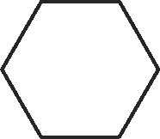
a) Measure each side of the hexagon to the nearest millimetre. How are the measurements of each side related?
_____________________________________________________________
b) Measure each angle of the hexagon to the nearest degree. How are the measurements of each angle related?
_____________________________________________________________
c) Is this a regular hexagon? ______
How do you know?
_____________________________________________________________
d) Copy the hexagon onto a piece of cardboard or construction paper.
e) Cut out the hexagon to use as a pattern.
f) Create a new design using the same process you used for the triangle
in #4.

6. Check off the transformations that you used to create your pattern in #5f).
translation
rotation
reflection
a combination of transformations (list them)
_____________________________________________________________

7. List the steps that you followed to create the pattern in #5f). Include the names of the transformations that you used.

