Congruent Figures

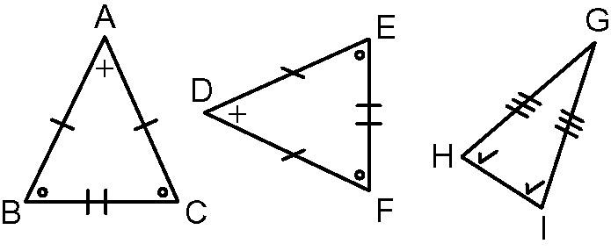
Congruent figures have the same shape
and size. The equal sides and angles of
congruent figures are called
corresponding sides and angles.
∆ABC is congruent to ∆DEF.
∠A = ∠D
∆ABC is not congruent to ∆GHI. The sides and the angles are not equal.
∠B and ∠C = ∠E and ∠F
and = and
=
This could also be written as ∆ABC ≅ ∆DEF.

1. Are the figures in each pair congruent? Explain your reasoning.
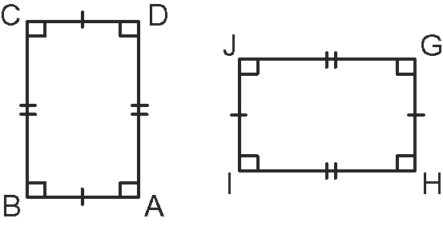
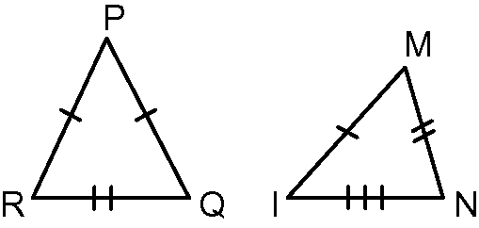
a) b)

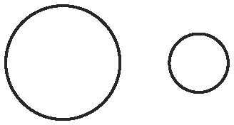
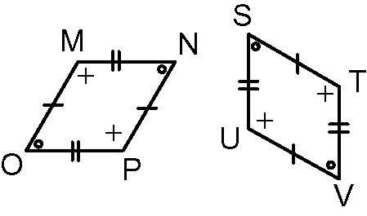
c) d)

2. For any congruent figures you found in #1, list the corresponding sides and angles.
Characteristics of Regular Polygons

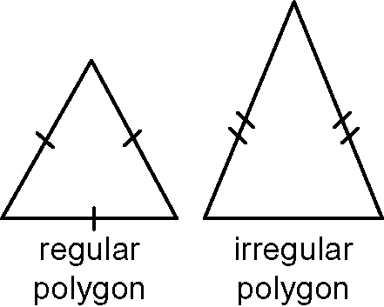
A regular polygon has all sides equal and all angles
equal. An equilateral triangle is an example of a regular
polygon. An irregular polygon is one that does not
have all sides and angles equal. An isosceles triangle is
an example of an irregular polygon.

3. Decide if each polygon is regular or irregular. Give reasons for your decisions.




a) b) c) d)

4. Draw and label one regular polygon and one irregular polygon.

Transformations and Transformation Images

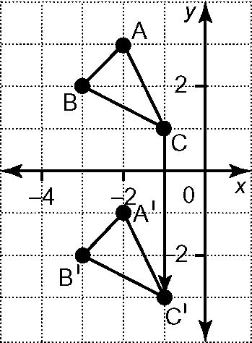
A transformation moves one geometric figure onto another. Transformations include translations, rotations, and reflections.
The transformed figure is called an image.
∆ABC has been translated 4 units
vertically down. The translation image
is ∆A′B′C′. The coordinates are (−2, −1),
(−3, −2), and (−1, −3).
Rectangle PQRS has been reflected in the
line of reflection, m. The coordinates of
P′Q′R′S′ are (1, 4), (3, 4), (3, 3), and (1, 3).
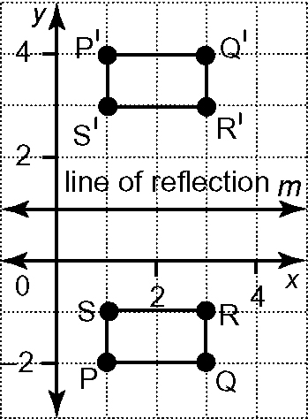

5. ∆THE is rotated around the centre of rotation, z.  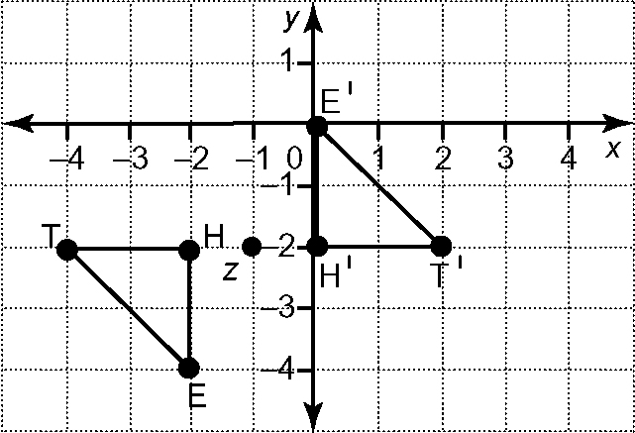  a) What are the coordinates of ∆THE and ∆T′H′E′?  b) What are the direction and angle of rotation? | 6. Copy parallelogram MORN onto a coordinate grid.  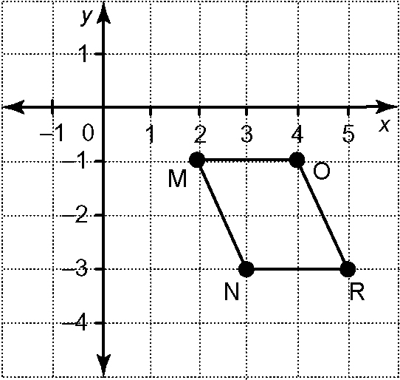  a) Translate MORN 3 units up and  4 units left.  b) Identify the coordinates of the translation image.  c) Draw a line of reflection, t, parallel to the y-axis at –2.  d) Reflect M’O’R’N’ in line of reflection t.

