Chapter 12 Warm-Up
Section 12.1

You spin the following spinner divided into four equal regions and roll a six-sided die. The outcomes tell you how many guests you predict having for each meal.
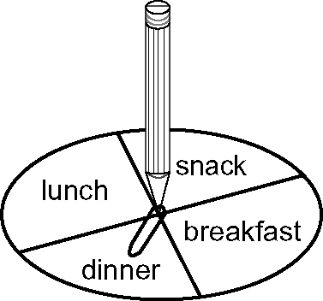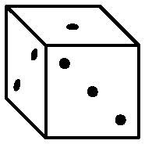
1. Construct a table to determine the sample space. How many possible outcomes are there?
2. Determine the number of possible outcomes, using multiplication.
3. From the table, what is P(breakfast, 1) expressed as a fraction?
4. Use multiplication to determine P(breakfast, 1).
5. Calculate the probability of having more than three guests for breakfast or lunch.
Mental Math
6. If 3t = 24, what is t?
7. If –3t = 24, what is t?
8. If –3t =–24, what is t?
9. If = 24, what is t?
10. If = –24, what is t?

Section 12.2

For #1–#3, identify which shapes can tessellate the plane. Justify each response.

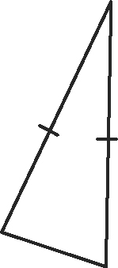
1. 2.

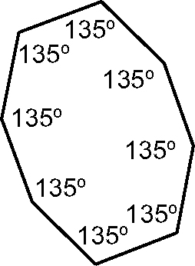
3.

For #4 and #5, you roll a four-sided die. Your partner spins a spinner with five equal sections numbered 1, 3, 5, 7, and 9.
4. What is the probability of rolling and spinning an odd number?
5. Verify your answer to #4 using another method.

Mental Math
Use the following prism to answer #6–#10.
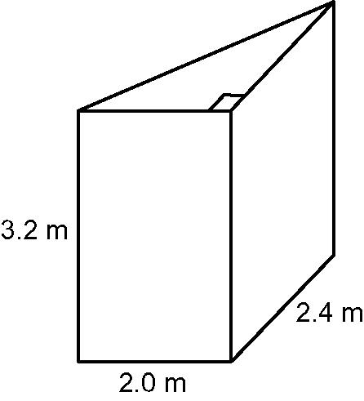

6. What type of prism is this?
7. Show the base to the height of the triangle as a ratio in simplest form.
8. Estimate the volume of this prism. Show your thinking.
9. Use another strategy for estimating the volume of this prism. Show your thinking.
10. Estimate the surface area of this prism. Show your thinking.

Section 12.3

Use the tessellation below for #1 and #2.
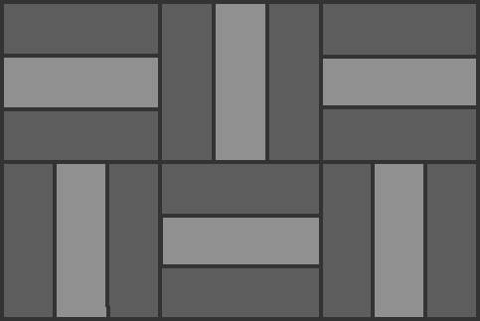
1. What polygons and what transformations are used to create this tessellation?
2. Does the area of the tessellating tile change during the tessellation?
3. Draw an example of a polygon that tessellates the plane.
Use the A-frame cottage below to answer #4 and #5.
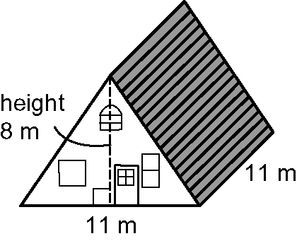
4. What is the width to the length to the height of this cottage as a three-term ratio?
5. What maximum volume of air will this cottage hold?
6. Convert 1.15 to a percent and a reduced fraction.
7. Convert 253% to a decimal and a fraction.
8. Convert to a decimal and a percent.
9. The population of a town was 5000. It increased by 0.5% in one year. What is the new population? Show your thinking.
10. Calculate the following:
a) 10²
b) 20²
c) 30²

Section 12.4

Use the tessellation below for
#1–#3.
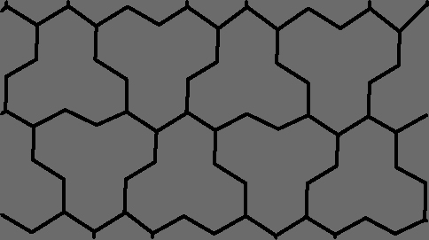
1. Describe the polygon used to create this tessellation.
2. What transformations could be used to create this tessellation?
3. When creating a tessellation using rotations, why is it important for the sum of the angle measures at the point of rotation to equal 360°?
Use the triangle below to answer #4 and #5.
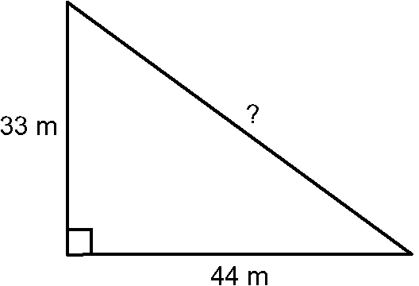
4. What is the ratio of the shorter to the longer measurement of this triangle? Show the ratio in reduced form.
5. Calculate the missing side length.
Mental Math
Estimate the square root of the numbers in #6–#8. Show your thinking.
6. 92
7. 45
8. 63
Mentally calculate the missing number for #9 and #10.
9.
10.

