Chapter 12 Problems of the Week
1. The following tessellation is to be reflected over line A. If a rhombus has a cost of $0.35, what is the cost of the entire tessellation? a triangle? a trapezoid? a hexagon?  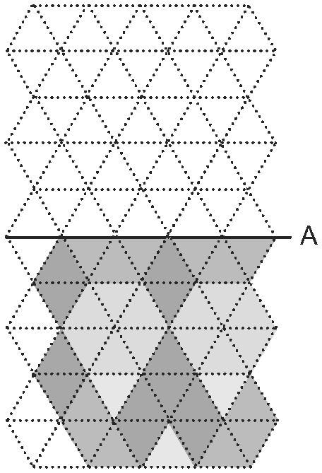 | 2. Does the letter H below tessellate?  If it does, what is the least number of different colours needed so that when each shape is coloured no touching shapes have the same colour?  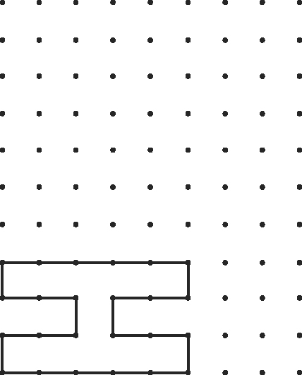
3. Does the letter Z below tessellate? How do you know?  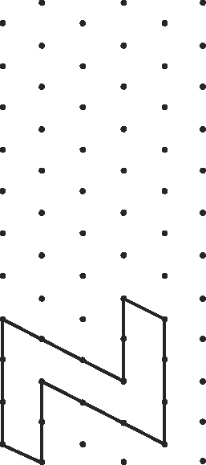 | 4. Although you are learning about tessellations in math class, you could argue that tessellations are more a form of art than of mathematics. What do you think?  • What mathematical skills are involved in creating tessellations?  • What artistic skills are used?  • Do you have to be good at both to explore tessellations?
5. Create your own unique tessellation.  Use the paint program on your computer to cut and paste a simple image of a bird or fish on your screen. Continue to paste and see if it tessellates.  What conclusions can you make about objects that tessellate? | 6. Using all the pattern block pieces except for the orange square, create a tessellation that would cost no more than $18.75, if a green triangle has a cost of $0.375. Justify your design.

