Section 12.1 Extra Practice
1. Are the polygons regular or irregular?

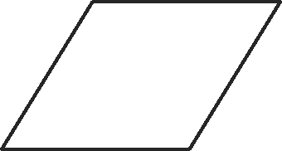
a)

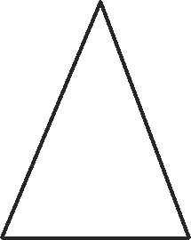
b)


c)

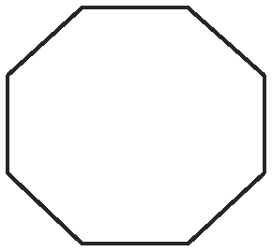
d)

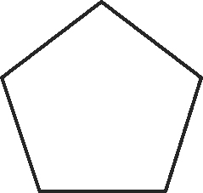
e)

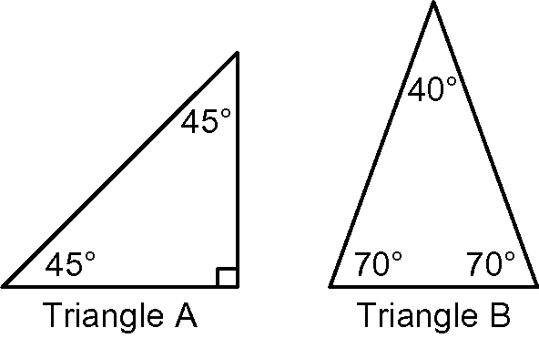
2. a) Triangle A and Triangle B are both examples
of what kind of triangle?
b) Tiling the plane means covering the plane with
a shape, with no gaps and no overlaps. Can you
tile the plane with Triangle A? Explain why or
why not.
c) Can you tile the plane with Triangle B?
Explain why or why not.

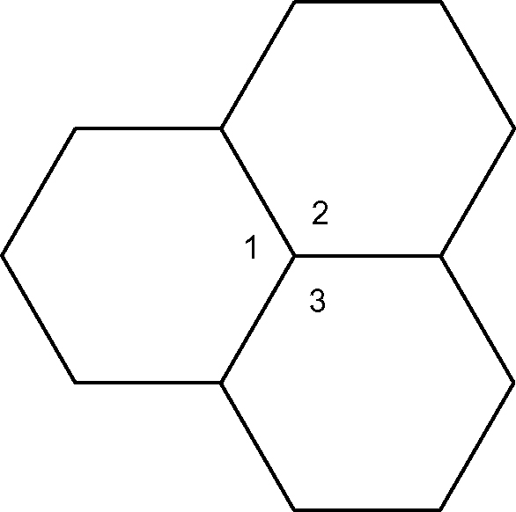
3. a) What is the measurement of angle 1?
angle 2? angle 3?
b) What is the sum of the three angles?
c) Can you tile the plane with the hexagon?

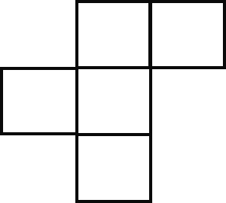
4. Does the pentomino tile the plane?
Explain why or why not.

