Section 12.1 Math Link
This worksheet will help you with the Math Link on page 451.

This tiling pattern is from Alhambra, a palace built in Granada, Spain.
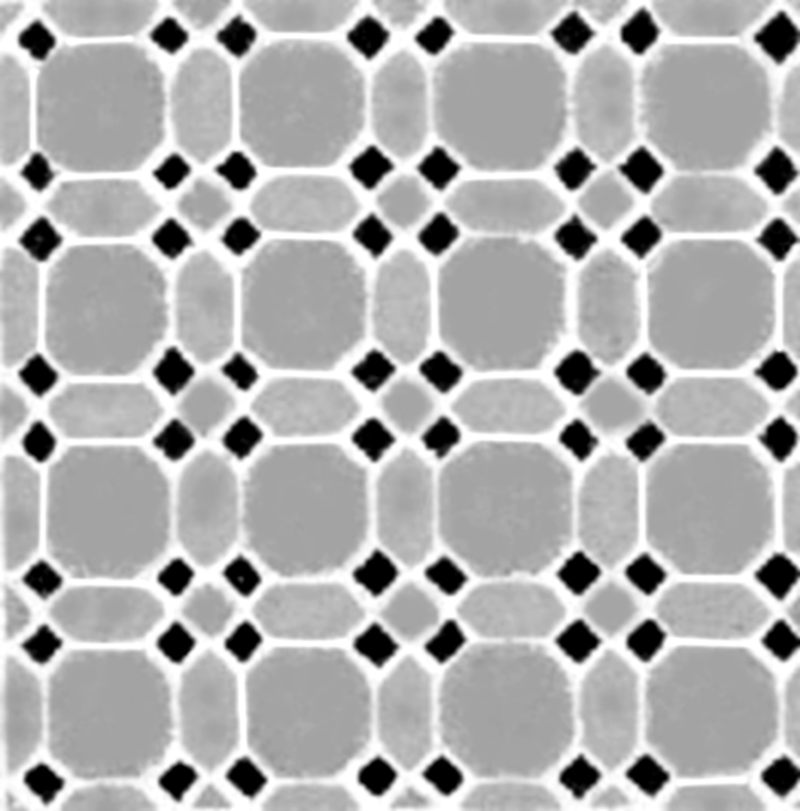
1. There are four shapes in this pattern. Circle each shape in the pattern with a coloured pencil and write the numbers 1 to 4 in each. Fill in the chart.

Shape # | Name of Shape | Regular Polygon? Yes/No
1
2
3
4

2. Trace ten of each shape from BLM 12–9 onto cardboard or construction paper.

3. Cut out the 40 shapes and use some or all of them to create at least two different tile mosaics. Use each of the four shapes in your mosaics.

