Section 12.2 Extra Practice
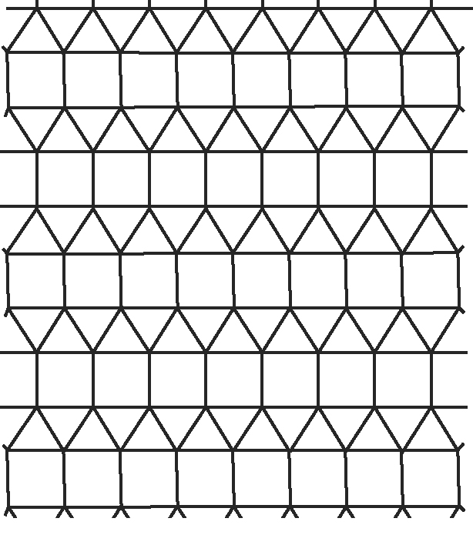
1. a) Which two polygons make up this tessellation?
b) Are both shapes regular polygons?
Explain your answer.
c) Explain how this tessellation could be
constructed using a translation.
d) Explain how this tessellation could be
constructed using a reflection.

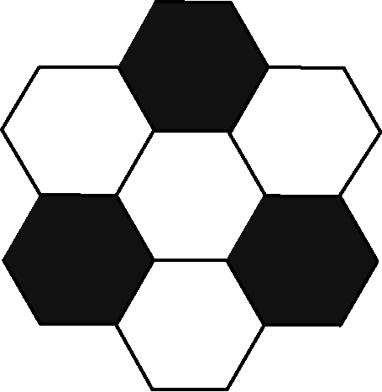
2. a) Which two polygons make up this tessellation?
b) Where have you seen this tessellation
used in sports?
c) Considering your answer in part b), can
this tessellation be used to tile the plane?
Explain how you know.

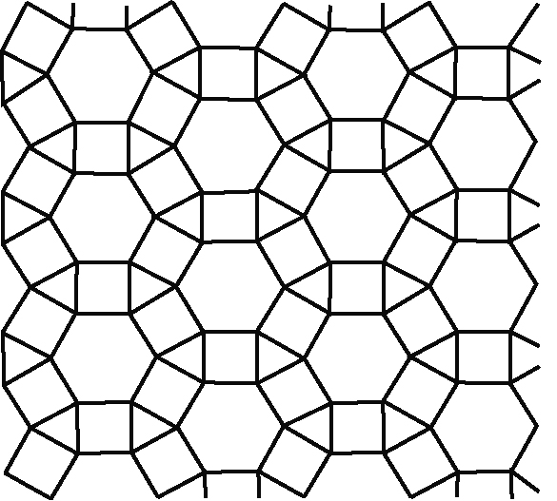
3. a) Which three polygons make up this
tessellation?
b) Which transformations could be used to
create this tessellation?

4. Which of these figures are reptiles? How do
you know? Hint: See #9 on student resource
page 456.
