Section 12.2 Math Link
This worksheet will help you with the Math Link on page 456.

Many quilt designs are made using tessellating shapes.
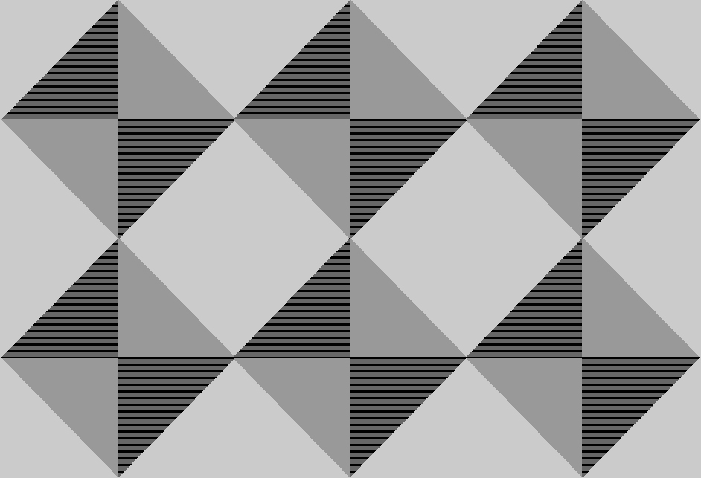
1. What shapes do you see in the design?
______________________________________________________________

2. Describe how the squares are formed from smaller shapes.
______________________________________________________________
______________________________________________________________

3. Describe how the squares are translated.
______________________________________________________________
______________________________________________________________

4. In this quilt, a “quilt square” consists of one large square made up of four triangles and then another four right triangles. Outline the quilt square with a highlighter.
Design your own quilt square using one regular tessellating polygon. Remember, the interior angles where the vertices of the polygons meet must total exactly 360°. Create an interesting design using patterns and colours.

