Section 12.3 Extra Practice
1. How many times could you rotate this equilateral triangle to make a tessellation?
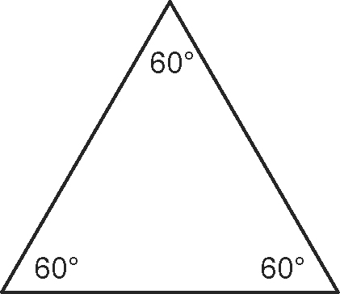
2. Which of these triangles could be rotated to make a tessellation?
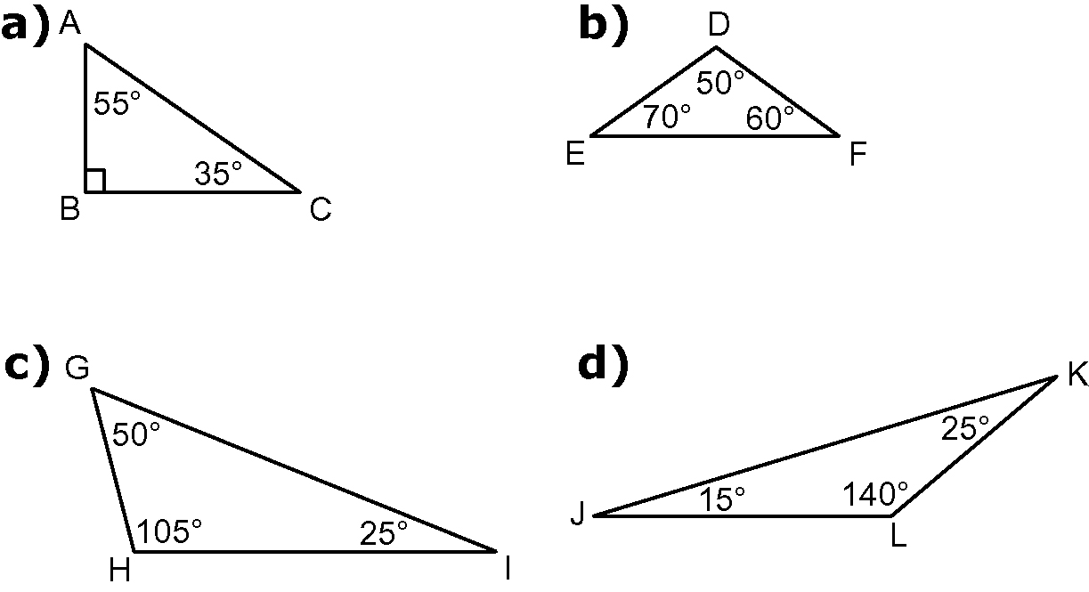

3. For each of the triangles in #2 that you found can be rotated to make a tessellation, indicate the letter of the point where the rotation occurs.

4. If you had two regular hexagons as the diagram shows, which other regular polygon could you use to make a rotation? Hint: It cannot be another hexagon. You would have to use more than one of that particular regular polygon.
