Section 12.3 Math Link
This worksheet will help you with the Math Link on page 460.
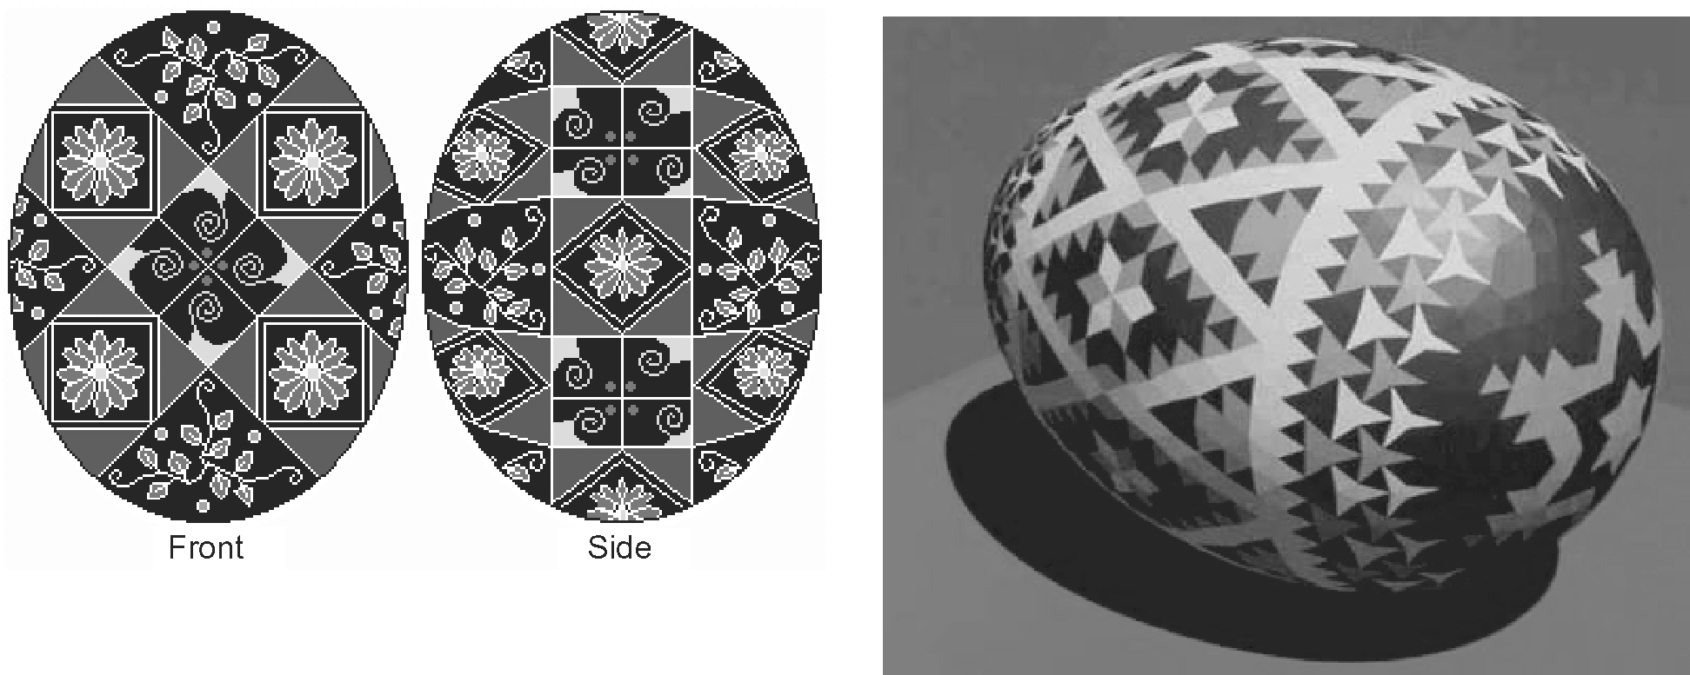
Examine these pysanka designs, or see the Web Link on page 460 for other examples.

1. Choose one of the designs.

2. Outline one of the designs in the pysanka with a highlighter.
a) What shapes did you highlight?
__________________________________________________________
b) How were the shapes tessellated?
__________________________________________________________

3. Create your own pysanka design based on tessellating one or more polygons.

4. Trace your design on grid paper, and colour it. Make sure it is the correct size to fit on an egg.

5. If you have time, decorate an egg with your pysanka design.

