Section 12.4 Math Link
This worksheet will help you with the Math Link on page 465.
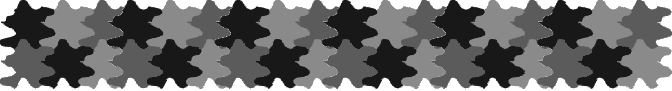
This design is an Escher-style tessellation. To see examples of M.C. Escher’s art, see the Web Link on student resource page 465.

1. Use a highlighter to outline one of the shapes. What basic shape was used?
____________________

2. What type(s) of transformation was used to make the tessellation?
____________________

3. Why is this design classified as an Escher-style tessellation?
______________________________________________________________

4. This design could be used as a binder cover, wrapping paper, a border for writing paper, or a placemat. How would you use it?
______________________________________________________________

5. Create an Escher-style tessellation to use as a design for one of the following:
• binder cover
• wrapping paper
• border for writing paper
• placemat
• some other purpose of your choice

