Chapter 12 Test
For #1 to #5, select the best answer.

1. Which of these polygons cannot be used to create a tessellation?
A equilateral triangle B pentagon C regular octagon D trapezoid

2. How many different polygons were used to create this tessellation?
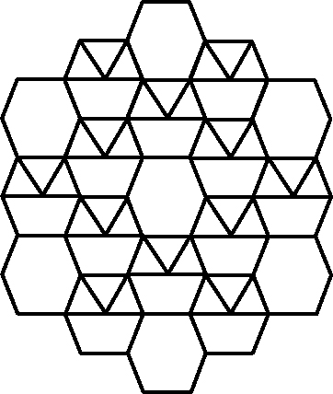
A 1 B 2 C 3 D 4

3. Regular and irregular polygons tessellate the plane when the interior angle measures total exactly how many degrees?
A 90° B 180° C 270° D 360°

4. Which is not a form of transformation?
A translation B rotation C reflection D reduction

5. Which one of the following pairs of polygons is congruent?
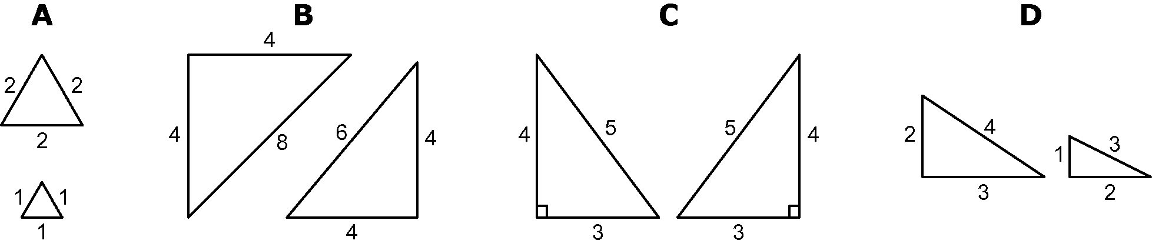

Short Answer

6. Can the following shape be used to tile the plane? Explain.
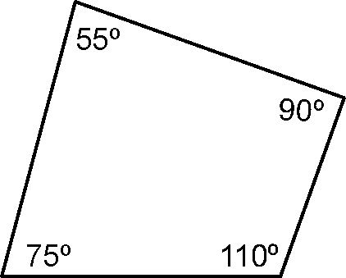
7. Can the following shape be used to tile the plane? Explain.
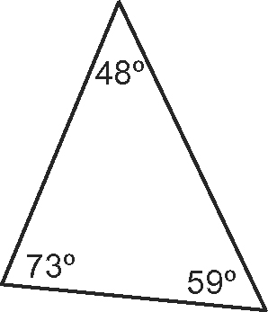

8. Fill the plane using an equilateral triangle with side length of 3 cm.
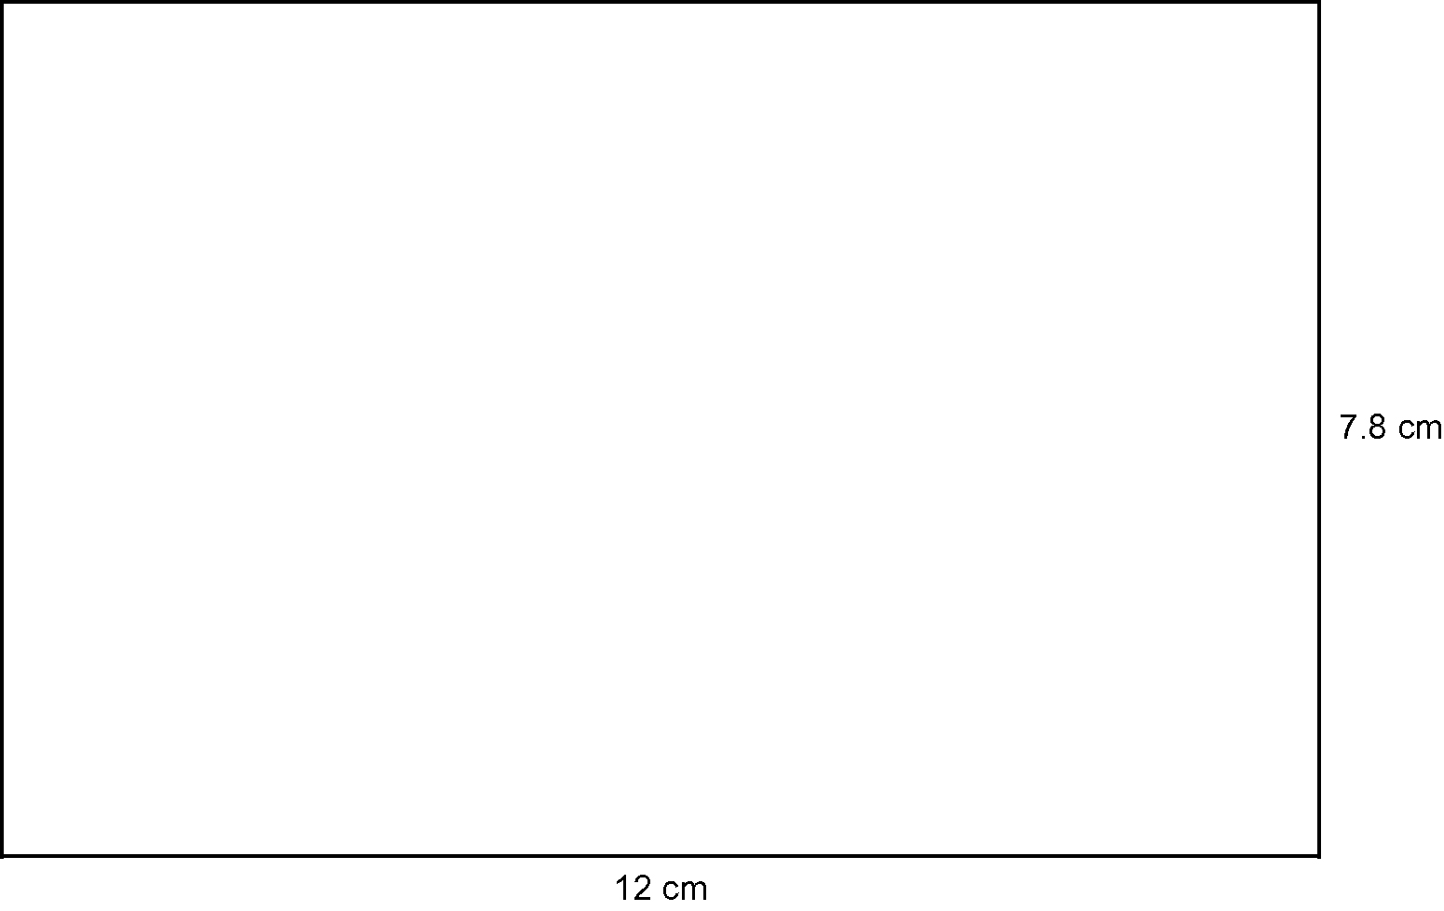

9. Create a tessellation for each pair of shapes that follow.
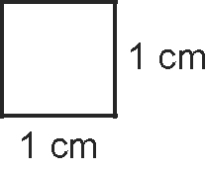
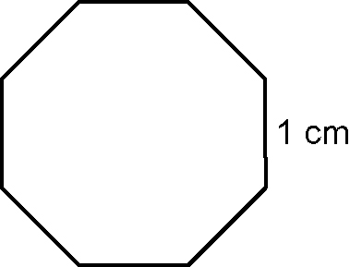
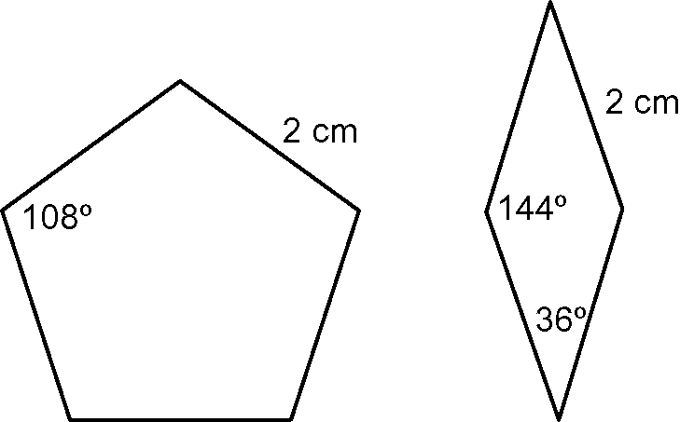
a) b)

Extended Response

10. Create an Escher-style tessellation using a square and rotations.

11. Ceramic tiles will be used to cover the floor of the school’s main entrance. Design a tessellation using four different polygons. The main entrance is
5 m by 6 m. Describe the size and colour of each polygon, and provide a pattern for the installers to follow.

