Chapter 12 BLM Answers

BLM 12–1 Math Link Introduction
1. Answers will vary. Example: A regular polygon is a polygon with all sides and all angles having equal measurements.
2. Answers will vary. Example: An irregular polygon is a polygon where sides and angles have different measurements.
3. a) Answers may vary slightly. Examples:
side AC = 16 mm; side AB = 13 mm;
side CB = 15 mm; side ZX = 16 mm;
side XY = 13 mm; side ZY =15 mm.
Yes. Answers will vary. Example: The corresponding sides are equal.
b) Answers may vary slightly. Examples:
angle A = 60°; angle B = 70°; angle C = 50°; angle X = 60°; angle Y = 70°; angle Z = 50°. Yes. Answers will vary. Example: The corresponding angles are equal.
c) Answers will vary. Example: Congruent means having the same size and shape.
d) Yes. Answers will vary. Example: The lengths of the sides are equal and the measures of the angles are equal.
5. a) Answers may vary slightly. Example: All the sides equal 8 mm.
b) Answers may vary slightly. Examples: All the angles equal 120°.
c) Yes. Answers will vary. Example: The lengths of the sides are equal and the measures of the angles are equal. d)−f) Answers will vary.
6. Ensure students check off the appropriate transformations for their pattern.
7. Ensure students accurately list the steps to create their pattern and list the names of the transformations they used.
BLM 12–2 Chapter 12 Get Ready
1. a) No. Some of their angles and one of their sides are not equal. b) Yes. There are corresponding angles and sides. c) No. The circles are different sizes. d) Yes. There are corresponding angles and sides.
2. b) In rectangles ABCD and GHIJ: all angles
are equal because they are all 90°; and
d) In parallelograms MNOP and STUV:
∠N = ∠O = ∠S = ∠V, ∠M = ∠P = ∠T = ∠U;
3. a) This is a regular polygon because all sides and all angles are equal.
b) This is a regular polygon because all sides and all angles are equal.
c) This is an irregular polygon because some of the sides and some of the angles differ.
d) This is an irregular polygon because some of the sides and some of the angles differ.

4. Answers may vary. Look for the following:
• Regular polygons have equal sides and angles, such as equilateral triangles, squares, and some hexagons.
• Irregular polygons have at least some sides and angles that are not equal, such as isosceles and scalene triangles.
5. a) ∆THE has coordinates (−4, −2), (−2, −2), and (−2, −4). ∆T′H′E′ has coordinates (2, −2),
(0, −2) and (0, 0).
b) The direction of rotation is clockwise or counter-clockwise. The angle of rotation is 180°.
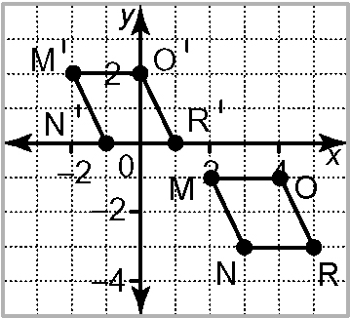
6. a)

b) The coordinates of M′O′R′N′ are (−2, 2),
(0, 2), (1, 0), and (−1, 0).
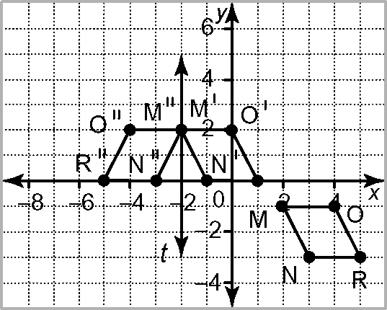
c), d)

BLM 12–3 Chapter 12 Warm-Up
Section 12.1
1.
 | 1 | 2 | 3 | 4 | 5 | 6
breakfast | B, 1 | B, 2 | B, 3 | B, 4 | B, 5 | B, 6
lunch | L, 1 | L, 2 | L, 3 | L, 4 | L, 5 | L, 6
dinner | D, 1 | D, 2 | D, 3 | D, 4 | D, 5 | D, 6
snack | S, 1 | S, 2 | S, 3 | S, 4 | S, 5 | S, 6
24 possible outcomes
2. 4 × 6 = 24 3. 4.
5. 6. t = 8 7. t = −8
8. t = 8 9. t = 72 10. t = −72
Section 12.2
1. Yes, isosceles triangles can tessellate the plane.
2. Yes, four 90° angles add up to 360°.
3. No, 135° angles do not add up to 360°.

4.
 | 1 | 2 | 3 | 4
1 | 1, 1 | 1, 2 | 1, 3 | 1, 4
3 | 3, 1 | 3, 2 | 3, 3 | 3, 4
5 | 5, 1 | 5, 2 | 5, 3 | 5, 4
7 | 7, 1 | 7, 2 | 7, 3 | 7, 4
9 | 9, 1 | 9, 2 | 9, 3 | 9, 4
P(2 odd numbers) =
5. P(2 odd numbers) =
This could also be done using a tree diagram.
6. triangular 7. 2.0 : 2.4 = 1 : 1.2
8. Answers will vary. Example: Front-end estimation: 2 × 2 ÷ 2 × 3 = 6 m³
9. Answers will vary. Example: Work with 5s:
2 × 2.5 ÷ 2 × 3 = 5.0 ÷ 2 × 3 = 7.5 m³
10. Answers will vary. Example:
triangular top/bottom = 2 × 2.5 ÷ 2 × 2 = 5 m²
rectangular sides = 3 × 2.5 × 2 = 15 m²
rectangular end = 2 × 3 = 6 m²
5 + 15 + 6 = 26 m²
Section 12.3
1. The tessellation is made from a tile consisting of three identical rectangles. The combined tile is then rotated 90° and translated horizontally and vertically.
2. No.
3. Answers will vary. Examples could include an equilateral triangle, isosceles triangle, square, regular hexagon, some irregular quadrilaterals and hexagons, and one irregular pentagon.
4. 11 : 11: 8 5. 484 m³ 6. 115%, 1
7. 2.53, 2 8. 0.875, 87.5%
9. 1% = 50
0.5% = 25
100.5% = 5025
10. a) 100 b) 400 c) 900
Section 12.4
1. This is a regular 12-sided polygon.
2. The polygon has been rotated and then translated vertically and horizontally.
3. Answers will vary. Example: If the angles do not add to 360°, the polygons will overlap or there will be gaps.
4. 33 : 44 = 3 : 4
5. 55 m. Note: Students who recognize this as a 3, 4, 5 Pythagorean triple may be able to do this mentally.
6. 9 × 9 = 81 7. 6 × 6 = 36
10 × 10 = 100 7 × 7 = 49
≈ 9.6 ≈ 6.7
8. 7 × 7 = 49 9. 5 10. 11
8 × 8 = 64
≈ 7.9
BLM 12–4 Chapter 12 Problems of the Week
1. The entire tessellation would cost $13.65. A triangle would cost $0.175, a trapezoid would cost $0.525, and a hexagon would cost $1.05.
2. The letter H tessellates. The least number of colours needed is seven.
3. The letter Z tessellates. Answers will vary. Example: The letter Z is a regular shape, so it will cover the area without leaving gaps or overlapping.
4. Answers will vary and should include points like the following:
• The mathematical skills involved in creating tessellations include transformations, such as translations, reflections, and rotations. You also need to know which shapes will tessellate.
• Having an interest in art may be more important than knowledge of math to do tessellations. Art is about imagination and tessellations are very creative. You use your drawing and colouring abilities to create tessellations.
5. Answers will vary. Example: For an object to tessellate, the interior angles at the vertices need to total exactly 360°.
6. Answers will vary. Look for tessellations that use all of the pattern block pieces, except for the orange square, and that add to no more than $18.75. hexagon = $2.25; trapezoid = $1.125; parallelogram = $0.75
BLM 12–7 Section 12.1 Extra Practice
1. a) irregular b) irregular c) irregular
d) regular e) regular
2. a) isosceles
b) Yes. Answers will vary. Example: Isosceles triangles can tile the plane.
c) Yes. Answers will vary. Example: Isosceles triangles can tile the plane.
3. a) Angles 1, 2, and 3 all equal 120°.
b) 360° c) Yes
4. Yes. Answers will vary. Example: The pentomino tiles the plane because the interior angles add to 360°.
BLM 12–8 Section 12.1 Math Link
1. Answers may vary. Example:
#1: square, yes; #2: square, yes;
#3: hexagon, no; #4: octagon, yes
2., 3. Ensure students accurately create two different tile mosaics.
BLM 12–11 Section 12.2 Extra Practice
1. a) square, equilateral triangle
b) Yes. All sides and all angles within each polygon are equal.
c) Answers may vary. Example: The square and triangles are translated horizontally.
d) Answers may vary. Example: Draw a line of symmetry horizontally through the middle of the squares or vertically through the middle of the triangles.

2. a) white hexagon and black hexagon
b) soccer ball
c) Yes. The tessellation covers the soccer ball without any overlaps or gaps.
3. a) triangle, hexagon, square
b) Answers may vary. Examples: a rotation using the interior angles of the hexagon, squares, or triangle; a reflection with lines of reflection horizontally or vertically through the middle of the hexagon
4. a) No. The shape is not made up of repeating shapes.
b) Yes. The shape is made up of repeating parallelograms.
c) Yes. The shape is made up of repeating rectangles.
BLM 12–12 Section 12.2 Math Link
1. Answers will vary. Example: squares and triangles
2. Answers will vary. Example: Each square is made up of four congruent right isosceles triangles.
3. Answers will vary. Example: Each square consisting of four right isosceles triangles could be translated diagonally.
4. Ensure students use one regular tessellating polygon to create an interesting design for a quilt square.
BLM 12–14 Section 12.3 Extra Practice
1. five times
2. a) Yes b) Yes c) No d) Yes
3. a) point B b) point F d) point J
4. two equilateral triangles
BLM 12–15 Section 12.3 Math Link
2. Answers will vary. Ensure students accurately identify the shapes and tessellations.
3.−5. Ensure students accurately tessellate one or more polygons to create a pysanka design.
BLM 12–16 Section 12.4 Extra Practice
1. a) No b) Yes c) No
2. a) square; translation
b) equilateral triangle; rotation
c) square; translation, reflection
3. Answers will vary. Ensure students provide accurate information about M.C. Escher.
BLM 12–17 Section 12.4 Math Link
1. Answers may vary. Example: flower shape
2. translation
3. Answers will vary. Example: It is an Escher-style tessellation because it uses an unusual shape.
4. Answers will vary.
5. Ensure students create an accurate Escher-style tessellation.

BLM 12–18 Chapter 12 Test
1. B 2. C 3. D 4. D 5. C
6. Yes. The interior angles can total 360°.
7. No. The interior angles cannot total 360°.
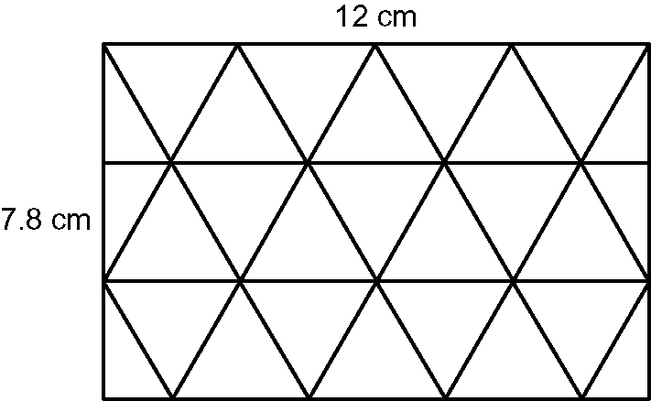
8.

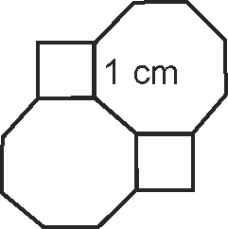
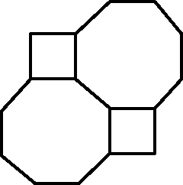
9. a)

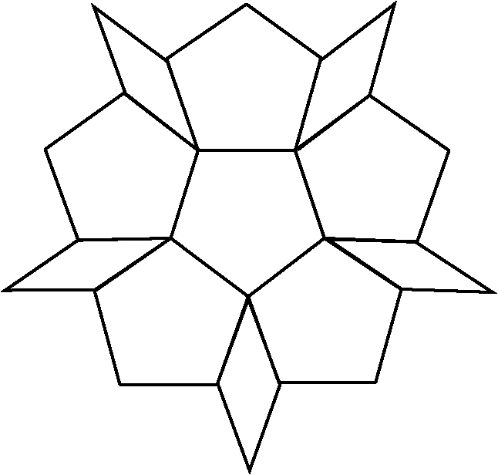
b)

10. Ensure students provide an Escher-style tessellation using a square and rotations.
11. Ensure students provide a design that covers 5 m by 6 m and that uses four different polygons.

