Bar Graphs and Double Bar Graphs

The bar graph shows that Zoe has twice as many science fiction books  as books about sports. | The double bar graph shows that Matt has twice as many sports books as Zoe has.
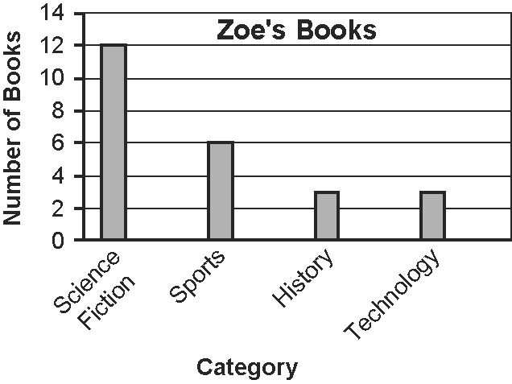 | 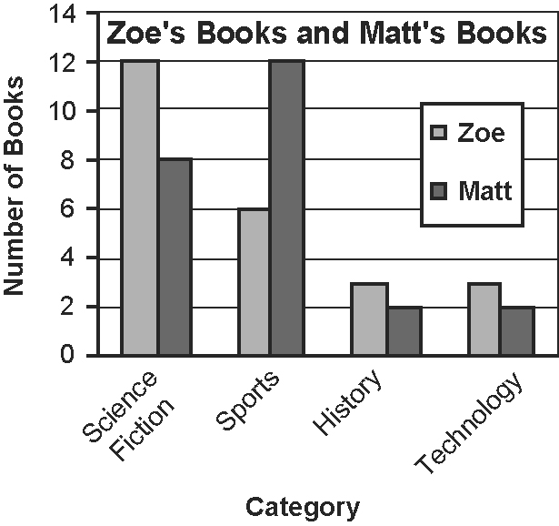
The bars in bar graphs can be vertical or horizontal. Bar graphs leave space between each data category.

1. Use the bar graph about Zoe’s books to answer these questions.  a) How many more books does Zoe have about science fiction than history?  b) If the bars were drawn horizontally, what would change on the graph? What would stay the same? Redraw the bar graph using horizontal bars. | 2. Use the double bar graph to answer these questions.  a) How many more science fiction books does Zoe have than Matt?  b) How many more sports books does Matt have than history books?  c) Write another question you could ask about the graph. Develop an answer for your question.
Circle Graphs

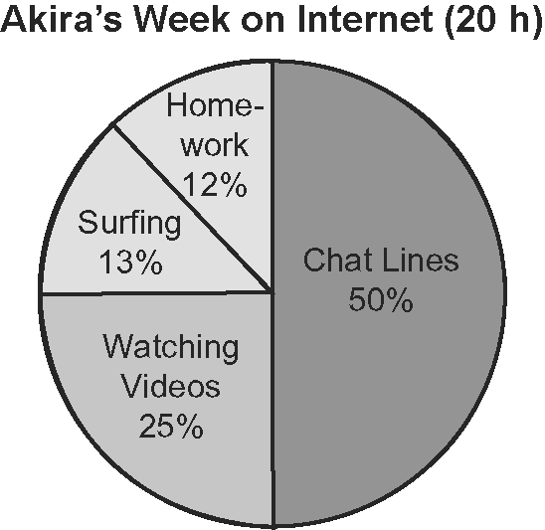
The circle graph shows the different activities
that Akira does online.

3. Use the circle graph to answer these questions.  a) What activity did Akira spend the most time on? How many hours did she spend?  b) How much more time does Akira spend on chat lines than surfing? | c) What percent of her Internet time is not spent watching videos?  d) Would this circle graph make sense if the titles or labels were missing? Explain.
Line Graphs

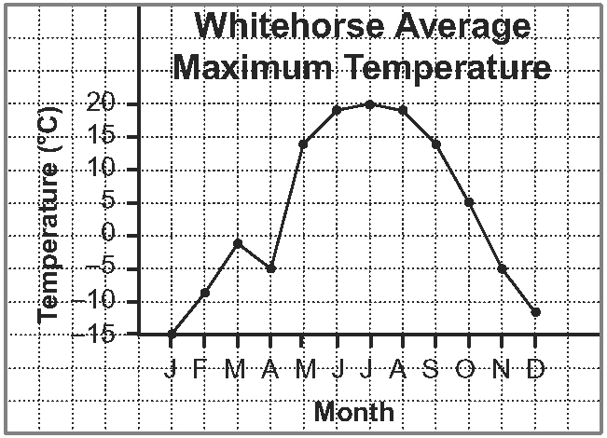
The line graph shows changes in average
maximum temperature for each month in
Whitehorse, Yukon Territory.

4. Use the line graph to answer these questions.  a) Which month had the highest average maximum temperature?  b) When did the greatest temperature change happen? | c) When did the smallest temperature change occur?  d) Do you think the trend of rising and falling temperatures will continue? Explain.
Pictographs

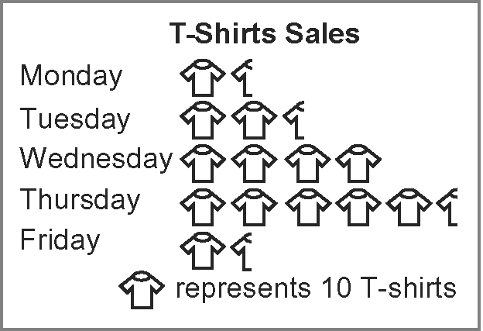
The pictograph shows that more T-shirts were
sold on Thursday than the rest of the week.

5. Use the pictograph to answer these questions.  a) How many more T-shirts were sold on Thursday than on Friday? | b) How many T-shirts were sold during the week?  c) Explain how you used the pictograph to answer a) and b).

