Chapter 1 Warm-Up
Section 1.1

1. What type of graph is this?
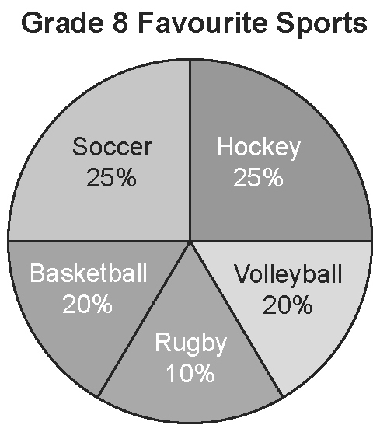
Use the graph in #1 to answer #2 and #3.
2. What percent of students prefer volleyball?
3. How popular is hockey?
4. What type of graph is this?
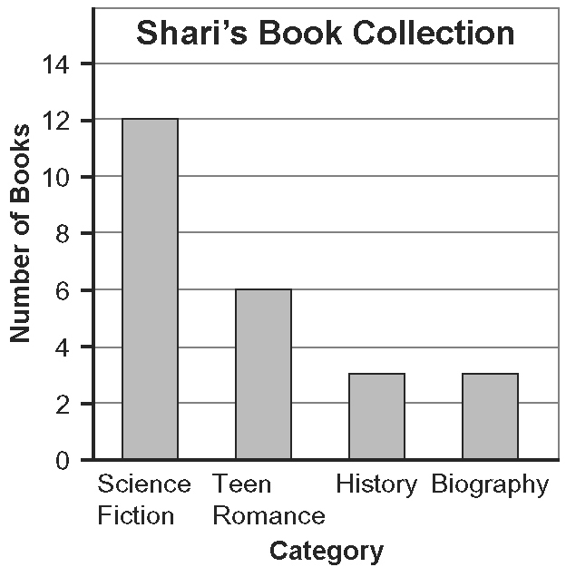
5. How many books does the graph in #4 show that Shari has?
Mental Math
6. You want to show on a circle graph. What fraction of the circle graph do you colour?
7. You want to show on a circle graph. How many degrees do you need for your sector angle?
8. Count by 5s from 30 to 60.
9. Count by 20s from 0 to 200.
10. Count by 25s from 100 to 300.

Section 1.2

1. What information does this graph provide?
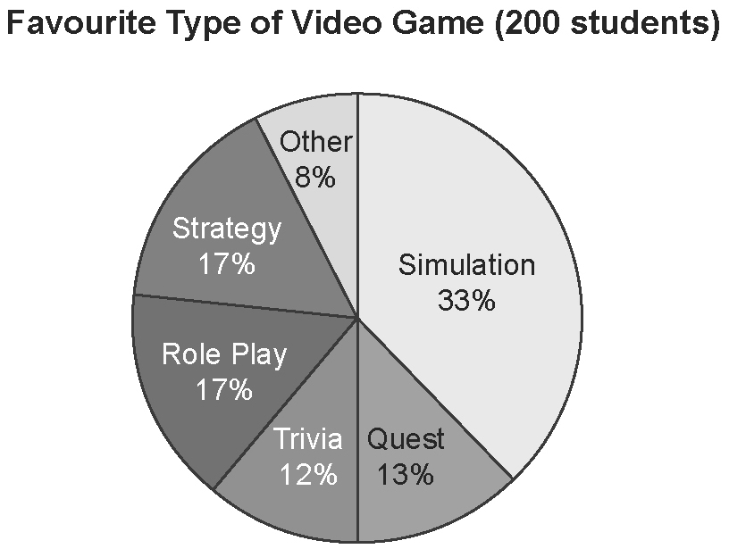
2. What information does this graph show?
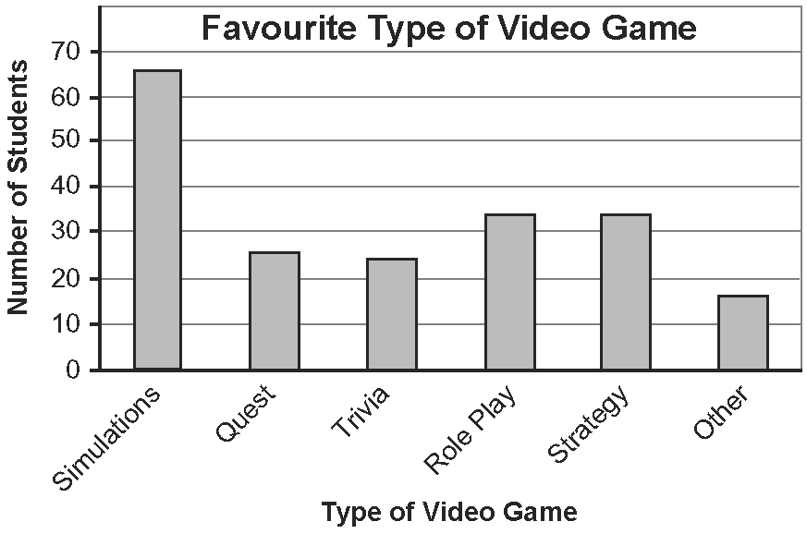
3. How many people prefer role-play games? Which graph shows this more clearly? Explain why.
4. Would a line graph be a useful way to show the data? Explain why or why not.
5. What other type of graph could be used to display the data?
Mental Math
6. On a pictograph, each soccer ball represents 10 players. How many players are represented by 2.5 soccer balls?
7. On a pictograph, each pair of ice skates represents 15 skaters. How many skaters are represented by 4 pairs of ice skates?
8. On a pictograph, each ice cream cone represents 5 ice creams sold. How many ice creams do you need to show that you have sold
a) 35 ice creams?
b) 42 ice creams?
9. You want to show 25% on a circle graph. How many degrees do you need for your sector?
10. You want to show 75% on a circle graph. How many degrees do you need for your sector?

Section 1.3

Use the graph in #1 to answer
#2 to #5.
1. According to the graph, how many people prefer each trip destination?
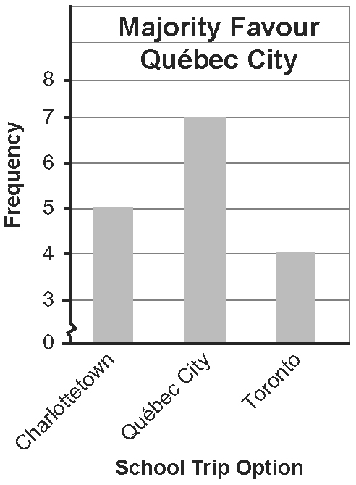
2. From the graph, what can you conclude about the number of people who prefer Québec City? How has the graph been distorted to give this impression?
3. Redraw the graph to show the information accurately.
4. What would be a more accurate conclusion about student preferences?
5. What other type of graph could be used to display the data? Explain your preference.

Mental Math
6. Alan wants to draw a pictograph using these symbols to represent ten people who prefer either soccer or basketball. What recommendations do you have for Alan?
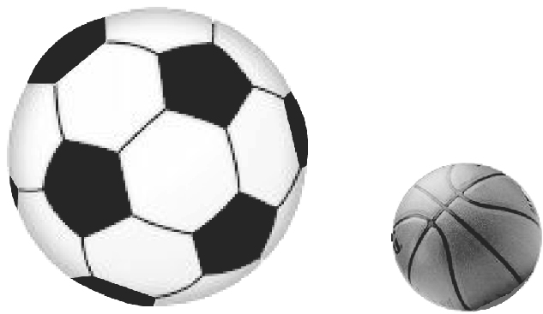
7. In most cases, what number should the y-axis start with? Explain why.
8. Draw the symbol you would use to show a break in the y-axis.
9. On a pictograph about lunch choices, a chef used a pizza to represent 5 sales and a hamburger to represent 10 sales. What suggestion do you have for the chef?
10. You want to show 50% on a circle graph. How many degrees do you need for your sector?

