Chapter 1 Problems of the Week
1. For two of the following situations, complete these steps:  • Prepare a survey question that will give you data.  • Display the data in an appropriate graph.  • Answer the question asked.  a) How many hours a day do teens  spend sleeping? What about  adults?  b) What percent of students in the  class wear glasses? contacts? no eyewear?  c) What are the four favourite  flavours of ice cream of students in the class?  d) How many students in the class  have a female sibling? male  sibling? no sibling? | 2. This weekend Dana recorded her activities for 20 h. She spent 7 h on homework, 4 h on chores, and 9 h with friends. Dana displayed the data on a triangle.  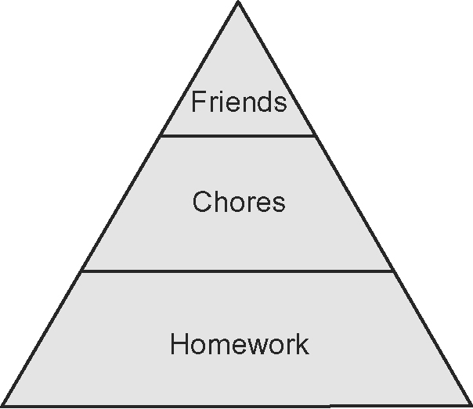  a) Does the triangle distort the  data? Explain.  b) Does it work to Dana’s  advantage or disadvantage to  display data this way? Explain.  c) Display the data accurately on a  graph of your choice.
3. In Mr. Pem’s class, the following percent scores were recorded on a Math test: 48, 50, 56, 57, 70, 72, 72, 73, 76, 77, 79, 80, 82, 86, 87, 89, 90, and 92.  A circle graph is constructed with values ranging from 0–59, 70–79,  80–89, and 90–100.  a) How many degrees do you need  to represent the sector angle for  scores from 70–79?  b) Create the graph.  c) Do you think that this is a fair  way to represent the scores?  Explain. | 4. Sandy, a business student, created a graph for her school newspaper that showed how many students graduated from the Faculty of Business.  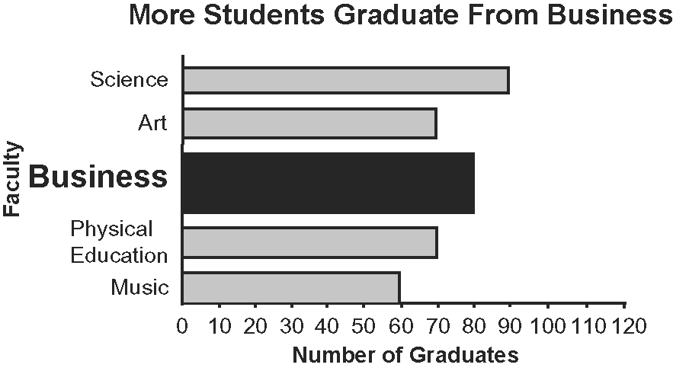  a) Is this graph misleading? Explain.  b) How would you improve this  graph?

