Section 1.2 Extra Practice
1. Describe two ways that the format of a graph can be misleading.
a) ______________________________________________________________
b) ______________________________________________________________
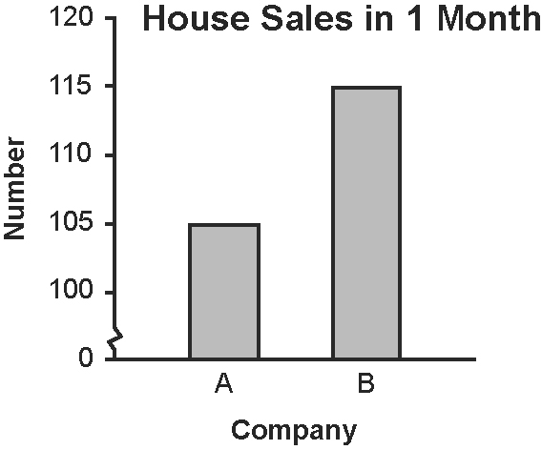
2. This graph shows the number of houses sold
in one month by two real estate companies.
a) According to the graph, how many houses did
each company sell?
______________________________
______________________________
b) From the graph, which company appears to
have sold many more houses? ____________________
What part of the graph has been distorted to create this impression?
_____________________________________________________________
_____________________________________________________________
c) How should the graph be redrawn to represent the house sales more accurately?
_____________________________________________________________
d) Write an accurate conclusion about the house sales.
_____________________________________________________________

3. Christy and her friends like three different rock bands: The Stones, The Pebbles, and The Boulders. Christy surveys her classmates about their favourite one of these bands. She records the data.

Band | Votes
The Stones | 8
The Pebbles | 6
The Boulders | 5

a) Draw a graph to make it appear that The Stones are much more popular than the other two bands.
b) Explain how your graph distorts the data.
_____________________________________________________________

